Region is a cluster of data centers

How to choose an AWS Region?

• Compliance with data governance and legal requirements

• Proximity to customers: reduced latency

• Available services within a Region

• Pricing

AWS Availability Zones

• Each region has many availability zones (usually 3, min is 3, max is 6)

• Each availability zone (AZ) is one or more discrete data centers with redundant power, networking, and connectivity

• They’re separate from each other, so that they’re isolated from disasters

• They’re connected with high bandwidth, ultra-low latency networking

AWS Points of Presence (Edge Locations)

• Content is delivered to end users with lower latency

AWS has Global Services:

• Identity and Access Management (IAM)

• Route 53 (DNS service)

• CloudFront (Content Delivery Network)

• WAF (Web Application Firewall)

IAM: Users & Groups

• IAM = Identity and Access Management, Global service

• Root account created by default, shouldn’t be used or shared

• Users are people within your organization, and can be grouped

• Groups only contain users, not other groups

• Users don’t have to belong to a group, and user can belong to multiple groups

IAM: Permissions

• Users or Groups can be assigned JSON documents called policies

• These policies define the permissions of the users

• In AWS you apply the least privilege principle: don’t give more permissions than a user needs

IAM – Password Policy

• Strong passwords = higher security for your account

• In AWS, you can setup a password policy:

• Set a minimum password length

• Require specific character types: including uppercase letters, lowercase letters, numbers and non-alphanumeric characters

• Allow all IAM users to change their own passwords

• Require users to change their password after some time (password expiration)

• Prevent password re-use

MFA devices options in AWS

Virtual MFA device: Google Authenticator (phone only), Authy(multi-device)

Universal 2nd Factor (U2F) Security Key: physical usb key

To access AWS, you have three options:

• AWS Management Console (protected by password + MFA)

• AWS Command Line Interface (CLI): protected by access keys

Access Key ID ~= username

Secret Access Key ~= password

• AWS Software Developer Kit (SDK) - for code: protected by access keys

AWS SDK

• AWS Software Development Kit (AWS SDK)

• Language-specific APIs (set of libraries)

• Enables you to access and manage AWS services programmatically

• Embedded within your application

IAM Roles for Services

• Some AWS service will need to perform actions on your behalf

• To do so, we will assign permissions to AWS services with IAM Roles

IAM Security Tools

• IAM Credentials Report (account-level)

a report that lists all your account's users and the status of their various credentials

• IAM Access Advisor (user-level)

Access advisor shows the service permissions granted to a user and when those services were last accessed.

You can use this information to revise your policies.

Inline policies are useful if you want to maintain a strict one-to-one relationship between a policy and the identity to which it is applied. For example, you want to be sure that the permissions in a policy are not inadvertently assigned to an identity other than the one they're intended for. when you use the AWS Management Console to delete that identity, the policies embedded in the identity are deleted as well. That's because they are part of the principal entity.

IAM Guidelines & Best Practices

• Don’t use the root account except for AWS account setup

• One physical user = One AWS user

• Assign users to groups and assign permissions to groups (to make sure security is managed on group level)

• Create a strong password policy

• Use and enforce the use of Multi Factor Authentication (MFA)

• Create and use Roles for giving permissions to AWS services

• Use Access Keys for Programmatic Access (CLI / SDK)

* Never enter your access keys and secret access key into an EC2 instance, as anyone who can connect to this EC2 instance can retrieve your credentials

• Audit permissions of your account with the IAM Credentials Report

• Apply the least privilege principle

• Never share IAM users & Access Keys

AWS CloudShell

a browser-based, pre-authenticated shell that you can launch directly from the AWS Management Console. You can run AWS CLI commands against AWS services

you can use up to 1 GB of persistent storage for each AWS Region at no additional cost. Persistent storage is located in your home directory ($HOME) and is private to you

you can also download from and upload files to closudshell

EC2 = Elastic Compute Cloud = Infrastructure as a Service

• It mainly consists in the capability of :

• Renting virtual machines (EC2)

• Storing data on virtual drives (EBS)

• Distributing load across machines (ELB)

• Scaling the services using an auto-scaling group (ASG)

EC2 sizing & configuration options

• Operating System (OS): Linux, Windows or Mac OS

• How much compute power & cores (CPU)

• How much random-access memory (RAM)

• How much storage space:

• Network-attached (EBS & EFS)

• hardware (EC2 Instance Store)

• Network card: speed of the card, Public IP address

• Firewall rules: security group

• Bootstrap script (configure at first launch): EC2 User Data

bootstrapping means launching commands when a machine starts, that script is only run once at the instance first start, runs with the root user SUDO

EC2 Instance Types

1-General Purpose

Great for a diversity of workloads such as web servers or code repositories

- Balance between:

• Compute

• Memory

• Networking

2-Compute Optimized

Great for compute-intensive tasks that require high performance processors:

• Batch processing workloads

• Media transcoding

• High performance web servers

• High performance computing (HPC)

• Scientific modeling & machine learning

• Dedicated gaming servers

3-Memory Optimized

• Fast performance for workloads that process large data sets in memory

- Use cases:

• High performance, relational/non-relational databases

• Distributed web scale cache stores

• In-memory databases optimized for BI (business intelligence)

• Applications performing real-time processing of big unstructured data

4-Storage Optimized

Great for storage-intensive tasks that require high, sequential read and write access to large data sets on local storage

-Use cases:

• High frequency online transaction processing (OLTP) systems

• Relational & NoSQL databases

• Cache for in-memory databases (for example, Redis)

• Data warehousing applications

• Distributed file systems

Security Groups

control how traffic is allowed into or out of our EC2 Instances

Security groups only contain allow rules

Security groups rules can reference by IP or by security group

Security groups are acting as a “firewall” on EC2 instances

-They regulate:

• Access to Ports

• Authorized IP ranges – IPv4 and IPv6

• Control of inbound network (from other to the instance)

• Control of outbound network (from the instance to other)

All inbound traffic is blocked by default

All outbound traffic is authorized by default

Can be attached to multiple instances

Locked down to a region / VPC combination

If your application is not accessible (time out), then it’s a security group issue

If your application gives a “connection refused “error, then it’s an application error or it’s not launched

Classic Ports to know

• 22 = SSH (Secure Shell) - log into a Linux instance

• 21 = FTP (File Transfer Protocol) – upload files into a file share

• 22 = SFTP (Secure File Transfer Protocol) – upload files using SSH

• 80 = HTTP – access unsecured websites

• 443 = HTTPS – access secured websites

• 3389 = RDP (Remote Desktop Protocol) – log into a Windows instance

EC2 Instance Connect

• Connect to your EC2 instance within your browser

• No need to use your key file that was downloaded

• a temporary key is uploaded onto EC2 by AWS

• Works only out-of-the-box with Amazon Linux 2

EC2 connection options

-EC2 instance connect (from browser)

-Systems manager session manager (removes the need to open inbound ports, manage SSH keys)

-SSH

-EC2 Serial Connect (access your Amazon EC2 instance's serial port, which you can use to troubleshoot boot, network configuration, and other issues. The serial console does not require your instance to have any networking capabilities. With the serial console, you can enter commands to an instance as if your keyboard and monitor are directly attached to the instance's serial port. The serial console session lasts during instance reboot and stop. During reboot, you can view all of the boot messages from the start.)

Enable password connection

* Vi /etc/ssh/sshd_config

PasswordAuthentication no 🡪 yes

Systemctl restart sshd

Passwd (change active user password”root”)

Then connect from aws console management using EC2 Serial Connect

EC2 Instances Purchasing Options

1-EC2 On Demand

Pay for what you use:

• Linux or Windows - billing per second, after the first minute (min 1 min.)

• All other operating systems - billing per hour

• Has the highest cost but no upfront payment

• No long-term commitment

• Recommended for short-term and un-interrupted workloads

2-EC2 Reserved Instances

Standard Reserved Instance:

• Up to 72% discount compared to On-demand

• You reserve a specific instance attributes (Instance Type, Region, Tenancy, OS)

• Reservation Period – 1 year (+discount) or 3 years (+++discount)

• Payment Options – No Upfront (+), Partial Upfront (++), All Upfront (+++)

• Reserved Instance’s Scope – Regional or Zonal (reserve capacity in an AZ)

• Recommended for steady-state usage applications (think database)

• You can buy and sell in the Reserved Instance Marketplace

-Convertible Reserved Instance:

• Can change the EC2 instance type, instance family, OS, scope and tenancy

• Up to 54% discount

Scheduled Reserved Instance:

available to launch within the time windows you reserve. This option allows you to match your capacity reservation to a predictable recurring schedule that only requires a fraction of a day, a week, or a month.

The following summarizes features of all RIs:

Provide a significant discount compared to running instances On-Demand.

Can apply to usage across all Availability Zones in an AWS region, or can provide a capacity reservation when assigned to a specific Availability Zone.

Are offered under three upfront payment options to provide you with payment flexibility at the point of purchase.

Can be shared between multiple accounts within a consolidated billing family.

3-EC2 Savings Plans

• Get a discount based on long-term usage (up to 72% - same as RIs)

• Commit to a certain type of usage ($10/hour for 1 or 3 years)

• Usage beyond EC2 Savings Plans is billed at the On-Demand price

• Locked to a specific instance family & AWS region (e.g., M5 in us-east-1)

-Flexible across:

• Instance Size (e.g., m5.xlarge, m5.2xlarge)

• OS (e.g., Linux, Windows)

• Tenancy (Host, Dedicated, Default)

*Compute Savings Plans

Compute Savings Plans provide the most flexibility and help to reduce your costs by up to 66%. These plans automatically apply to EC2 instance usage regardless of instance family, size, AZ, Region, OS or tenancy, and also apply to Fargate or Lambda usage. For example, with Compute Savings Plans, you can change from C4 to M5 instances, shift a workload from EU (Ireland) to EU (London), or move a workload from EC2 to Fargate or Lambda at any time and automatically continue to pay the Savings Plans price.

4-EC2 Spot Instances

• Can get a discount of up to 90% compared to On-demand

• Instances that you can “lose” at any point of time if your max price is less than the current spot price

• The MOST cost-efficient instances in AWS

• Useful for workloads that are resilient to failure

• Batch jobs

• Data analysis

• Image processing

• Any distributed workloads

• Workloads with a flexible start and end time

• Not suitable for critical jobs or databases

5-EC2 Dedicated Hosts

• A physical server with EC2 instance capacity fully dedicated to your use

• Allows you address compliance requirements and use your existing server bound software licenses (per-socket, per-core, per VM software licenses)

• Purchasing Options:

• On-demand – pay per second for active Dedicated Host

• Reserved - 1 or 3 years (No Upfront, Partial Upfront, All Upfront)

• The most expensive option

• Useful for software that have complicated licensing model (BYOL – Bring Your Own License)

• Or for companies that have strong regulatory or compliance needs

6-EC2 Dedicated Instances

• Instances run on hardware that’s dedicated to you

• May share hardware with other instances in same account

• No control over instance placement (can move hardware after Stop / Start)

* An important difference between a Dedicated Host and a Dedicated instance is that a Dedicated Host gives you additional visibility and control over how instances are placed on a physical server, and you can consistently deploy your instances to the same physical server over time. As a result, Dedicated Hosts enable you to use your existing server-bound software licenses and address corporate compliance and regulatory requirements.

7-EC2 Capacity Reservations

• Reserve On-Demand instances capacity in a specific AZ for any duration

• You always have access to EC2 capacity when you need it

• No time commitment (create/cancel anytime), no billing discounts

• Combine with Regional Reserved Instances and Savings Plans to benefit from billing discounts

• You’re charged at On-Demand rate whether you run instances or not

• Suitable for short-term, uninterrupted workloads that needs to be in a specific AZ

EC2 Spot Instance Requests

• Can get a discount of up to 90% compared to On-demand

• Define max spot price and get the instance while current spot price < max

• The hourly spot price varies based on offer and capacity

• If the current spot price > your max price you can choose to stop or terminate your instance with a 2 minutes grace period.

-Other strategy: Spot Block

• “block” spot instance during a specified time frame (1 to 6 hours) without interruptions

• In rare situations, the instance may be reclaimed

Used for batch jobs, data analysis, or workloads that are resilient to failures.

Not great for critical jobs or databases

You can only cancel Spot Instance requests that are open, active, or disabled.

Cancelling a Spot Request does not terminate instances

You must first cancel a Spot Request, and then terminate the associated Spot Instances

Spot Fleets

• Spot Fleets = set of Spot Instances + (optional) On-Demand Instances

• The Spot Fleet will try to meet the target capacity with price constraints

• Define possible launch pools: instance type (m5.large), OS, Availability Zone

• Can have multiple launch pools, so that the fleet can choose

• Spot Fleet stops launching instances when reaching capacity or max cost

-Strategies to allocate Spot Instances:

•priceCapacityOptimized (recommended)- new

Spot Fleet identifies the pools with the highest capacity availability for the number of instances that are launching. This means that we will request Spot Instances from the pools that we believe have the lowest chance of interruption in the near term. Spot Fleet then requests Spot Instances from the lowest priced of these pools.

• lowestPrice: from the pool with the lowest price (cost optimization, short workload)

• diversified: distributed across all pools (great for availability, long workloads)

• capacityOptimized: pool with the optimal capacity for the number of instances

Spot Fleets allow us to automatically request Spot Instances with the lowest price

Elastic IPs

• When you stop and then start an EC2 instance, it can change its public IP.

• If you need to have a fixed public IP for your instance, you need an Elastic IP

• An Elastic IP is a public IPv4 IP you own as long as you don’t delete it

• You can attach it to one instance at a time

• With an Elastic IP address, you can mask the failure of an instance or software by rapidly remapping the address to another instance in your account.

• You can only have 5 Elastic IP in your account (you can ask AWS to increase that).

• Overall, try to avoid using Elastic IP:

• They often reflect poor architectural decisions

• Instead, use a random public IP and register a DNS name to it

• Or use a Load Balancer and don’t use a public IP

-An Elastic IP address doesn’t incur charges as long as all the following conditions are true:

•The Elastic IP address is associated with an EC2 instance.

•The instance associated with the Elastic IP address is running.

•The instance has only one Elastic IP address attached to it.

•The Elastic IP address is associated with an attached network interface.

You're charged by the hour for each Elastic IP address that doesn't meet these conditions

EC2 Placement Groups

Cluster

cluster instances into a low-latency group in a single Availability Zone (same rack)

• Pros: Great network (10 Gbps bandwidth between instances with Enhanced Networking enabled - recommended)

• Cons: If the rack fails, all instances fails at the same time

-Use case:

• Big Data job that needs to complete fast

• Application that needs extremely low latency and high network throughput

Spread

spreads instances across underlying hardware (max 7 instances per group per AZ) “each instance is on a different rack”

- Pros:

• Can span across Availability Zones (AZ)

• Reduced risk is simultaneous failure

• EC2 Instances are on different physical hardware

- Cons:

• Limited to 7 instances per AZ per placement group

- Use case:

• Application that needs to maximize high availability

• Critical Applications where each instance must be isolated from failure from each other

Partition

spreads instances across many different partitions (which rely on different sets of racks) within an AZ. Scales to 100s of EC2 instances per group (Hadoop, Cassandra, Kafka)

• Up to 7 partitions per AZ ( each partition represents a rack)

• Can span across multiple AZs in the same region

• Up to 100s of EC2 instances

• The instances in a partition do not share racks with the instances in the other partitions

• A partition failure can affect many EC2 but won’t affect other partitions

• EC2 instances get access to the partition information as metadata

• Use cases: HDFS, HBase, Cassandra,Kafka

Elastic Network Interfaces (ENI)

• Logical component in a VPC that represents a virtual network card

• The ENI can have the following attributes:

• Primary private IPv4, one or more secondary IPv4

• One Elastic IP (IPv4) per private IPv4

• One Public IPv4

• One or more security groups

• A MAC address

• You can create ENI independently and attach them on the fly (move them) on EC2 instances for failover

• Bound to a specific availability zone (AZ)

EC2 Hibernate:

• The in-memory (RAM) state is preserved

• The instance boot is much faster! (the OS is not stopped / restarted)

• Under the hood: the RAM state is written to a file in the root EBS volume

• The root EBS volume must be encrypted

- Use cases:

• Long-running processing

• Saving the RAM state

• Services that take time to initialize

• Supported Instance Families – C3, C4, C5, I3, M3, M4, R3, R4, T2, T3, …

• Instance RAM Size – must be less than 150 GB.

• Instance Size – not supported for bare metal instances.

• AMI – Amazon Linux 2, Linux AMI, Ubuntu, RHEL, CentOS & Windows…

• Root Volume – must be EBS, encrypted, not instance store, and large

• Available for On-Demand, Reserved and Spot Instances

• An instance can NOT be hibernated more than 60 days

*Dedicated Hosts have pre-installed virtualization software (Xen or Nitro Hypervisor) whereas bare metal servers do not have pre-installed virtualization software. Bare-metal servers are meant for customers who wish to use their own hypervisor or for applications that need to run in non-virtualized environments.

EBS (Elastic Block Store) Volume is a network drive you can attach to your instances while they run

provides block level storage volumes for use with EC2 instances. EBS volumes behave like raw, unformatted block devices. You can mount these volumes as devices on your instances

• They are bound to a specific availability zone

• It’s a network drive (i.e. not a physical drive)

• It uses the network to communicate the instance, which means there might be a bit of latency

• It can be detached from an EC2 instance and attached to another one quickly

• It’s locked to an Availability Zone (AZ)

• An EBS Volume in us-east-1a cannot be attached to us-east-1b

• To move a volume across, you first need to snapshot it

• Have a provisioned capacity (size in GBs, and IOPS)

• You get billed for all the provisioned capacity

• You can increase the capacity of the drive over time

-Delete on Termination attribute

• By default, the root EBS volume is deleted (attribute enabled)

• By default, any other attached EBS volume is not deleted (attribute disabled)

EBS Snapshots

• Make a backup (snapshot) of your EBS volume at a point in time

• Not necessary to detach volume to do snapshot, but recommended

• Can copy snapshots across AZ or Region

EBS Snapshots Features

-EBS Snapshot Archive

• Move a Snapshot to an” archive tier” that is 75% cheaper

• Takes within 24 to 72 hours for restoring the archive

-Recycle Bin for EBS Snapshots

• Setup rules to retain deleted snapshots so you can recover them after an accidental deletion

• Specify retention (from 1 day to 1 year)

-Fast Snapshot Restore (FSR)

• Force full initialization of snapshot to have no latency on the first use (expensive)

*Empty EBS volumes receive their maximum performance the moment that they are created and do not require initialization (formerly known as pre-warming).

For volumes that were created from snapshots, the storage blocks must be pulled down from Amazon S3 and written to the volume before you can access them. This preliminary action takes time and can cause a significant increase in the latency of I/O operations the first time each block is accessed. Volume performance is achieved after all blocks have been downloaded and written to the volume.

-To avoid this initial performance hit in a production environment, you can use one of the following options:

1-Force the immediate initialization of the entire volume. For more information, see [Initialize Amazon EBS volumes on Linux](https://docs.aws.amazon.com/AWSEC2/latest/UserGuide/ebs-initialize.html#ebs-initialize-linux).

2-Enable fast snapshot restore on a snapshot to ensure that the EBS volumes created from it are fully-initialized at creation and instantly deliver all of their provisioned performance. For more information

AMI Overview

• AMI = Amazon Machine Image

• AMI are a customization of an EC2 instance

• You add your own software, configuration, operating system, monitoring…

• Faster boot / configuration time because all your software is pre-packaged

• AMI are built for a specific region (and can be copied across regions)

- You can launch EC2 instances from:

• A Public AMI: AWS provided

• Your own AMI: you make and maintain them yourself

• An AWS Marketplace AMI: an AMI someone else made (and potentially sells)

AMI Process (from an EC2 instance)

• Start an EC2 instance and customize it, Stop the instance (for data integrity)

• Build an AMI – this will also create EBS snapshots

• Launch instances from other AMIs

EC2 Instance Store

An instance store provides temporary block-level storage for your instance. This storage is located on disks that are physically attached to the host computer. Instance store is ideal for temporary storage of information that changes frequently, such as buffers, caches, scratch data, and other temporary content, or for data that is replicated across a fleet of instances, such as a load-balanced pool of web servers.

*Scratch data is data used by your tool and deleted after your tool is run

• Better I/O performance than EBS

• EC2 Instance Store lose their storage if they’re stopped (ephemeral)

• Good for buffer / cache / scratch data / temporary content

• Risk of data loss if hardware fails

• Backups and Replication are your responsibility

-If you’re using an NVMe instance type, then data at rest is encrypted by default

EBS Volume Types Use cases

General Purpose SSD

• Cost effective storage, low-latency

• System boot volumes, Virtual desktops, Development and test environments

• 1 GiB - 16 TiB

-gp3:

• Baseline of 3,000 IOPS and throughput of 125 MiB/s

• Can increase IOPS up to 16,000 and throughput up to 1000 MiB/s independently

- gp2:

• Small gp2 volumes can burst IOPS to 3,000

• Size of the volume and IOPS are linked, max IOPS is 16,000

• 3 IOPS per GB, means at 5,334 GB we are at the max IOPS

Provisioned IOPS (PIOPS) SSD

• Critical business applications with sustained IOPS performance

• Or applications that need more than 16,000 IOPS

• Great for databases workloads (sensitive to storage perf and consistency)

- io1/io2 (4 GiB - 16 TiB):

• Max PIOPS: 64,000 for Nitro EC2 instances & 32,000 for other

• Can increase PIOPS independently from storage size

• io2 have more durability and more IOPS per GiB (at the same price as io1)

- io2 Block Express (4 GiB – 64 TiB):

• Sub-millisecond latency

• Max PIOPS: 256,000 with an IOPS:GiB ratio of 1,000:1

• Supports EBS Multi-attach

Hard Disk Drives (HDD)

• Cannot be a boot volume

• 125 GiB to 16 TiB

-Throughput Optimized HDD (st1)

• Big Data, Data Warehouses, Log Processing

• Max throughput 500 MiB/s – max IOPS 500

- Cold HDD (sc1):

• For data that is infrequently accessed

• Scenarios where lowest cost is important

• Max throughput 250 MiB/s – max IOPS 250

EBS Multi-Attach – io1/io2 family

• Attach the same EBS volume to multiple EC2 instances in the same AZ

• Each instance has full read & write permissions to the high-performance volume

- Use case:

• Achieve higher application availability in clustered Linux applications (ex: Teradata)

• Applications must manage concurrent write operations

• Up to 16 EC2 Instances at a time

• Must use a file system that’s cluster-aware (not XFS, EX4, etc…)

EBS Encryption

• When you create an encrypted EBS volume, you get the following:

• Data at rest is encrypted inside the volume

• All the data in flight moving between the instance and the volume is encrypted

• All snapshots are encrypted

• All volumes created from the snapshot

• Encryption and decryption are handled transparently (you have nothing to do)

• Encryption has a minimal impact on latency

• EBS Encryption leverages keys from KMS (AES-256)

• Copying an unencrypted snapshot allows encryption

• Snapshots of encrypted volumes are encrypted

Encryption: encrypt an unencrypted EBS volume

• Create an EBS snapshot of the volume

• Encrypt the EBS snapshot ( using copy )

• Create new ebs volume from the snapshot ( the volume will also be encrypted )

• Now you can attach the encrypted volume to the original instance

-you can create an encrypted EBS volume from an unencrypted EBS Snapshot

Amazon EFS – Elastic File System

• Managed NFS (network file system) that can be mounted on many EC2

• EFS works with EC2 instances in multi-AZ

• Highly available, scalable, expensive (3x gp2), pay per use

• Use cases: content management, web serving, data sharing, Wordpress

• Uses NFSv4.1 protocol

• Uses security group to control access to EFS

• Compatible with Linux based AMI (not Windows)

• Encryption at rest using KMS

• POSIX file system (~Linux) that has a standard file API

*POSIX (Portable Operating System Interface) is a set of standard operating system interfaces based on the Unix operating system. to ease the task of cross-platform software development by establishing a set of guidelines for operating system vendors to follow, Ideally, a developer should have to write a program only once to run on all POSIX-compliant systems.

• File system scales automatically, pay-per-use, no capacity planning

EFS – Performance & Storage Classes

- EFS Scale

• 1000s of concurrent NFS clients, 10 GB+ /s throughput

• Grow to Petabyte-scale network file system, automatically

- Performance mode (set at EFS creation time)

• General purpose (default): latency-sensitive use cases (web server, CMS, etc…)

• Max I/O – higher latency, throughput, highly parallel (big data, media processing)

- Throughput mode

• Bursting (1 TB = 50MiB/s + burst of up to 100MiB/s)

• Provisioned: set your throughput regardless of storage size, ex: 1 GiB/s for 1 TB storage

EFS – Storage Classes

• Storage Tiers (lifecycle management feature –move file after N days)

- Standard: for frequently accessed files

- Infrequent access (EFS-IA): cost to retrieve files, lower price to store. Enable EFS-IA with a LifecyclePolicy

• Availability and durability

-Standard: Multi-AZ, great for prod

- One Zone: One AZ, great for dev, backup enabled

by default, compatible with IA (EFS One Zone-IA” Over 90% in cost savings”)

*throughput vs. IOPS, IOPS is a count of the read/write operations per second, but throughput is the actual measurement of read/write bits per second that are transferred over a network

Elastic Load Balancing (ELB)

automatically distributes incoming application traffic across multiple targets and virtual appliances in one or more Availability Zones (AZs).

•Expose a single point of access (DNS) to your application

• Seamlessly handle failures of downstream instances

• Do regular health checks to your instances

• Provide SSL termination (HTTPS) for your websites

• Enforce stickiness with cookies

• High availability across zones

• Separate public traffic from private traffic

ELB Health Checks

• They enable the load balancer to know if instances it forwards traffic to are available to reply to requests

• The health check is done on a port and a route (/health is common)

• If the response is not 200 (OK), then the instance is unhealthy

ELB Types

1-Classic Load Balancers (v1)

• Supports TCP (Layer 4), HTTP &HTTPS (Layer 7)

• Health checks are TCP or HTTP based

• Fixed hostname XXX.region.elb.amazonaws.com

You can migrate from classic load balancer to a next generation LB

2-Application Load Balancer (v2)

• Application load balancers is Layer 7 (HTTP)

• Load balancing to multiple HTTP applications across machines (target groups)

• Load balancing to multiple applications on the same machine (ex: containers)

• Support for HTTP/2 and WebSocket

• Support redirects (from HTTP to HTTPS for example)

• Routing tables to different target groups:

• Routing based on path in URL (example.com/users & example.com/posts)

• Routing based on hostname in URL (one.example.com & other.example.com)

• Routing based on Query String, Headers (example.com/users?id=123&order=false)

• ALB are a great fit for micro services & container-based application (example: Docker & Amazon ECS)

• Has a port mapping feature to redirect to a dynamic port in ECS

• In comparison, we’d need multiple Classic Load Balancer per application

• Fixed hostname (XXX.region.elb.amazonaws.com)

• The application servers don’t see the IP of the client directly

• The true IP of the client is inserted in the header X-Forwarded-For

• We can also get Port (X-Forwarded-Port) and proto (X-Forwarded-Proto)

Application Load Balancer Target Groups

• EC2 instances (can be managed by an Auto Scaling Group) – HTTP

• ECS tasks (managed by ECS itself) – HTTP

• Lambda functions – HTTP request is translated into a JSON event

• IP Addresses – must be private IPs

• ALB can route to multiple target groups

• Health checks are at the target group level

3-Network Load Balancer (v2)

• Network load balancers (Layer 4) allow to:

• Forward TCP & UDP traffic to your instances

• Handle millions of request per seconds

• Less latency ~100 ms (vs 400 ms for ALB)

• NLB has one static IP per AZ, and supports assigning Elastic IP (helpful for whitelisting specific IP)

• NLB are used for extreme performance, TCP or UDP traffic

• Not included in the AWS free tier

Network Load Balancer – Target Groups

• EC2 instances

• IP Addresses – must be private IPs

• Application Load Balancer

• Health Checks support the TCP, HTTP and HTTPS Protocols

4-Gateway Load Balancer

• Deploy, scale, and manage a fleet of 3rd party network virtual appliances in AWS

• Example: Firewalls, Intrusion Detection and Prevention Systems, Deep Packet Inspection Systems, payload manipulation, …

• Operates at Layer 3 (Network Layer) – IP Packets

• Combines the following functions:

• Transparent Network Gateway – single entry/exit for all traffic

• Load Balancer – distributes traffic to your virtual appliances

• Uses the GENEVE protocol on port 6081

Gateway Load Balancer – Target Groups

• EC2 instances

• IP Addresses – must be private IPs

Sticky Sessions (Session Affinity)

• It is possible to implement stickiness so that the same client is always redirected to the same instance behind a load balancer

• This works for Classic Load Balancers & Application Load Balancers

• The “cookie” used for stickiness has an expiration date you control

• Use case: make sure the user doesn’t lose his session data

• Enabling stickiness may bring imbalance to the load over the backend EC2 instances

Sticky Sessions – Cookie Names

- Application-based Cookies

• Custom cookie

• Generated by the target

• Can include any custom attributes required by the application

• Cookie name must be specified individually for each target group

• Don’t use AWSALB, AWSALBAPP, or AWSALBTG (reserved for use by the ELB)

• Application cookie

• Generated by the load balancer

• Cookie name is AWSALBAPP

-Duration-based Cookies

• Cookie generated by the load balancer

• Cookie name is AWSALB for ALB, AWSELB for CLB

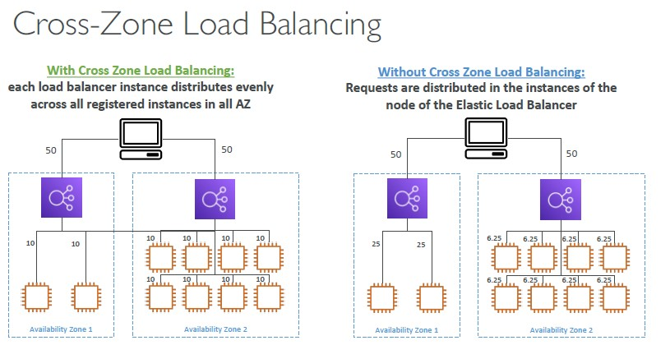

Cross-Zone Load Balancing

-Application Load Balancer

• Enabled by default (can be disabled at the Target Group level)

• No charges for inter AZ data

-Network Load Balancer & Gateway Load Balancer

• Disabled by default

• You pay charges ($) for inter AZ data if enabled

-Classic Load Balancer

• Disabled by default

• No charges for inter AZ data if enabled

SSL/TLS - Basics

• An SSL Certificate allows traffic between your clients and your load balancer

to be encrypted in transit (in-flight encryption)

• SSL refers to Secure Sockets Layer, used to encrypt connections

• TLS refers to Transport Layer Security, which is a newer version

• Nowadays, TLS certificates are mainly used, but people still refer as SSL

• Public SSL certificates are issued by Certificate Authorities (CA)

• Comodo, Symantec, GoDaddy, GlobalSign, Digicert, Letsencrypt, etc…

• SSL certificates have an expiration date (you set) and must be renewed

• The load balancer uses an X.509 certificate (SSL/TLS server certificate)

• You can manage certificates using ACM (AWS Certificate Manager)

• You can create upload your own certificates alternatively

• HTTPS listener:

• You must specify a default certificate

• You can add an optional list of certs to support multiple domains

• Clients can use SNI (Server Name Indication) to specify the hostname they reach

• Ability to specify a security policy to support older versions of SSL / TLS (legacy clients)

• SNI solves the problem of loading multiple SSL certificates onto one web server (to serve multiple websites)

• It’s a “newer” protocol, and requires the client to indicate the hostname of the target server in the initial SSL handshake

• The server will then find the correct certificate, or return the default one

Note:

• Only works for ALB & NLB (newer generation), CloudFront

• Does not work for CLB (older gen)

Elastic Load Balancers – SSL Certificates

- Classic Load Balancer (v1)

• Support only one SSL certificate

• Must use multiple CLB for multiple hostname with multiple SSL certificates

-Application Load Balancer (v2)

• Supports multiple listeners with multiple SSL certificates

• Uses Server Name Indication (SNI) to make it work

- Network Load Balancer (v2)

• Supports multiple listeners with multiple SSL certificates

• Uses Server Name Indication (SNI) to make it work

Connection Draining

• Feature naming

• Connection Draining – for CLB

• Deregistration Delay – for ALB & NLB

• Time to complete “in-flight requests” while the instance is de-registering or unhealthy

• Stops sending new requests to the EC2 instance which is de-registering

• Between 1 to 3600 seconds (default: 300 seconds)

• Can be disabled (set value to 0)

• Set to a low value if your requests are short

Auto Scaling Group

-The goal of an Auto Scaling Group (ASG) is to:

• Scale out (add EC2 instances) to match an increased load

• Scale in (remove EC2 instances) to match a decreased load

• Ensure we have a minimum and a maximum number of EC2 instances running

• Automatically register new instances to a load balancer

• Re-create an EC2 instance in case a previous one is terminated (ex: if unhealthy)

• ASG are free (you only pay for the underlying EC2 instances)

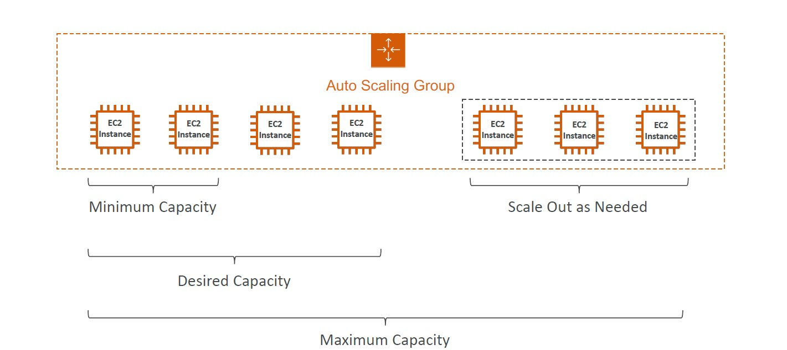

Auto Scaling Groups – Dynamic Scaling Policies

-Target Tracking Scaling

• Most simple and easy to set-up

• Example: I want the average ASG CPU to stay at around 40%

- Simple / Step Scaling

• When a CloudWatch alarm is triggered (example CPU > 70%), then add 2 units

• When a CloudWatch alarm is triggered (example CPU < 30%), then remove 1

-Scheduled Actions

• Anticipate a scaling based on known usage patterns

• Example: increase the min capacity to 10 at 5 pm on Fridays

-Predictive scaling: continuously forecast load and schedule scaling ahead

*Good metrics to scale on

• CPUUtilization: Average CPU utilization across your instances

• RequestCountPerTarget: to make sure the number of requests per EC2 instances is stable

• Average Network In / Out (if you’re application is network bound)

• Any custom metric (that you push using CloudWatch)

Auto Scaling Groups - Scaling Cooldowns

• After a scaling activity happens, you are in the cooldown period (default 300 seconds)

• During the cooldown period, the ASG will not launch or terminate additional instances (to allow for metrics to stabilize)

• Advice: Use a ready-to-use AMI to reduce configuration time in order to be serving request fasters and reduce the cool down

Amazon RDS Overview

• RDS stands for Relational Database Service

• It’s a managed DB service for DB use SQL as a query language.

• It allows you to create databases in the cloud that are managed by AWS

(PostgreSQL, MySQL, Maria DB, Oracle, Microsoft SQL Server, Aurora (AWS Proprietary database))

Advantage over using RDS versus deployingDB on EC2

• RDS is a managed service:

• Automated provisioning, OS patching

• Continuous backups and restore to specific timestamp (Point in Time Restore)!

• Monitoring dashboards

• Read replicas for improved read performance

• Multi AZ setup for DR (Disaster Recovery)

• Maintenance windows for upgrades

• Scaling capability (vertical and horizontal)

• Storage backed by EBS (gp2 or io1)

• BUT you can’t SSH into your instances

RDS – Storage Auto Scaling

• Helps you increase storage on your RDS DB instance dynamically

• When RDS detects you are running out of free database storage, it scales automatically

• Avoid manually scaling your database storage

• You have to set Maximum Storage Threshold (maximum limit for DB storage)

• Automatically modify storage if:

• Free storage is less than 10% of allocated storage

• Low-storage lasts at least 5 minutes

• 6 hours have passed since last modification

• Useful for applications with unpredictable workloads

• Supports all RDS database engines (Maria DB, MySQL, PostgreSQL, SQL Server, Oracle)

RDS Read Replicas for read scalability

• Up to 5 Read Replicas

• Within AZ, Cross AZ or Cross Region

• Replication is ASYNC, so reads are eventually consistent

• Replicas can be promoted to their own DB

• Applications must update the connection string to leverage read replicas

*Most synchronous replication products write data to primary storage and the replica simultaneously. As such, the primary copy and the replica should always remain synchronized. In contrast, asynchronous replication products write data to the primary storage first and then copy the data to the replica.

RDS Read Replicas – Use Cases

• You have a production database that is taking on normal load

• You want to run a reporting application to run some analytics

• You create a Read Replica to run the new workload there

• The production application is unaffected

• Read replicas are used for SELECT (=read) only kind of statements (not INSERT, UPDATE, DELETE)

RDS Read Replicas – Network Cost

• In AWS there’s a network cost when data goes from one AZ to another

• For RDS Read Replicas within the same region, you don’t pay that fee

RDS Multi AZ (Disaster Recovery)

• SYNC replication

• One DNS name – automatic app failover to standby

• Increase availability

• Failover in case of loss of AZ, loss of network, instance or storage failure

• No manual intervention in apps

• Not used for scaling

• Multi-AZ replication is free

• Note: The Read Replicas be setup as Multi AZ for Disaster Recovery (DR)

RDS – From Single-AZ to Multi-AZ

• Zero downtime operation (no need to stop the DB)

• Just click on “modify” for the database

• The following happens internally:

• A snapshot is taken

• A new DB is restored from the snapshot in a new AZ

• Synchronization is established between the two databases

Amazon RDS Optimized Writes

The Amazon RDS Optimized Writes feature skips the MySQL double-write buffer, while still ensuring data protection. Amazon RDS Optimized Writes guarantee atomicity, consistency, isolation, and durability (ACID) properties. With Amazon RDS Optimized Writes turned on, RDS for MySQL DB instances achieve up to two times faster write transaction throughput.

* The doublewrite buffer is a storage area where InnoDB writes pages flushed from the buffer pool before writing the pages to their proper positions in the InnoDB data files.

*InnoDB is a general-purpose storage engine that balances high reliability and high performance. In MySQL 5.6, InnoDB is the default MySQL storage engine

* A database engine (or storage engine) is the underlying software component that a database management system (DBMS) uses to create, read, update and delete (CRUD) data from a database

RDS Blue/Green Deployments

A blue/green deployment creates a staging environment that copies the production environment. In a blue/green deployment, the blue environment is the current production environment. The green environment is the staging environment. The staging environment stays in sync with the current production environment using logical replication.

You can make changes to the RDS DB instances in the green environment without affecting production workloads. For example, you can upgrade the major or minor DB engine version, change database parameters, or make schema changes in the staging environment. You can thoroughly test changes in the green environment. When ready, you can switch over the environments to promote the green environment to be the new production environment. The switchover typically takes under a minute with no data loss and no need for application changes.

Because the green environment is a copy of the topology of the production environment, the green environment includes the features used by the DB instance. These features include the read replicas, the storage configuration, DB snapshots, automated backups, Performance Insights, and Enhanced Monitoring. If the blue DB instance is a Multi-AZ DB instance deployment, then the green DB instance is also a Multi-AZ DB instance deployment.

RDS Custom

• Managed Oracle and Microsoft SQL Server Database with OS and database customization

• RDS: Automates setup, operation, and scaling of database in AWS

• Custom: access to the underlying database and OS so you can

• Configure settings

• Install patches

• Enable native features

• Access the underlying EC2 Instance using SSH or SSM Session Manager

• De-activate Automation Mode to perform your customization, better to take a DB snapshot before

- RDS vs. RDS Custom

• RDS: entire database and the OS to be managed by AWS

• RDS Custom: full admin access to the underlying OS and the database

*when deleting RDS database you are given the option to “Create final snapshot” and determine the snapshot name, and to “Retain automated backups” but you will be billed for retained backup storage at the rate described as ‘Additional backup storage’ found in Backup Storage.

Amazon Aurora

• Aurora is a proprietary technology from AWS (not open sourced)

• PostgreSQL and MySQL are both supported as Aurora DB (that means your drivers will work as if Aurora was a Postgres or MySQL database)

• Aurora is “AWS cloud optimized” and claims 5x performance improvement over MySQL on RDS, over 3x the performance of PostgreSQL on RDS

• Aurora storage automatically grows in increments of 10GB, up to 128 TB.

• Aurora can have 15 replicas while MySQL has 5, and the replication process is faster (sub 10 ms replica lag)

• Failover in Aurora is instantaneous. It’s HA (High Availability) native.

• Aurora costs more than RDS (20% more) – but is more efficient

Aurora High Availability and Read Scaling

• 6 copies of your data across 3 AZ:

• 4 copies out of 6 needed for writes

• 3 copies out of 6 need for reads

• Self-healing with peer-to-peer replication

• Storage is striped across 100s of volumes

• One Aurora Instance takes writes (master)

• Automated failover for master in less than 30 seconds

• Master + up to 15 Aurora Read Replicas serve reads

• Support for Cross Region Replication

Features of Aurora

• Automatic fail-over

• Backup and Recovery

• Isolation and security

• Industry compliance

• Push-button scaling

• Automated Patching with Zero Downtime

• Advanced Monitoring

• Routine Maintenance

• Backtrack: restore data at any point of time without using backups (Enabling Backtrack will charge you for storing the changes you make for backtracking.)

Aurora Parallel query

Aurora will split the query among the cluster server and it will organize the data in the same server and will give the output.

When sharing the data among the network, it won’t send whole table instead of that it will send only the required value (based on the query condition) among the network.

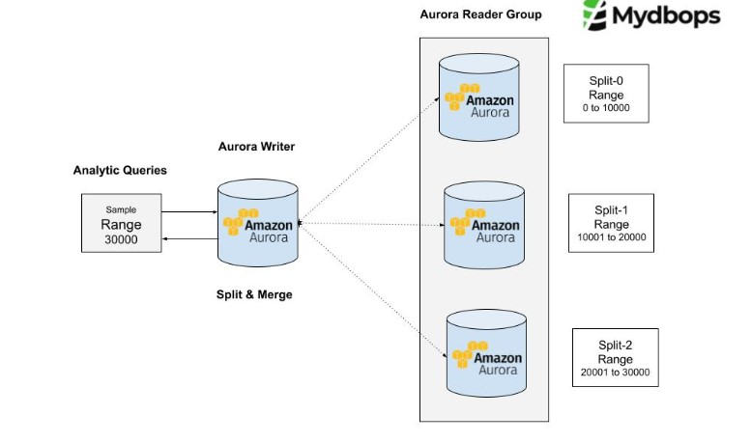

Use cases of Parallel Query

-It works better when queries have RANGE or IN or EQUAL (=) conditions.

-It is more optimized for analytical query, since it split the query among the nodes and then merge the result set.

-Due the splitting of query among the nodes, the resource utilization is uniform among the nodes and it avoids heavy utilization on a single node.

Prerequisites

Aurora version should be greater than 2.09 or 1.23.

Instance type should be R-series; other instance types are not supported.

The tables should be non-partitioned, if any table has partition parallel query won’t support for that.

We need to hash join optimization for the same.

Limitations

Parallel query won’t work if the row format is compressed, it will work with dynamic row format only.

It will work for all the tables, if the table size is smaller it will bypass the parallel query.

Concurrent parallel query depends on the instance type, i.e. if the instance type is r3.large only one parallel query is supported, if the instance type is r3.xlarge only 2 parallel query is supported.

The aurora version should be > 2.09.

Aurora storage

Aurora data is stored in the cluster volume, which is a single, virtual volume that uses solid state drives (SSDs). A cluster volume consists of copies of the data across three Availability Zones in a single AWS Region

Aurora – Custom Endpoints

• Define a subset of Aurora Instances as a Custom Endpoint

• Example: Run analytical queries on specific replicas

• The Reader Endpoint is generally not used after defining Custom Endpoints

Aurora Serverless

• Automated database instantiation and auto scaling based on actual usage

• Good for infrequent, intermittent or unpredictable workloads

• No capacity planning needed

• Pay per second, can be more cost-effective

*What is the difference between Aurora Serverless v2 and v1?

Aurora Serverless v2 can scale both by changing the size of the DB instance and by adding more DB instances to the DB cluster. It can also scale by adding clusters in other AWS Regions to an Aurora global database. In contrast, Aurora Serverless v1 only scales by increasing or decreasing the capacity of the writer.

Aurora Multi-Master

• In case you want immediate failover for write node (HA) –

• Every node does R/W - vs promoting a RR as the new master

Global Aurora

• Aurora Cross Region Read Replicas:

• Useful for disaster recovery

• Simple to put in place

• Aurora Global Database (recommended):

• 1 Primary Region (read / write)

• Up to 5 secondary (read-only) regions, replication lag is less than 1 second

• Up to 16 Read Replicas per secondary region

• Helps for decreasing latency

• Promoting another region (for disaster recovery) has an RTO of < 1 minute

• Typical cross-region replication takes less than 1 second

*RTO -> recovery time objective

Aurora Machine Learning

• Enables you to add ML-based predictions to your applications via SQL

• Simple, optimized, and secure integration between Aurora and AWS ML services

• Supported services

• Amazon Sage Maker (use with any ML model)

• Amazon Comprehend (for sentiment analysis)

• You don’t need to have ML experience

• Use cases: fraud detection, ads targeting, sentiment analysis, product recommendations

RDS Backups

• Automated backups:

• Daily full backup of the database (during the backup window)

• Transaction logs are backed-up by RDS every 5 minutes

• => ability to restore to any point in time (from oldest backup to 5 minutes ago)

• 1 to 35 days of retention, set 0 to disable automated backups

• Manual DB Snapshots

• Manually triggered by the user

• Retention of backup for as long as you want

• Trick: in a stopped RDS database, you will still pay for storage. If you plan on stopping it for a long time, you should snapshot & restore instead

Aurora Backups

• Automated backups

• 1 to 35 days (cannot be disabled)

• point-in-time recovery in that timeframe

• Manual DB Snapshots

• Manually triggered by the user

• Retention of backup for as long as you want

RDS & Aurora Restore options

• Restoring a RDS / Aurora backup or a snapshot creates a new database

• Restoring MySQL RDS database from S3

• Create a backup of your on-premises database

• Store it on Amazon S3 (object storage)

• Restore the backup file onto a new RDS instance running MySQL

• Restoring MySQL Aurora cluster from S3

• Create a backup of your on-premises database using Percona XtraBackup

• Store the backup file on Amazon S3

• Restore the backup file onto a new Aurora cluster running MySQL

Aurora Database Cloning

• Create a new Aurora DB Cluster from an existing one

• Faster than snapshot & restore

• The new DB cluster uses the same cluster volume and data as the original but will change when data updates are made

• Very fast & cost-effective

• Useful to create a “staging” database from a “production” database without impacting the production database

RDS & Aurora Security

- At-rest encryption:

• Database master & replicas encryption using AWS KMS – must be defined as launch time

• If the master is not encrypted, the read replicas cannot be encrypted

• To encrypt an un-encrypted database, go through a DB snapshot & restore as encrypted

-In-flight encryption: TLS-ready by default, use the AWS TLS root certificates client-side

- IAM Authentication: IAM roles to connect to your database (instead of username/pw)

-Security Groups: Control Network access to your RDS / Aurora DB

-No SSH available except on RDS Custom

-Audit Logs can be enabled and sent to CloudWatch Logs for longer retention

Amazon RDS Proxy

• Fully managed database proxy for RDS

• Allows apps to pool and share DB connections established with the database

• Improving database efficiency by reducing the stress on database resources (e.g., CPU, RAM) and minimize open connections (and timeouts)

• Serverless, autoscaling, highly available (multi-AZ)

• Reduced RDS & Aurora failover time by up 66%

• Supports RDS (MySQL, PostgreSQL, MariaDB) and Aurora (MySQL, PostgreSQL)

• No code changes required for most apps

• Enforce IAM Authentication for DB, and securely store credentials in AWS Secrets Manager

• RDS Proxy is never publicly accessible (must be accessed from VPC)

Amazon ElastiCache

• The same way RDS is to get managed Relational Databases…

• ElastiCache is to get managed Redis or Memcached

• Caches are in-memory databases with really high performance, low latency

• Helps reduce load off of databases for read intensive workloads

• Helps make your application stateless

• AWS takes care of OS maintenance / patching, optimizations, setup, configuration, monitoring, failure recovery and backups

• Using ElastiCache involves heavy application code changes

ElastiCache Solution Architecture - DB Cache

• Applications queries ElastiCache, if not available, get from RDS and store in ElastiCache.

• Helps relieve load in RDS

• Cache must have an invalidation strategy to make sure only the most current data is used in there.

ElastiCache Solution Architecture – User Session Store

• User logs into any of the application

• The application writes the session data into ElastiCache

• The user hits another instance of our application

• The instance retrieves the data and the user is already logged in

ElastiCache – Redis vs Memcached

REDIS

• Multi AZ with Auto-Failover

• Read Replicas to scale reads and have high availability

• Data Durability using AOF persistence

• Backup and restore features

MEMCACHED

• Multi-node for partitioning of data (sharding)

• No high availability (replication)

• Non persistent

• No backup and restore

• Multi-threaded architecture

*AOF (Append Only File): AOF persistence logs every write operation received by the server. These operations can then be replayed again at server startup, reconstructing the original dataset. Commands are logged using the same format as the Redis protocol itself.

ElastiCache – Cache Security

• All caches in ElastiCache:

• Do not support IAM authentication

• IAM policies on ElastiCache are only used for AWS API-level security

- Redis AUTH

• You can set a “password/token” when you create a Redis cluster

• This is an extra level of security for your cache (on top of security groups)

• Support SSL in flight encryption

- Memcached

• Supports SASL-based authentication (advanced)

*SASL -> Simple Authentication and Security Layer

Patterns for ElastiCache

• Lazy Loading: all the read data is cached, data can become stale in cache

• Write Through: Adds or update data in the cache when written to a DB (no stale data)

• Session Store: store temporary session data in a cache (using TTL features)

ElastiCache – Redis Use Case

• Gaming Leaderboards are computationally complex

• Redis Sorted sets guarantee both uniqueness and element ordering

• Each time a new element added, it’s ranked in real time, then added in correct order

DNS Terminologies

• Domain Registrar: Amazon Route 53, GoDaddy, …

• DNS Records: A, AAAA, CNAME, NS, …

• Zone File: contains DNS records

• Name Server: resolves DNS queries (Authoritative or Non-Authoritative)

• Top Level Domain (TLD): .com, .us, .in, .gov, .org, …

• Second Level Domain (SLD): amazon.com, google.com, …

*Authoritative DNS servers

Authoritative DNS servers are responsible for the proper mapping of records and to respond to the recursive servers with important information for each website, such as; corresponding IP addresses and other necessary DNS records.

*Non-Authoritative DNS servers

Non-authoritative name servers do not contain the original zone files.

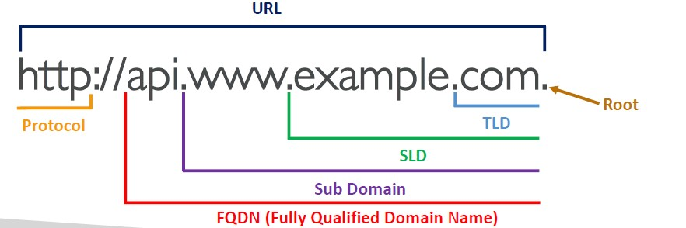

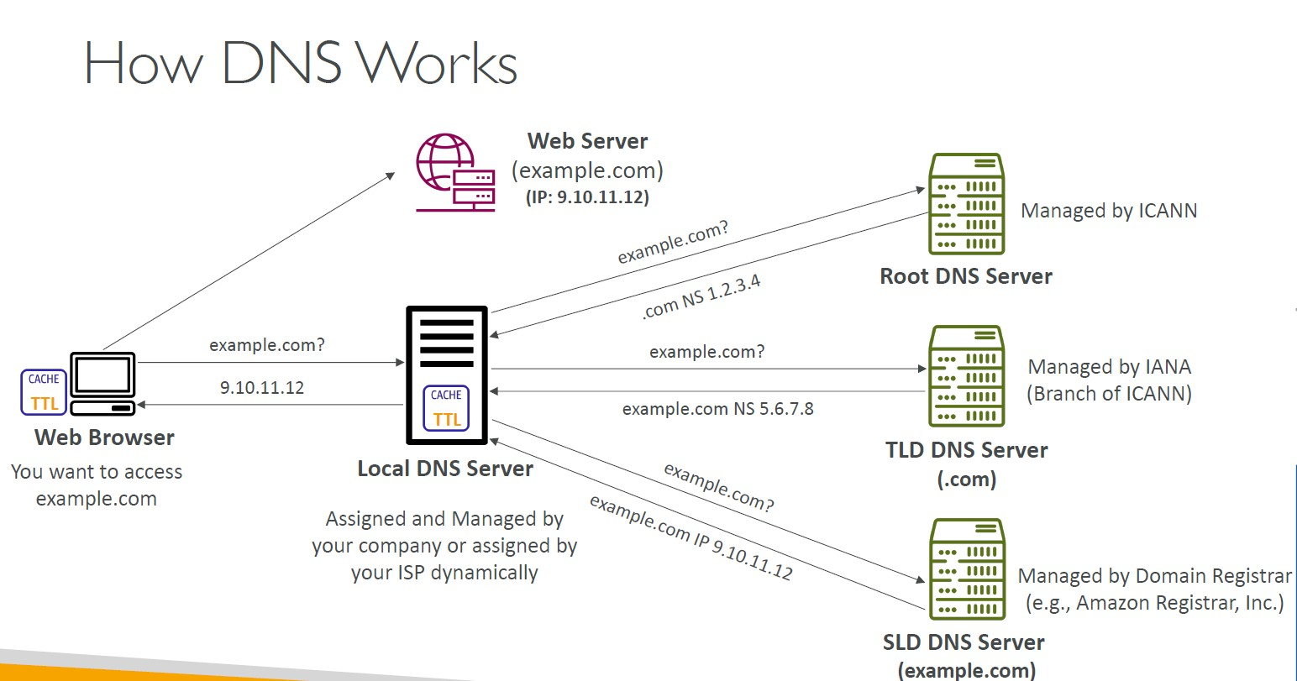

Amazon Route 53

• A highly available, scalable, fully managed and Authoritative DNS

• Authoritative = the customer (you) can update the DNS records

• Route 53 is also a Domain Registrar

• Ability to check the health of your resources

• The only AWS service which provides 100% availability SLA

• Why Route 53? 53 is a reference to the traditional DNS port

Route 53 – Records

• How you want to route traffic for a domain

• Each record contains:

• Domain/subdomain Name – e.g., example.com

• Record Type – e.g., A or AAAA

• Value – e.g., 12.34.56.78

• Routing Policy – how Route 53 responds to queries

• TTL – amount of time the record cached at DNS Resolvers

• Route 53 supports the following DNS record types:

• (must know) A / AAAA / CNAME / NS

• (advanced) CAA / DS / MX / NAPTR / PTR / SOA / TXT / SPF / SRV

Route 53 – Record Types

• A – maps a hostname to IPv4

• AAAA – maps a hostname to IPv6

• CNAME – maps a hostname to another hostname

• The target is a domain name which must have an A or AAAA record

• Can’t create a CNAME record for the top node of a DNS namespace (Zone Apex)

• Example: you can’t create for example.com, but you can create for www.example.com

• NS – Name Servers for the Hosted Zone

• Control how traffic is routed for a domain

Route 53 – Hosted Zones

• A container for records that define how to route traffic to a domain and its subdomains

• Public Hosted Zones – contains records that specify how to route traffic on the Internet (public domain names) application1.mypublicdomain.com

• Private Hosted Zones – contain records that specify how you route traffic within one or more VPCs (private domain names) application1.company. internal

• You pay $0.50 per month per hosted zone

Route 53 – Records TTL (Time To Live)

-High TTL – e.g., 24 hr

• Less traffic on Route 53

• Possibly outdated records

- Low TTL – e.g., 60 sec.

• More traffic on Route 53 ($$)

• Records are outdated for lesstime

• Easy to change records

- Except for Alias records, TTL is mandatory for each DNS record

CNAME vs Alias

• AWS Resources (Load Balancer, CloudFront...) expose an AWS hostname:

• lb1-1234.us-east-2.elb.amazonaws.com and you want myapp.mydomain.com

• CNAME:

• Points a hostname to any other hostname. (app.mydomain.com => blabla.anything.com)

• ONLY FOR NON ROOT DOMAIN (aka. something.mydomain.com)

• Alias:

• Points a hostname to an AWS Resource (app.mydomain.com => blabla.amazonaws.com)

• Works for ROOT DOMAIN and NON ROOT DOMAIN (aka mydomain.com)

• Free of charge

• Native health check

Route 53 – Alias Records

• Maps a hostname to an AWS resource

• An extension to DNS functionality

• Automatically recognizes changes in the resource’s IP addresses

• Unlike CNAME, it can be used for the top node of a DNS namespace (Zone Apex), e.g.: example.com

• Alias Record is always of type A/AAAA for AWS resources (IPv4 / IPv6)

• You can’t set the TTL

Route 53 – Alias Records Targets

• Elastic Load Balancers

• CloudFront Distributions

• API Gateway

• Elastic Beanstalk environments

• S3 Websites

• VPC Interface Endpoints

• Global Accelerator accelerator

• Route 53 record in the same hosted zone

• You cannot set an ALIAS record for an EC2 DNS name

Route 53 – Routing Policies

• Define how Route 53 responds to DNS queries

-Route 53 Supports the following Routing Policies

• Simple

• Weighted

• Failover

• Latency based

• Geolocation

• Multi-Value Answer

• Geoproximity (using Route 53 Traffic Flow feature)

Routing Policies – Simple

• Typically, route traffic to a single resource

• Can specify multiple values in the same record

• If multiple values are returned, a random one is chosen by the client

• When Alias enabled, specify only one AWS resource

• Can’t be associated with Health Checks

Routing Policies – Weighted

• Control the % of the requests that go to each specific resource

• DNS records must have the same name and type

• Can be associated with Health Checks

• Use cases: load balancing between regions, testing new application versions…

• Assign a weight of 0 to a record to stop sending traffic to a resource

• If all records have weight of 0, then all records will be returned equally

Routing Policies – Latency-based

• Redirect to the resource that has the least latency close to us

• Super helpful when latency for users is a priority

• Latency is based on traffic between users and AWS Regions

• Can be associated with Health Checks (has a failover capability)

-create multiple “latency record” each one with different ip and you have to specify the region

Route 53 – Health Checks

• HTTP Health Checks are only for public resources

• Health Check => Automated DNS Failover:

1. Health checks that monitor an endpoint (application, server, other AWS resource)

2. Health checks that monitor other health checks (Calculated Health Checks)

3. Health checks that monitor CloudWatch Alarms (full control !!) – e.g., throttles ofDynamoDB, alarms on RDS, custom metrics,… (helpful for private resources)

• Health Checks are integrated with Cloudwatch metrics

Health Checks – Monitor an Endpoint

• About 15 global health checkers will check the endpoint health

• Healthy/Unhealthy Threshold – 3 (default)

• Interval – 30 sec (can set to 10 sec – higher cost)

• Supported protocol: HTTP, HTTPS and TCP

• If > 18% of health checkers report the endpoint is healthy, Route 53 considers it Healthy. Otherwise, it’s Unhealthy

• Ability to choose which locations you want Route 53 to use

• Health Checks pass only when the endpoint responds with the 2xx and 3xx status codes

• Health Checks can be setup to pass / fail based on the text in the first 5120 bytes of the response

• Configure you router/firewall to allow incoming requests from Route 53 Health Checkers

Route 53 – Calculated Health Checks

• Combine the results of multiple Health Checks into a single Health Check

• You can use OR, AND, or NOT

• Can monitor up to 256 Child Health Checks

• Specify how many of the health checks need to pass to make the parent pass

• Usage: perform maintenance to your website without causing all health checks to fail

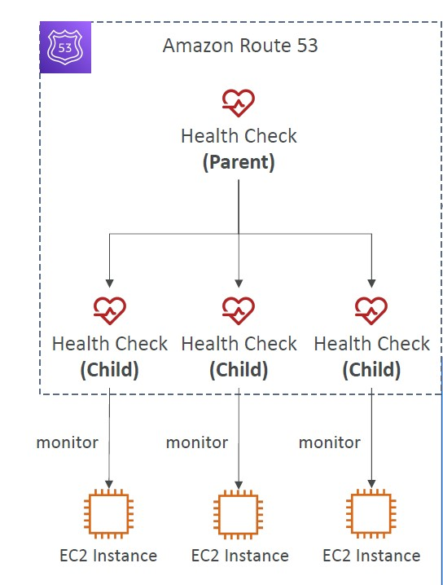

Health Checks – Private Hosted Zones

• Route 53 health checkers are outside the VPC

• They can’t access private endpoints (private VPC or on-premises resource)

• You can create a CloudWatch Metric and associate a CloudWatch Alarm, then create a Health Check that checks the

alarm itself

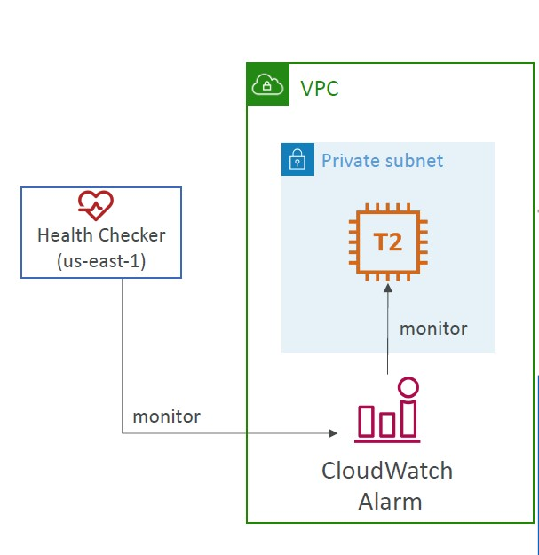

Routing Policies – Failover (Active-Passive)

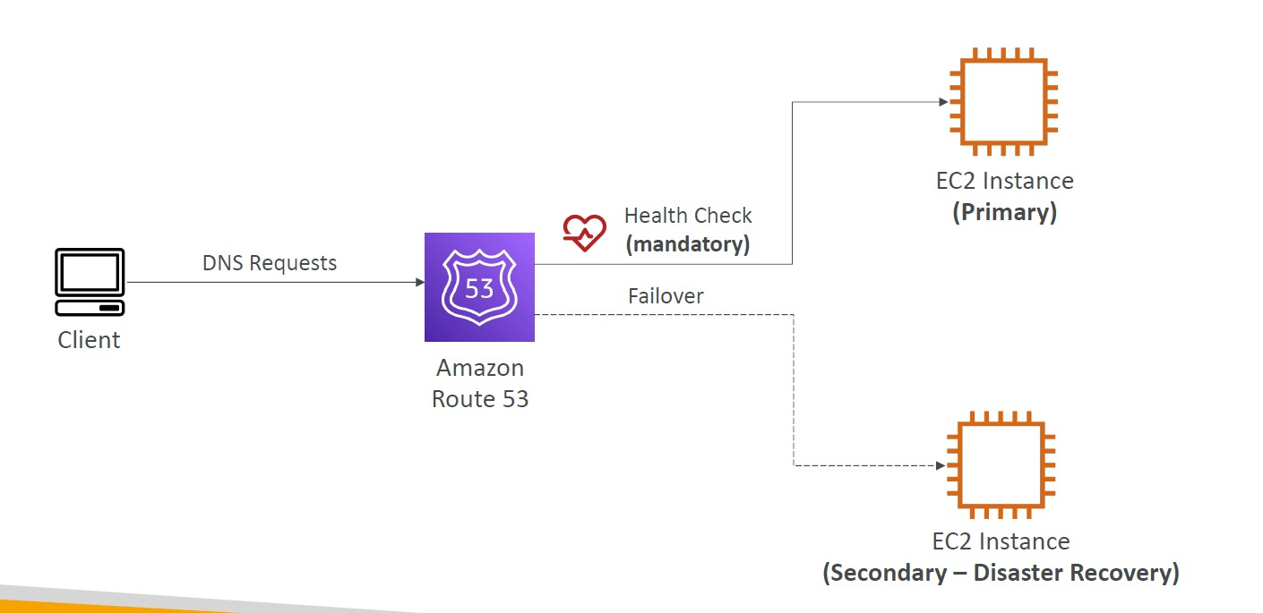

-you create 2 failover records 1 primary (In which health check is mandatory) and secondary record (health check is optional)

-when the primary EC2 is unhealthy then Route 53 will failover to the second EC2

Routing Policies – Geolocation

• Different from Latency-based

• This routing is based on user location

• Specify location by Continent, Country or by US State (if there’s overlapping, most precise location selected)

• Should create a “Default” record (in case there’s no match on location)

• Use cases: website localization, restrict content distribution, load balancing, …

• Can be associated with Health Checks

Routing Policies – Geoproximity

• Route traffic to your resources based on the geographic location of users and resources

• Ability to shift more traffic to resources based on the defined bias

• To change the size of the geographic region, specify bias values:

• To expand (1 to 99) – more traffic to the resource

• To shrink (-1 to -99) – less traffic to the resource

- Resources can be:

• AWS resources (specify AWS region)

• Non-AWS resources (specify Latitude and Longitude)

• You must use Route 53 Traffic Flow to use this feature

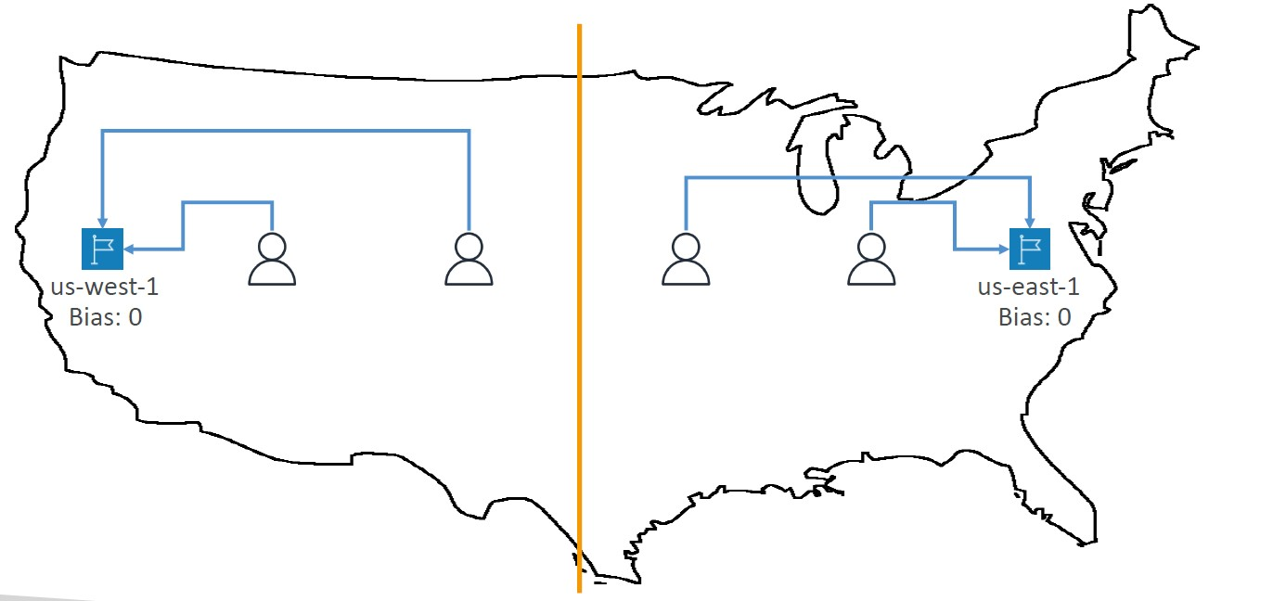

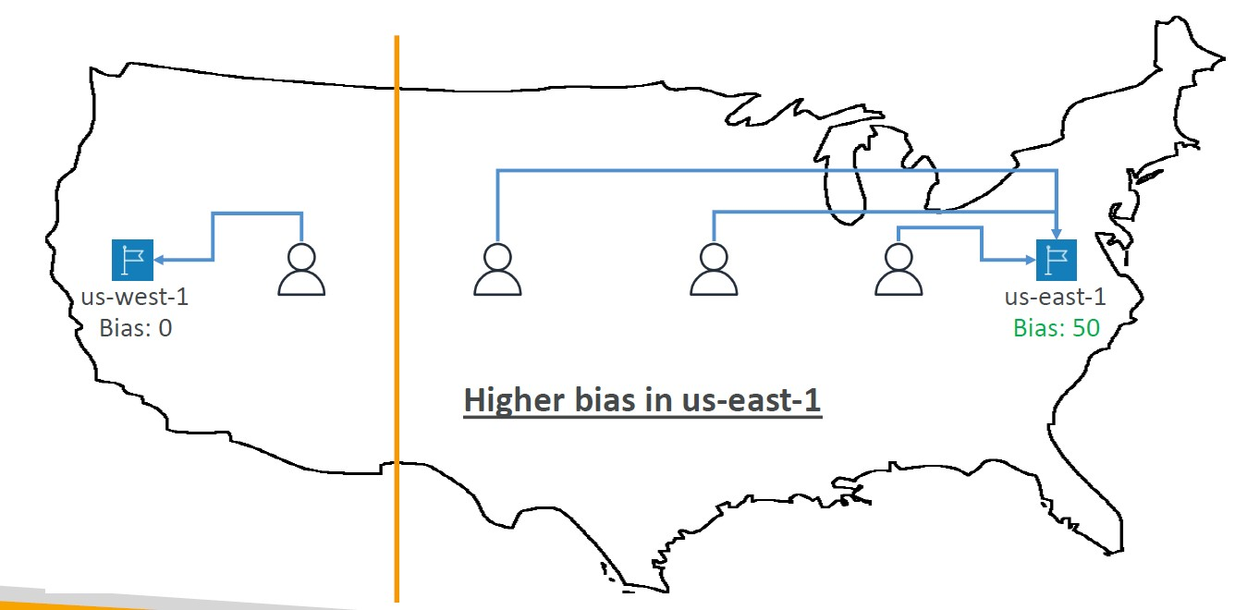

Routing Policies – Multi-Value

• Use when routing traffic to multiple resources

• Route 53 return multiple values/resources

• Can be associated with Health Checks (return only values for healthy resources)

• Up to 8 healthy records are returned for each Multi-Value query

• Multi-Value is not a substitute for having an ELB

3rd Party Registrar with Amazon Route 53

• If you buy your domain on a 3rd party registrar, you can still use Route 53 as the DNS Service provider

1. Create a Hosted Zone in Route 53

2. Update NS Records on 3rd party website to use Route 53 Name Servers

• Domain Registrar! = DNS Service

• But every Domain Registrar usually comes with some DNS features

Elastic Beanstalk

• Elastic Beanstalk is a developer centric view of deploying an application on AWS

• Managed service

• Automatically handles capacity provisioning, load balancing, scaling, application health monitoring, instance configuration, …

• Just the application code is the responsibility of the developer

• We still have full control over the configuration

• Beanstalk is free but you pay for the underlying instances

Elastic Beanstalk – Components

• Application: collection of Elastic Beanstalk components (environments, versions, configurations, …)

• Application Version: an iteration of your application code

• Environment

• Collection of AWS resources running an application version (only one application version at a time)

• Tiers: Web Server Environment Tier & Worker Environment Tier

• You can create multiple environments (dev, test, prod, …)

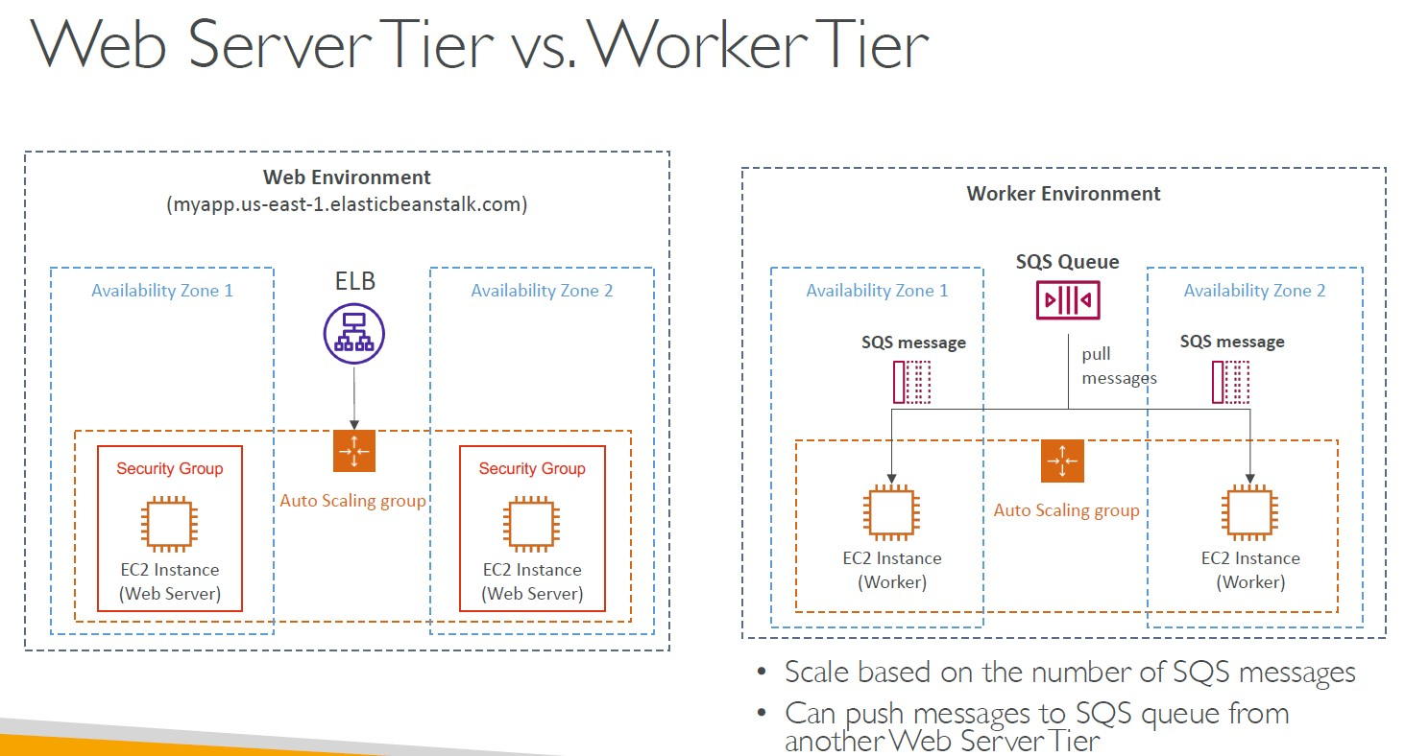

Amazon S3 - Buckets

• Amazon S3 allows people to store objects (files) in “buckets” (directories)

• Buckets must have a globally unique name (across all regions all accounts)

• Buckets are defined at the region level

• S3 looks like a global service but buckets are created in a region

- Naming convention

• No uppercase, No underscore

• 3-63 characters long

• Not an IP

• Must start with lowercase letter or number

• Must NOT start with the prefix xn--

• Must NOT end with the suffix -s3alias

Amazon S3 - Objects

• Objects (files) have a Key

• The key is the FULL path:

• s3://my-bucket/my_file.txt

• s3://my-bucket/my_folder1/another_folder/my_file.txt

• The key is composed of prefix + object name

• s3://my-bucket/my_folder1/another_folder/my_file.txt

• There’s no concept of “directories” within buckets

(although the UI will trick you to think otherwise)

• Just keys with very long names that contain slashes (“/”)

- Object values are the content of the body:

• Max. Object Size is 5TB (5000GB)

• If uploading more than 5GB, must use “multi-part upload”

• Metadata (list of text key / value pairs – system or user metadata)

• Tags (Unicode key / value pair – up to 10) – useful for security / lifecycle

• Version ID (if versioning is enabled)

Amazon S3 – Security

• User-Based

• IAM Policies – which API calls should be allowed for a specific user from IAM

• Resource-Based

• Bucket Policies – bucket wide rules from the S3 console - allows cross account

• Object Access Control List (ACL) – finer grain (can be disabled)

• Bucket Access Control List (ACL) – less common (can be disabled)

• Note: an IAM principal can access an S3 object if

• The user IAM permissions ALLOW it OR the resource policy ALLOWS it

• AND there’s no explicit DENY

• Encryption: encrypt objects in Amazon S3 using encryption keys

S3 Bucket Policies

• JSON based policies

• Resources: buckets and objects

• Effect: Allow / Deny

• Actions: Set of API to Allow or Deny

• Principal: The account or user to apply the policy to

• Use S3 bucket for policy to:

• Grant public access to the bucket

• Force objects to be encrypted at upload

• Grant access to another account (Cross Account)

-Block Public Access can be set at the account level

Amazon S3 – Static Website Hosting

• S3 can host static websites and have them accessible on the Internet

• The website URL will be (depending on the region)

• http://bucket-name.s3-website-aws-region.amazonaws.com

OR

• http://bucket-name.s3-website.aws-region.amazonaws.com

• If you get a 403 Forbidden error, make sure the bucket policy allows public reads

Amazon S3 - Versioning

• You can version your files in Amazon S3

• It is enabled at the bucket level

• Same key overwrite will change the “version”: 1, 2, 3….

• It is best practice to version your buckets

• Protect against unintended deletes (ability to restore a version)

• Easy roll back to previous version

- Notes:

• Any file that is not versioned prior to enabling versioning will have version “null”

• Suspending versioning does not delete the previous versions

Amazon S3 – Replication (CRR & SRR)

• Must enable Versioning in source and destination buckets

• Cross-Region Replication (CRR)

• Same-Region Replication (SRR)

• Buckets can be in different AWS accounts

• Copying is asynchronous

• Must give proper IAM permissions to S3

- Use cases:

• CRR – compliance, lower latency access, replication across accounts

• SRR – log aggregation, live replication between production and test accounts

Amazon S3 – Replication (Notes)

• After you enable Replication, only new objects are replicated

• Optionally, you can replicate existing objects using S3 Batch Replication

• Replicates existing objects and objects that failed replication

• For DELETE operations

• Can replicate delete markers from source to target (optional setting)

• Deletions with a version ID are not replicated (to avoid malicious deletes)

- There is no “chaining” of replication

• If bucket 1 has replication into bucket 2, which has replication into bucket 3

• Then objects created in bucket 1 are not replicated to bucket 3

S3 Storage Classes

1-S3 Standard – General Purpose

• 99.99% Availability

• Used for frequently accessed data

• Low latency and high throughput

• Sustain 2 concurrent facility failures

• Use Cases: Big Data analytics, mobile & gaming applications, content distribution…

S3 Storage Classes – Infrequent Access

• For data that is less frequently accessed, but requires rapid access when needed

• Lower cost than S3 Standard

2- Amazon S3 Standard-Infrequent Access (S3 Standard-IA)

• 99.9% Availability

• Use cases: Disaster Recovery, backups

3- Amazon S3 One Zone-Infrequent Access (S3 One Zone-IA)

• High durability (99.999999999%) in a single AZ; data lost when AZ is destroyed

• 99.5% Availability

• Use Cases: Storing secondary backup copies of on-premises data, or data you can recreate

Amazon S3 Glacier Storage Classes

• Low-cost object storage meant for archiving / backup

• Pricing: price for storage + object retrieval cost

4- Amazon S3 Glacier Instant Retrieval

• Millisecond retrieval, great for data accessed once a quarter

• Minimum storage duration of 90 days

5- Amazon S3 Glacier Flexible Retrieval (formerly Amazon S3 Glacier):

• Expedited (1 to 5 minutes), Standard (3 to 5 hours), Bulk (5 to 12 hours) – free

• Minimum storage duration of 90 days

6- Amazon S3 Glacier Deep Archive – for long term storage:

• Standard (12 hours), Bulk (48 hours)

• Minimum storage duration of 180 days

7-S3 Intelligent-Tiering

• Small monthly monitoring and auto-tiering fee

• Moves objects automatically between Access Tiers based on usage

• There are no retrieval charges in S3 Intelligent-Tiering

• Frequent Access tier (automatic): default tier

• Infrequent Access tier (automatic): objects not accessed for 30 days

• Archive Instant Access tier (automatic): objects not accessed for 90 days

• Archive Access tier (optional): configurable from 90 days to 700+ days

• Deep Archive Access tier (optional): config. from 180 days to 700+

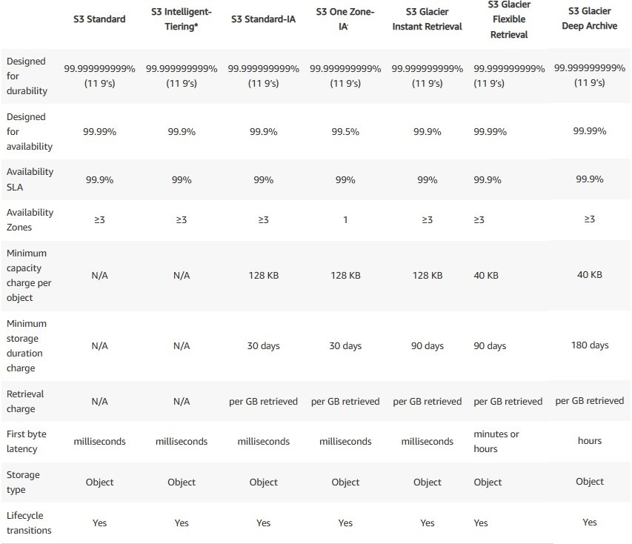

*First Byte Latency displays the time per request from the complete request being received by a bucket to when the response starts to be returned.

Amazon S3 – Moving between Storage Classes

• You can transition objects between storage classes

• For infrequently accessed object, move them to Standard IA

• For archive objects that you don’t need fast access to, move them to Glacier or Glacier Deep Archive

• Moving objects can be automated using a Lifecycle Rules

Amazon S3 – Lifecycle Rules

- Transition Actions – configure objects to transition to another storage class Example:

• Move objects to Standard IA class 60 days after creation

• Move to Glacier for archiving after 6 months

- Expiration actions – configure objects to expire (delete) after some time Example:

• Access log files can be set to delete after a 365 days

• Can be used to delete old versions of files (if versioning is enabled)

• Can be used to delete incomplete Multi-Part uploads

- Rules can be created for a certain prefix (example: s3://mybucket/mp3/*)

- Rules can be created for certain objects Tags (example: Department: Finance

Amazon S3 Analytics – Storage Class Analysis

• Help you decide when to transition objects to the right storage class

• Recommendations for Standard and Standard IA

• Does NOT work for One-Zone IA or Glacier

• Report is updated daily

• 24 to 48 hours to start seeing data analysis

• Good first step to put together Lifecycle Rules (or improve them)

S3 – Requester Pays

• In general, bucket owners pay for all Amazon S3 storage and data transfer costs associated with their bucket

• With Requester Pays buckets, the requester instead of the bucket owner pays the cost of the request and the data download from the bucket

• Helpful when you want to share large datasets with other accounts

• The requester must be authenticated in AWS (cannot be anonymous)

S3 Event Notifications

• S3:ObjectCreated, S3:ObjectRemoved,S3:ObjectRestore, S3:Replication…

• Object name filtering possible (*.jpg)

• Use case: generate thumbnails of images uploaded to S3

• Can create as many “S3 events” as desired

• S3 event notifications typically deliver events in seconds but can sometimes take a minute or longer

S3 Event Notifications with Amazon EventBridge

• Advanced filtering options with JSON rules (metadata, object size, name...)

• Multiple Destinations – ex Step Functions, Kinesis Streams / Firehose…

• EventBridge Capabilities – Archive, Replay Events, Reliable delivery

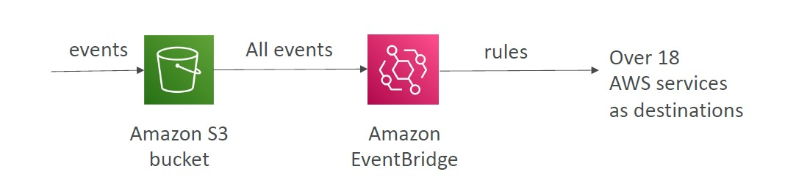

S3 – Baseline Performance

• Amazon S3 automatically scales to high request rates, latency 100-200 ms

• Your application can achieve at least 3,500 PUT/COPY/POST/DELETE and 5,500 GET/HEAD requests per second per prefix in a bucket.

• There are no limits to the number of prefixes in a bucket.

- Example (object path => prefix):

• bucket/folder1/sub1/file => /folder1/sub1/

• bucket/folder1/sub2/file => /folder1/sub2/

• bucket/1/file => /1/

• bucket/2/file => /2/

• If you spread reads across all four prefixes evenly, you can achieve 22,000 requests per second for GET and HEAD

S3 Performance

- Multi-Part upload:

• recommended for files > 100MB, must use for files > 5GB

• Can help parallelize uploads (speed up transfers)

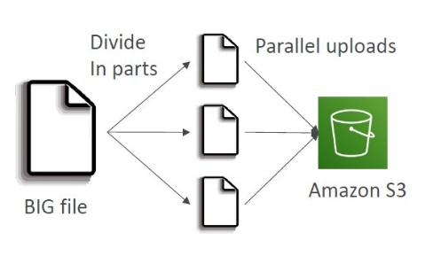

- S3 Transfer Acceleration

• Increase transfer speed by transferring file to an AWS edge location which will forward the data to the S3 bucket in the target region

• Compatible with multi-part upload

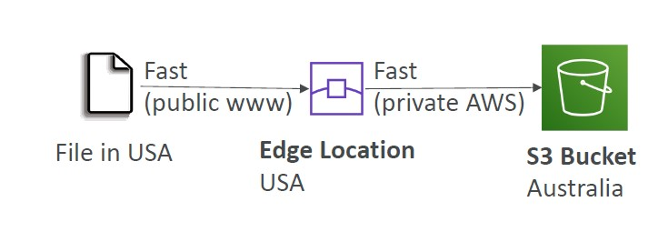

S3 Byte-Range Fetches

• Parallelize GETs by requesting specific byte ranges

• Better resilience in case of failures

Can be used to speed up downloads

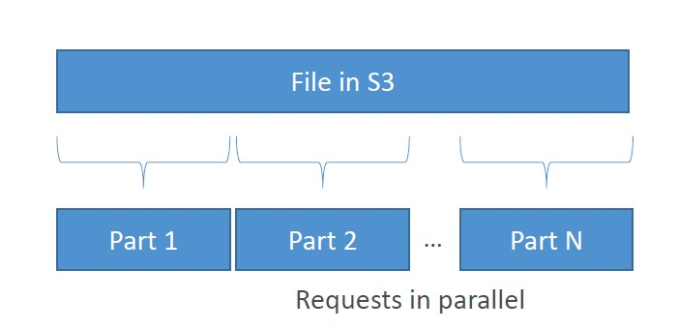

Can be used to retrieve only partial data (for example the head of a file)

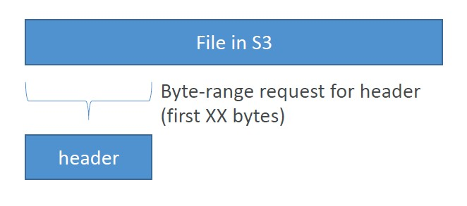

S3 Select & Glacier Select

• Retrieve less data using SQL by performing server-side filtering

• Can filter by rows & columns (simple SQL statements)

• Less network transfer, less CPU cost client-side

Amazon S3 – Object Encryption

• You can encrypt objects in S3 buckets using one of 4 methods

-Server-Side Encryption (SSE)

1- Server-Side Encryption with Amazon S3-Managed Keys (SSE-S3) – Enabled by Default

•Encrypts S3 objects using keys handled, managed, and owned by AWS

2- Server-Side Encryption with KMS Keys stored in AWS KMS (SSE-KMS)

• Leverage AWS Key Management Service (AWS KMS) to manage encryption keys

3- Server-Side Encryption with Customer-Provided Keys (SSE-C)

• When you want to manage your own encryption keys

4- Client-Side Encryption

Amazon S3 Encryption – SSE-S3

• Encryption using keys handled, managed, and owned by AWS

• Object is encrypted server-side

• Encryption type is AES-256

• Must set header "x-amz-server-side-encryption": "AES256"

• Enabled by default for new buckets & new objects (Starting January 5, 2023)

Amazon S3 Encryption – SSE-KMS

• Encryption using keys handled and managed by AWS KMS (Key Management Service)

• KMS advantages: user control + audit key usage using CloudTrail

• Object is encrypted server side

• Must set header "x-amz-server-side-encryption": "aws:kms"

SSE-KMS Limitation

• If you use SSE-KMS, you may be impacted by the KMS limits

• When you upload, it calls the GenerateDataKey KMS API

• When you download, it calls the Decrypt KMS API

• Count towards the KMS quota per second(5500, 10000, 30000 req/s based on region)

• You can request a quota increase using the Service Quotas Console

*-S3 Bucket Keys for SSE-KMS

AWS generates a short-lived bucket-level key from AWS KMS then temporarily keeps it in S3. This bucket-level key will create data keys for new objects during its lifecycle. S3 Bucket Keys are used for a limited time period within Amazon S3, reducing the need for S3 to make requests to AWS KMS to complete encryption operations. This reduces traffic from S3 to AWS KMS, allowing you to access AWS KMS-encrypted objects in Amazon S3 at a fraction of the previous cost.

A unique bucket-level key is generated for each requester to ensure an AWS KMS CloudTrail event captures the requester.

Amazon S3 Encryption – SSE-C

• Server-Side Encryption using keys fully managed by the customer outside of AWS

• Amazon S3 does NOT store the encryption key you provide

• HTTPS must be used

• Encryption key must provided in HTTP headers, for every HTTP request made

Amazon S3 Encryption – Client-Side Encryption

• Use client libraries such as Amazon S3 Client-Side Encryption Library

• Clients must encrypt data themselves before sending to Amazon S3

• Clients must decrypt data themselves when retrieving from Amazon S3

• Customer fully manages the keys and encryption cycle

Amazon S3 – Encryption in transit (SSL/TLS)

• Encryption in flight is also called SSL/TLS

• Amazon S3 exposes two endpoints:

• HTTP Endpoint – non encrypted

• HTTPS Endpoint – encryption in flight

• HTTPS is recommended

• HTTPS is mandatory for SSE-C

• Most clients would use the HTTPS endpoint by default

Amazon S3 – Default Encryption vs. Bucket Policies

• SSE-S3 encryption is automatically applied to new objects stored in S3 bucket

• Optionally, you can “force encryption” using a bucket policy and refuse any API call to PUT an S3 object without encryption headers (SSE-KMS or SSE-C)

• Note: Bucket Policies are evaluated before “Default Encryption”

CORS

• Cross-Origin Resource Sharing (CORS)

• Origin = scheme (protocol) + host (domain) + port

• example: https://www.example.com (implied port is 443 for HTTPS, 80 for HTTP)

• Web Browser based mechanism to allow requests to other origins while visiting the main origin

• Same origin: http://example.com/app1 & http://example.com/app2

• Different origins: http://www.example.com & http://other.example.com

• The requests won’t be fulfilled unless the other origin allows for the requests, using CORS Headers (example: Access-Control-Allow-Origin)

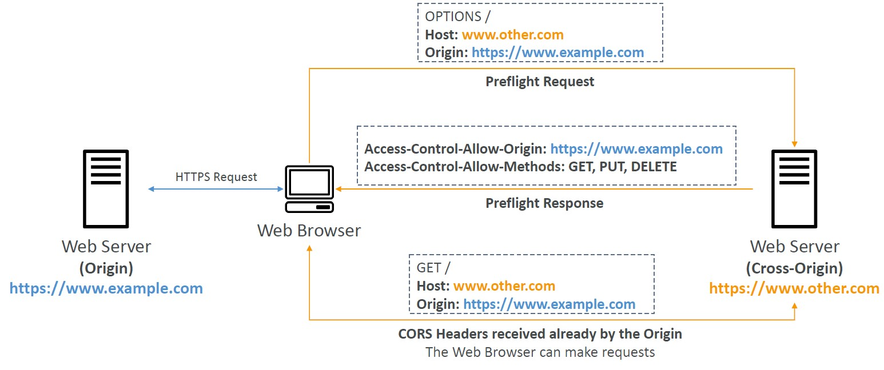

Amazon S3 – CORS

• If a client makes a cross-origin request on our S3 bucket, we need to enable the correct CORS headers

• You can allow for a specific origin or for * (all origins)

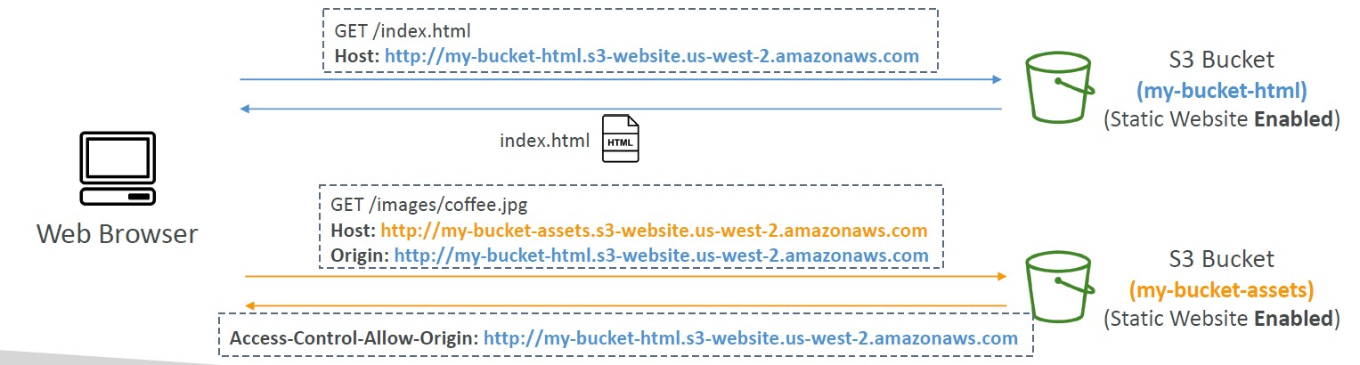

Amazon S3 – MFA Delete

• MFA (Multi-Factor Authentication) – force users to generate a code on a device (usually a mobile phone or hardware) before doing important operations on S3

- MFA will be required to:

• Permanently delete an object version

• Suspend Versioning on the bucket

- MFA won’t be required to:

• Enable Versioning

• List deleted versions

-To use MFA Delete, Versioning must be enabled on the bucket

- Only the bucket owner (root account) can enable/disable MFA Delete

S3 Access Logs

• For audit purpose, you may want to log all access to S3 buckets

• Any request made to S3, from any account, authorized or denied, will be logged into another S3 bucket

• That data can be analyzed using data analysis tools

• The target logging bucket must be in the same AWS region

-When you enable server access logging, the S3 console automatically updates your bucket policy to include access to the S3 log delivery group.

-Disabling server access logging after enabling it does not automatically remove access for the S3 log delivery group in your bucket policy.

S3 Access Logs: Warning

• Do not set your logging bucket to be the monitored bucket

• It will create a logging loop, and your bucket will grow exponentially (as every log created will generate a new log in an endless loop)

Amazon S3 – Pre-Signed URLs

• Generate pre-signed URLs using the S3 Console, AWS CLI or SDK

• URL Expiration

• S3 Console – 1 min up to 720 mins (12 hours)

• AWS CLI – configure expiration with --expires-in parameter in seconds (default 3600 secs, max. 604800 secs ~ 168 hours)

• Users given a pre-signed URL inherit the permissions of the user that generated the URL for GET / PUT

• Examples:

• Allow only logged-in users to download a premium video from your S3 bucket

• Allow an ever-changing list of users to download files by generating URLs dynamically

• Allow temporarily a user to upload a file to a precise location in your S3 bucket

S3 Glacier Vault Lock

• Adopt a WORM (Write Once Read Many) model

• Create a Vault Lock Policy

• Lock the policy for future edits (can no longer be changed or deleted)

• Helpful for compliance and data retention

• It is recommended that you first create a vault, complete a Vault Lock policy, and then upload your archives to the vault so that the policy will be applied to them.

• After the Vault Lock policy is locked, it cannot be changed or deleted

S3 Object Lock (versioning must be enabled)

• Adopt a WORM (Write Once Read Many) model

• Block an object version deletion for a specified amount of time

- Retention mode - Compliance:

• Object versions can't be overwritten or deleted by any user, including the root user

• Objects retention modes can't be changed, and retention periods can't be shortened

- Retention mode - Governance:

• Most users can't overwrite or delete an object version or alter its lock settings

• Some users have special permissions to change the retention or delete the object

• Retention Period: protect the object for a fixed period, it can be extended

- Legal Hold:

• protect the object indefinitely, independent from retention period

• can be freely placed and removed using the s3:PutObjectLegalHold IAM permission

-Enabling Object Lock automatically enables Bucket Versioning

S3 – Access Points

• Each Access Point gets its own DNS and policy to limit who can access it

• A specific IAM user / group

• One policy per Access Point => Easier to manage than complex bucket policies

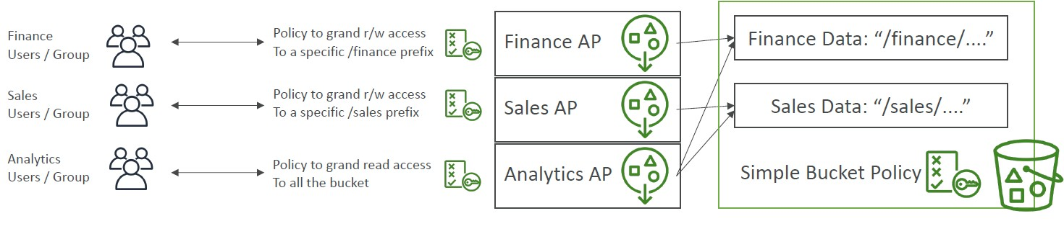

S3 Object Lambda

• Use AWS Lambda Functions to change the object before it is retrieved by the caller application

• Only one S3 bucket is needed, on top of which we create S3 Access Point and S3 Object Lambda Access Points.

- Use Cases:

• Redacting personally identifiable information for analytics or nonproduction environments.

• Converting across data formats, such as converting XML to JSON.

• Resizing and watermarking images on the fly using caller-specific details, such as the user who requested the object.

* Data Redaction or Dynamic Data Masking is the process of obfuscating or hiding sensitive data elements such as Credit Card Numbers in the SQL query results prior to display by applications.

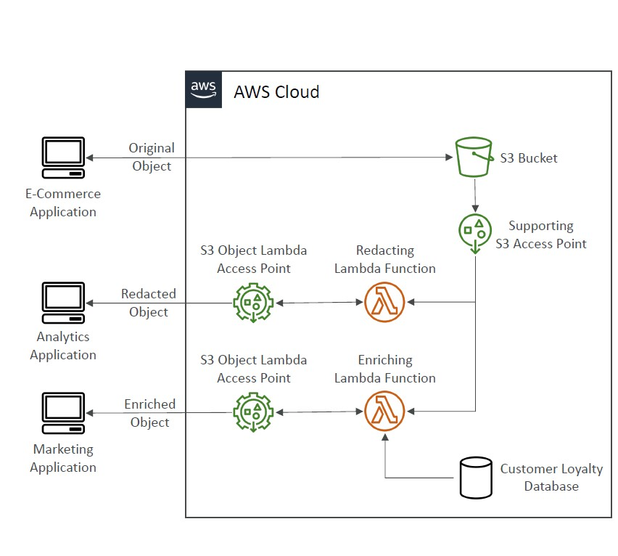

AWS EC2 Instance Metadata

• AWS EC2 Instance Metadata is powerful but one of the least known features to developers

• It allows AWS EC2 instances to ”learn about themselves” without using an IAM Role for that purpose.

• The URL is http://169.254.169.254/latest/meta-data

• You can retrieve the IAM Role name from the metadata, but you CANNOT retrieve the IAM Policy.

• Metadata = Info about the EC2 instance

• Userdata = launch script of the EC2 instance

AWS SDK

• If you want to perform actions on AWS directly from your applications code (without using the CLI) you can use an SDK (software development kit)

• Official SDKs are: Java, .NET, Node.js, PHP, Python (named boto3 / botocore), Go, Ruby, C++

• We have to use the AWS SDK when coding against AWS Services such as DynamoDB

• The AWS CLI uses the Python SDK (boto3)

• If you don’t specify or configure a default region, then us-east-1 will be chosen by default

Amazon CloudFront

• Content Delivery Network (CDN)

• Improves read performance, content is cached at the edge

• Improves users experience

• 216 Point of Presence globally (edge locations)

• DDoS protection (because worldwide), integration with Shield, AWS Web Application Firewall

CloudFront – Origins

- S3 bucket

• For distributing files and caching them at the edge

• Enhanced security with CloudFront Origin Access Control (OAC)

• OAC is replacing Origin Access Identity (OAI)

*Compared with OAI, some of the notable enhancements OAC provide include:

-Security – OAC is implemented with enhanced security practices like short term credentials, frequent credential rotations, and resource-based policies. They strengthen your distributions’ security posture and provides better protections against attacks like confused deputy.

-Comprehensive HTTP methods support – OAC supports GET, PUT, POST, PATCH, DELETE, OPTIONS, and HEAD.

-SSE-KMS – OAC supports downloading and uploading S3 objects encrypted with SSE-KMS. OAI only supports SSE-S3

-Access S3 in all AWS regions – OAC supports accessing S3 in all AWS regions, including existing regions and all future regions. In contrast, OAI will only be supported in existing AWS regions and regions launched before December 2022.

• CloudFront can be used as an ingress (to upload files to S3)

- Custom Origin (HTTP)

• Application Load Balancer

• EC2 instance

• S3 website (must first enable the bucket as a static S3 website)

• Any HTTP backend you want

CloudFront vs S3 Cross Region Replication

• CloudFront:

• Global Edge network

• Files are cached for a TTL (maybe a day)

• Great for static content that must be available everywhere

• S3 Cross Region Replication:

• Must be setup for each region you want replication to happen

• Files are updated in near real-time

• Read only

• Great for dynamic content that needs to be available at low-latency in few regions

CloudFront Geo Restriction

• You can restrict who can access your distribution

• Allowlist: Allow your users to access your content only if they're in one of the countries on a list of approved countries.

• Blocklist: Prevent your users from accessing your content if they're in one of the countries on a list of banned countries.

• The “country” is determined using a 3rd party Geo-IP database

• Use case: Copyright Laws to control access to content

CloudFront – Price Classes

• You can reduce the number of edge locations for cost reduction

• Three price classes:

1. Price Class All: all regions – best performance

2. Price Class 200: most regions, but excludes the most expensive regions

3. Price Class 100: only the least expensive regions

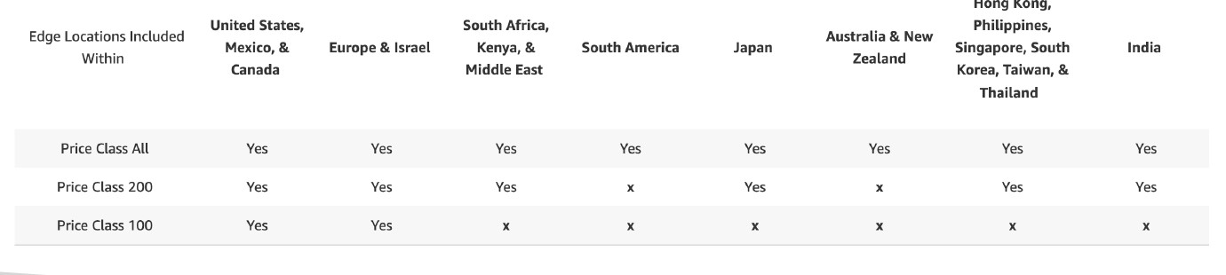

CloudFront – Cache Invalidations

• In case you update the back-end origin, CloudFront doesn’t know about it and will only get the refreshed content after the TTL has expired

• However, you can force an entire or partial cache refresh (thus bypassing the TTL) by performing a CloudFront Invalidation

• You can invalidate all files (*) or a special path (/images/*)

Unicast IP vs Anycast IP

• Unicast IP: one server holds one IP address

• Anycast IP: all servers hold the same IP address and the client is routed to the nearest one

AWS Global Accelerator

• Leverage the AWS internal network to route to your application

• 2 Anycast IP are created for your application

• The Anycast IP send traffic directly to Edge Locations

• The Edge locations send the traffic to your application

• Works with Elastic IP, EC2 instances, ALB, NLB, public or private

-Consistent Performance

• Intelligent routing to lowest latency and fast regional failover

• No issue with client cache (because the IP doesn’t change)

• Internal AWS network

-Health Checks

• Global Accelerator performs a health check of your applications

• Helps make your application global (failover less than 1 minute for unhealthy)

• Great for disaster recovery (thanks to the health checks)

- Security

• only 2 external IP need to be whitelisted

• DDoS protection thanks to AWS Shield

AWS Global Accelerator vs CloudFront

• They both use the AWS global network and its edge locations around the world

• Both services integrate with AWS Shield for DDoS protection.

• CloudFront

• Improves performance for both cacheable content (such as images and videos)

• Dynamic content (such as API acceleration and dynamic site delivery)

• Content is served at the edge

• Global Accelerator

• Improves performance for a wide range of applications over TCP or UDP

• Proxying packets at the edge to applications running in one or more AWS Regions.

• Good fit for non-HTTP use cases, such as gaming (UDP), IoT (MQTT), or Voice over IP

• Good for HTTP use cases that require static IP addresses

• Good for HTTP use cases that required deterministic, fast regional failover

AWS Snow Family

AWS Snowcone (for data transfers)

• Small, portable computing, anywhere, rugged & secure, withstands harsh environments

• Light (4.5 pounds, 2.1 kg)

• Device used for edge computing, storage, and data transfer

• 8 TBs of usable storage

• Use Snowcone where Snowball does not fit (space-constrained environment)

• Must provide your own battery / cables

• Can be sent back to AWS offline, or connect it to internet and use AWS DataSync to send data (Pre-installed)

Snowball Edge (for data transfers)

• Physical data transport solution: move TBs or PBs of data in or out of AWS

• Alternative to moving data over the network (and paying network fees)

• Pay per data transfer job

• Provide block storage and Amazon S3-compatible object storage

• Snowball Edge Storage Optimized

• 80 TB of HDD capacity for block volume and S3 compatible object storage

• Snowball Edge Compute Optimized

• 42 TB of HDD capacity for block volume and S3 compatible object storage

• Use cases: large data cloud migrations, DC decommission, disaster recovery

AWS Snowmobile

• Transfer exabytes of data (1 EB = 1,000 PB = 1,000,000 TBs)

• Each Snowmobile has 100 PB of capacity (use multiple in parallel)

• High security: temperature controlled, GPS, 24/7 video surveillance

• Better than Snowball if you transfer more than 10 PB

Snow Family – Usage Process

1. Request Snowball devices from the AWS console for delivery

2. Install the snowball client / AWS OpsHub on your servers

3. Connect the snowball to your servers and copy files using the client

4. Ship back the device when you’re done (goes to the right AWS facility)

5. Data will be loaded into an S3 bucket

6. Snowball is completely wiped

What is Edge Computing?

• Process data while it’s being created on an edge location

• A truck on the road, a ship on the sea, a mining station underground...

• These locations may have

• Limited / no internet access

• Limited / no easy access to computing power

• We setup a Snowball Edge / Snowcone device to do edge computing

- Use cases of Edge Computing:

• Preprocess data

• Machine learning at the edge

• Transcoding media streams

• Eventually (if need be) we can ship back the device to AWS (for transferring data for example)

Snow Family – Edge Computing

- Snowcone (smaller)

• 2 CPUs, 4 GB of memory, wired or wireless access

• USB-C power using a cord or the optional battery

• Snowball Edge – Compute Optimized

• 52 vCPUs, 208 GiB of RAM

• Optional GPU (useful for video processing or machine learning)

• 42 TB usable storage

- Snowball Edge – Storage Optimized

• Up to 40 vCPUs, 80 GiB of RAM

• Object storage clustering available

• All: Can run EC2 Instances & AWS Lambda functions (using AWS IoT Greengrass)

• Long-term deployment options: 1 and 3 years discounted pricing

AWS OpsHub

• Historically, to use Snow Family devices, you needed a CLI (Command Line Interface tool)

• Today, you can use AWS OpsHub (a software you install on your computer / laptop) to manage your Snow Family Device

• Unlocking and configuring single or clustered devices

• Transferring files

• Launching and managing instances running on Snow Family Devices

• Monitor device metrics (storage capacity, active instances on your device)

• Launch compatible AWS services on your devices (ex: Amazon EC2 instances, AWS DataSync, Network File System (NFS))

Solution Architecture: Snowball into Glacier

• Snowball cannot import to Glacier directly

• You must use Amazon S3 first, in combination with an S3 lifecycle policy

Amazon FSx – Overview

• Launch 3rd party high-performance file systems on AWS

• Fully managed service

Amazon FSx for Windows (File Server)

• FSx for Windows is a fully managed Windows file system share drive

• Supports SMB protocol & Windows NTFS

• Microsoft Active Directory integration, ACLs, user quotas

• Can be mounted on Linux EC2 instances

• Supports Microsoft's Distributed File System (DFS) Namespaces (group files across multiple FS)

• Scale up to 10s of GB/s, millions of IOPS, 100s PB of data

• Storage Options:

• SSD – latency sensitive workloads (databases, media processing, data analytics, …)

• HDD – broad spectrum of workloads (home directory, CMS, …)

• Can be accessed from your on-premises infrastructure (VPN or Direct Connect)

• Can be configured to be Multi-AZ (high availability)

• Data is backed-up daily to S3

Amazon FSx for Lustre

• Lustre is a type of parallel distributed file system, for large-scale computing

• The name Lustre is derived from “Linux” and “cluster

• Machine Learning, High Performance Computing (HPC)

• Video Processing, Financial Modeling, Electronic Design Automation

• Scales up to 100s GB/s, millions of IOPS, sub-ms latencies

• Storage Options:

• SSD – low-latency, IOPS intensive workloads, small & random file operations

• HDD – throughput-intensive workloads, large & sequential file operations

• Seamless integration with S3

• Can “read S3” as a file system (through FSx)

• Can write the output of the computations back to S3 (through FSx)

• Can be used from on-premises servers (VPN or Direct Connect)

FSx Lustre - File System Deployment Options

-Scratch File System

• Temporary storage

• Data is not replicated (doesn’t persist if file server fails)

• High burst (6x faster, 200MBps per TiB)

• Usage: short-term processing, optimize costs

- Persistent File System

• Long-term storage

• Data is replicated within same AZ

• Replace failed files within minutes

• Usage: long-term processing, sensitive data

Amazon FSx for NetApp ONTAP

• Managed NetApp ONTAP on AWS

• File System compatible with NFS, SMB, iSCSI protocol

• Move workloads running on ONTAP or NAS to AWS

• Works with:

• Linux

• Windows

• MacOS

• VMware Cloud on AWS

• Amazon Workspaces & AppStream 2.0

• Amazon EC2, ECS and EKS

• Storage shrinks or grows automatically

• Snapshots, replication, low-cost, compression and data de-duplication

• Point-in-time instantaneous cloning (helpful for testing new workloads)

Amazon FSx for OpenZFS

• Managed OpenZFS file system on AWS

• File System compatible with NFS (v3, v4, v4.1, v4.2)

• Move workloads running on ZFS to AWS

• Works with:

• Linux

• Windows

• MacOS

• VMware Cloud on AWS

• Amazon Workspaces & AppStream 2.0

• Amazon EC2, ECS and EKS

• Up to 1,000,000 IOPS with < 0.5ms latency

• Snapshots, compression and low-cost

• Point-in-time instantaneous cloning (helpful for testing new workloads)

AWS Storage Cloud Native Options

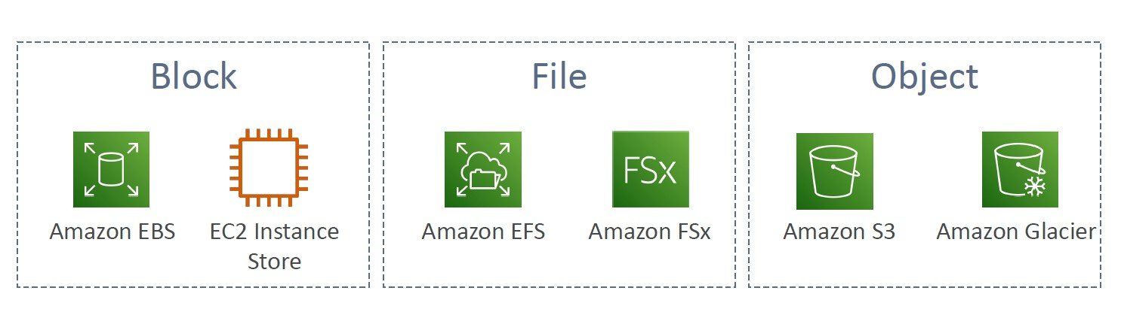

AWS Storage Gateway

• Bridge between on-premises data and cloud data

• Use cases:

• disaster recovery

• backup & restore

• tiered storage

• on-premises cache & low-latency files access

Amazon S3 File Gateway

• Configured S3 buckets are accessible using the NFS and SMB protocol

• Most recently used data is cached in the file gateway

• Supports S3 Standard, S3 Standard IA, S3 One Zone A, S3 Intelligent Tiering

• Transition to S3 Glacier using a Lifecycle Policy

• Bucket access using IAM roles for each File Gateway

• SMB Protocol has integration with Active Directory (AD) for user authentication

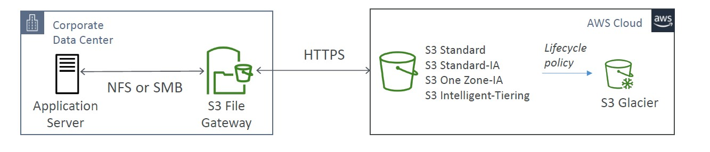

Amazon FSx File Gateway

• Native access to Amazon FSx for Windows File Server

• Local cache for frequently accessed data

• Windows native compatibility (SMB, NTFS, Active Directory...)

• Useful for group file shares and home directories

Volume Gateway

• Block storage using iSCSI protocol backed by S3

• Backed by EBS snapshots which can help restore on-premises volumes!

• Cached volumes: low latency access to most recent data

• Stored volumes: entire dataset is on premise, scheduled backups to S3

Tape Gateway

• Some companies have backup processes using physical tapes (!)

• With Tape Gateway, companies use the same processes but, in the cloud

• Virtual Tape Library (VTL) backed by Amazon S3 and Glacier

• Back up data using existing tape-based processes (and iSCSI interface)

• Works with leading backup software vendors

Storage Gateway – Hardware appliance

• Using Storage Gateway means you need on-premises virtualization

• Otherwise, you can use a Storage Gateway Hardware Appliance

• You can buy it on amazon.com

• Works with File Gateway, Volume Gateway, Tape Gateway

• Has the required CPU, memory, network, SSD cache resources

• Helpful for daily NFS backups in small data centers

AWS Transfer Family

• A fully-managed service for file transfers into and out of Amazon S3 or Amazon EFS using the FTP protocol

• Supported Protocols

• AWS Transfer for FTP (File Transfer Protocol (FTP))

• AWS Transfer for FTPS (File Transfer Protocol over SSL (FTPS))

• AWS Transfer for SFTP (Secure File Transfer Protocol (SFTP))

• Managed infrastructure, Scalable, Reliable, Highly Available (multi-AZ)

• Pay per provisioned endpoint per hour + data transfers in GB

• Store and manage users’ credentials within the service

• Integrate with existing authentication systems (Microsoft Active Directory, LDAP, Okta, Amazon Cognito, custom)

• Usage: sharing files, public datasets, CRM, ERP, …

AWS DataSync

• Move large amount of data to and from

• On-premises / other cloud to AWS (NFS, SMB, HDFS, S3 API…) – needs agent

• AWS to AWS (different storage services) – no agent needed

• Can synchronize to:

• Amazon S3 (any storage classes – including Glacier)

• Amazon EFS

• Amazon FSx (Windows, Lustre, NetApp, OpenZFS...)

• Replication tasks can be scheduled hourly, daily, weekly

• File permissions and metadata are preserved (NFS POSIX, SMB…)

• One agent task can use 10 Gbps, can setup a bandwidth limit

Storage Comparison

• S3: Object Storage

• S3 Glacier: Object Archival

• EBS volumes: Network storage for one EC2 instance at a time

• Instance Storage: Physical storage for your EC2 instance (high IOPS)

• EFS: Network File System for Linux instances, POSIX filesystem

• FSx for Windows: Network File System for Windows servers

• FSx for Lustre: High Performance Computing Linux file system

• FSx for NetApp ONTAP: High OS Compatibility

• FSx for OpenZFS: Managed ZFS file system

• Storage Gateway: S3 & FSx File Gateway, Volume Gateway (cache & stored), Tape Gateway

• Transfer Family: FTP, FTPS, SFTP interface on top of Amazon S3 or Amazon EFS

• DataSync: Schedule data sync from on-premises to AWS, or AWS to AWS

• Snowcone / Snowball / Snowmobile: to move large amount of data to the cloud, physically

• Database: for specific workloads, usually with indexing and querying

AWS Integration & Messaging

• There are two patterns of application communication

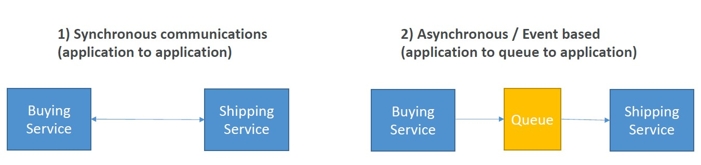

• Synchronous between applications can be problematic if there are sudden spikes of traffic

- it’s better to decouple your applications

• using SQS: queue model

• using SNS: pub/sub model

• using Kinesis: real-time streaming model

- These services can scale independently from our application

Amazon SQS

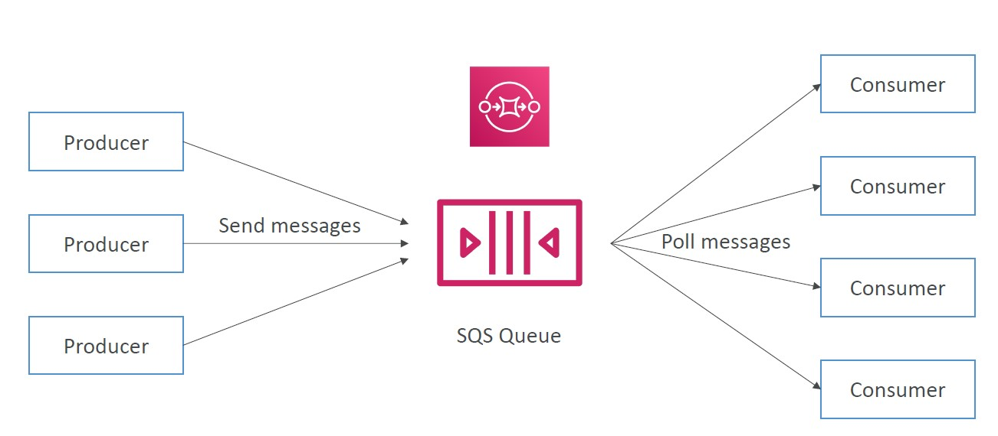

Amazon SQS – Standard Queue

• Fully managed service, used to decouple applications

-Attributes:

• Unlimited throughput, unlimited number of messages in queue

• Default retention of messages: 4 days, maximum of 14 days

• Low latency (<10 ms on publish and receive)

• Limitation of 256KB per message sent

• Can have duplicate messages (at least once delivery, occasionally)

• Can have out of order messages (best effort ordering)

•Amazon SQS provides in-transit encryption by default.

SQS – Producing Messages

• Produced to SQS using the SDK (SendMessage API)

• The message is persisted in SQS until a consumer deletes it

• Message retention: default 4 days, up to 14 days

• Example: send an order to be processed

• Order id

• Customer id

• Any attributes you want

• SQS standard: unlimited throughput

SQS – Consuming Messages

• Consumers (running on EC2 instances, servers, or AWS Lambda)…

• Poll SQS for messages (receive up to 10 messages at a time)

• Process the messages (example: insert the message into an RDS database)

• Delete the messages using the DeleteMessage API

SQS – Multiple EC2 Instances Consumers

• Consumers receive and process messages in parallel

• At least once delivery

• Best-effort message ordering

• Consumers delete messages after processing them

• We can scale consumers horizontally to improve throughput of processing

SQS with Auto Scaling Group (ASG)

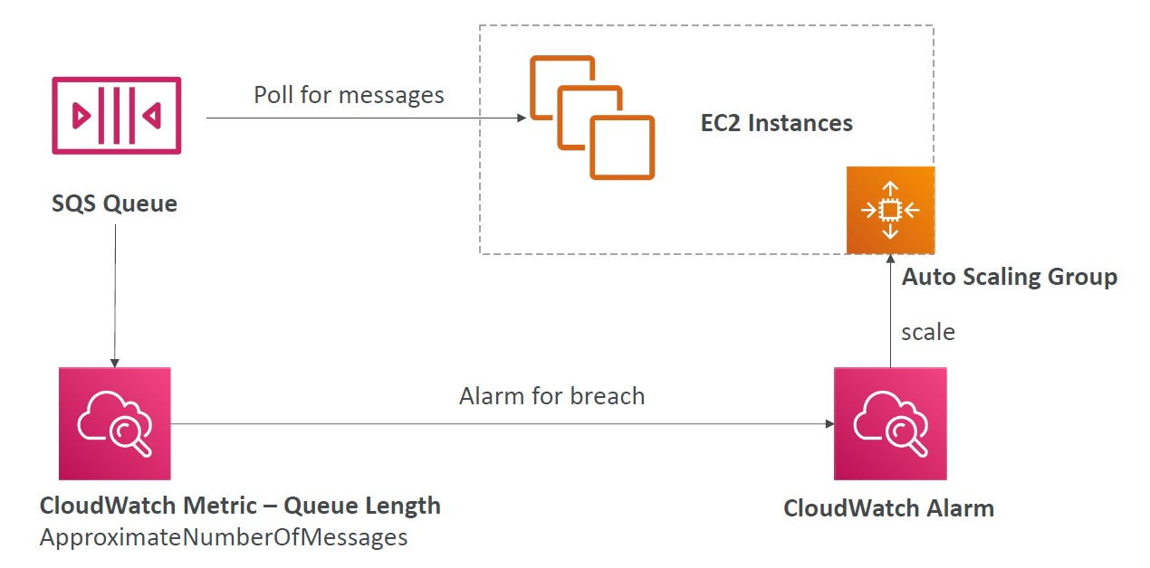

SQS to decouple between application tiers

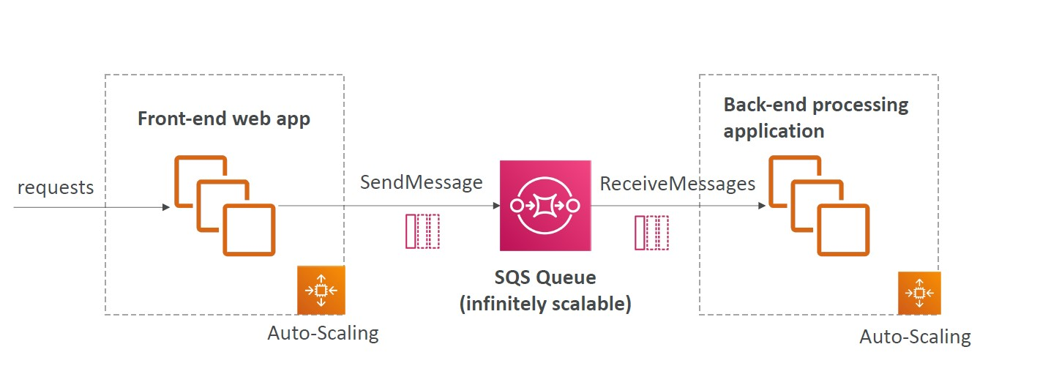

Amazon SQS - Security

- Encryption:

• In-flight encryption using HTTPS API

• At-rest encryption using KMS keys

• Client-side encryption if the client wants to perform encryption/decryption itself

- Access Controls: IAM policies to regulate access to the SQS API

- SQS Access Policies (similar to S3 bucket policies)

• Useful for cross-account access to SQS queues

• Useful for allowing other services (SNS, S3…) to write to an SQS queue

SQS – Message Visibility Timeout

• After a message is polled by a consumer, it becomes invisible to other consumers

• By default, the “message visibility timeout” is 30 seconds

• That means the message has 30 seconds to be processed

• After the message visibility timeout is over, the message is “visible” in SQS

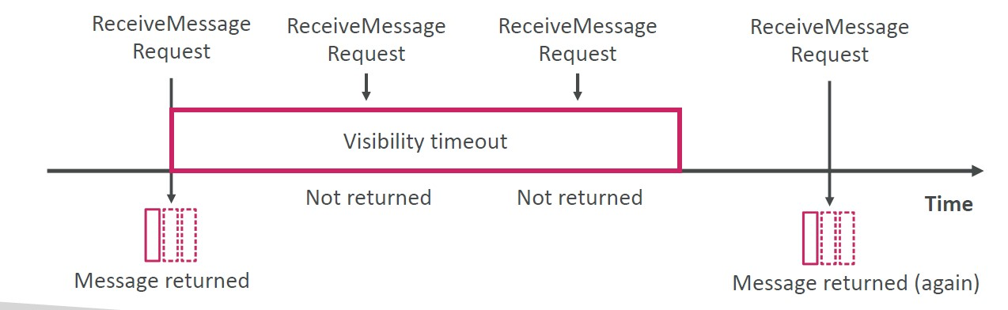

• If a message is not processed within the visibility timeout, it will be processed twice

• A consumer could call the ChangeMessageVisibility API to get more time

• If visibility timeout is high (hours), and consumer crashes, re-processing will take time

• If visibility timeout is too low (seconds), we may get duplicates

Amazon SQS - Long Polling

• When a consumer requests messages from the queue, it can optionally “wait” for messages to arrive if there are none in the queue

• This is called Long Polling

• LongPolling decreases the number of API calls made to SQS while increasing the efficiency and reducing latency of your application

• The wait time can be between 1 sec to 20 secs (20 secs preferable)

• Long Polling is preferable to Short Polling

• Long polling can be enabled at the queue level or at the API level using WaitTimeSeconds

Amazon SQS – FIFO Queue

• FIFO = First In First Out (ordering of messages in the queue)

• Limited throughput: 300 msg/s without batching, 3000 msg/s with

• Exactly-once send capability (by removing duplicates)

• Messages are processed in order by the consumer

SQS as a buffer to database writes

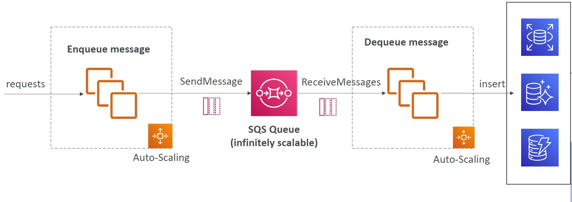

Amazon SNS

• The “event producer” only sends message to one SNS topic

• As many “event receivers” (subscriptions) as we want to listen to the SNS topic notifications

• Each subscriber to the topic will get all the messages (note: new feature to filter messages)

• Up to 12,500,000 subscriptions per topic

• 100,000 topics limit

Amazon SNS – How to publish

- Topic Publish (using the SDK)

• Create a topic

• Create a subscription (or many)

• Publish to the topic

- Direct Publish (for mobile apps SDK)

• Create a platform application

• Create a platform endpoint

• Publish to the platform endpoint

• Works with Google GCM, Apple APNS, Amazon ADM

Amazon SNS – Security

- Encryption:

• In-flight encryption using HTTPS API

• At-rest encryption using KMS keys

• Client-side encryption if the client wants to perform encryption/decryption itself

-Access Controls: IAM policies to regulate access to the SNS API

- SNS Access Policies (similar to S3 bucket policies)

• Useful for cross-account access to SNS topics

• Useful for allowing other services ( S3…) to write to an SNS topic

SNS + SQS: Fan Out

• Push once in SNS, receive in all SQS queues that are subscribers

• Fully decoupled, no data loss

• SQS allows for: data persistence, delayed processing and retries of work

• Ability to add more SQS subscribers over time

• Make sure your SQS queue access policy allows for SNS to write

• Cross-Region Delivery: works with SQS Queues in other regions

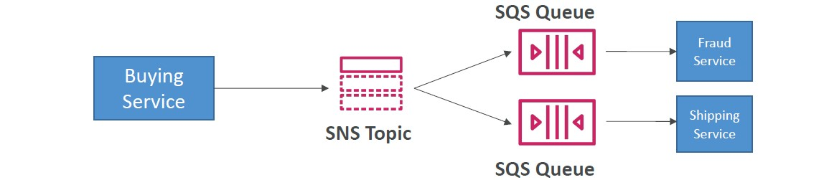

Application: S3 Events to multiple queues

• For the same combination of: event type (e.g. object create) and prefix (e.g. images/) you can only have one S3 Event rule

• If you want to send the same S3 event to many SQS queues, use fan-out

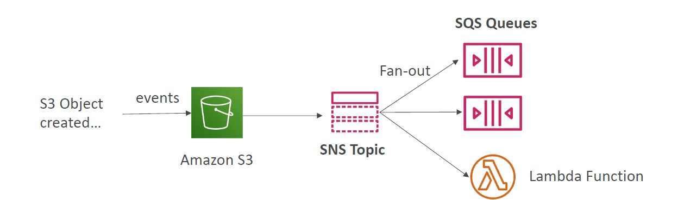

Application: SNS to Amazon S3 through Kinesis Data Firehose

• SNS can send to Kinesis and therefore we can have the following solutions architecture:

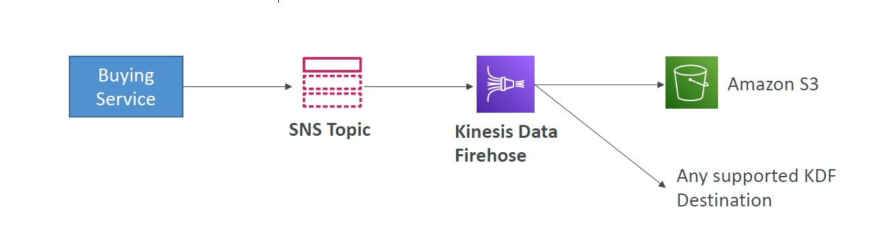

Amazon SNS – FIFO Topic

• FIFO = First In First Out (ordering of messages in the topic)

• Similar features as SQS FIFO:

• Ordering by Message Group ID (all messages in the same group are ordered)

• Deduplication using a Deduplication ID or Content Based Deduplication

• Can only have SQS FIFO queues as subscribers

• Limited throughput (same throughput as SQS FIFO)

SNS – Message Filtering

• JSON policy used to filter messages sent to SNS topic’s subscriptions

• If a subscription doesn’t have a filter policy, it receives every message

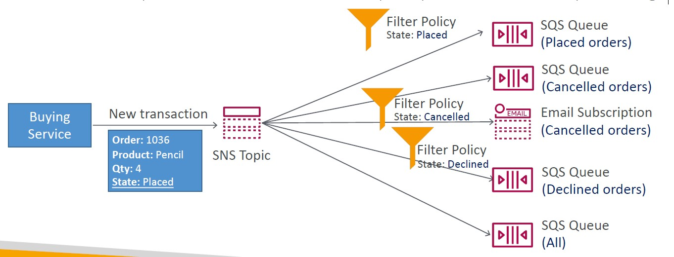

Kinesis Data Streams

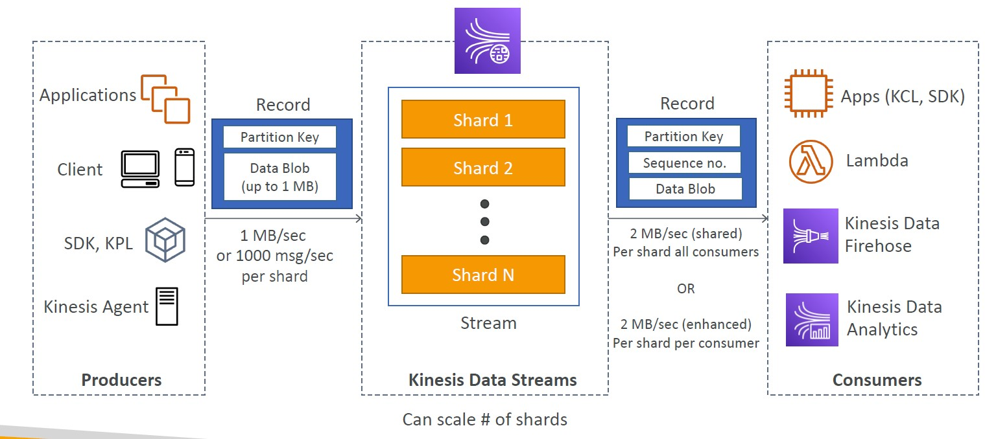

• Retention between 1 day to 365 days

• Ability to reprocess (replay) data

• Once data is inserted in Kinesis, it can’t be deleted (immutability)

• Data that shares the same partition goes to the same shard (ordering)

• Producers: AWS SDK, Kinesis Producer Library (KPL), Kinesis Agent

• Consumers:

• Write your own: Kinesis Client Library (KCL), AWS SDK

• Managed: AWS Lambda, Kinesis Data Firehose, Kinesis Data Analytics

Kinesis Data Streams – Capacity Modes

-Provisioned mode:

• You choose the number of shards provisioned, scale manually or using API

• Each shard gets 1MB/s in (or 1000 records per second)

• Each shard gets 2MB/s out (classic or enhanced fan-out consumer)

• You pay per shard provisioned per hour

-On-demand mode:

• No need to provision or manage the capacity

• Default capacity provisioned (4 MB/s in or 4000 records per second)

• Scales automatically based on observed throughput peak during the last 30 days

• Pay per stream per hour & data in/out per GB

Kinesis Data Streams Security

• Control access / authorization using IAM policies

• Encryption in flight using HTTPS endpoints

• Encryption at rest using KMS

• You can implement encryption/decryption of data on client side (harder)

• VPC Endpoints available for Kinesis to access within VPC

• Monitor API calls using CloudTrail

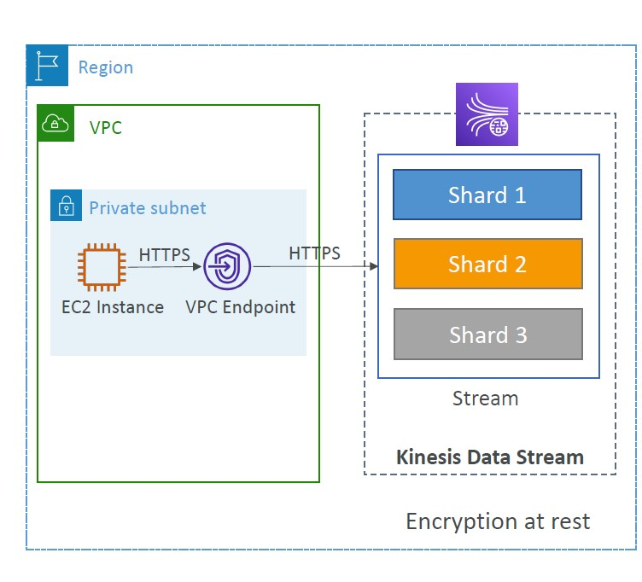

Kinesis Data Firehose

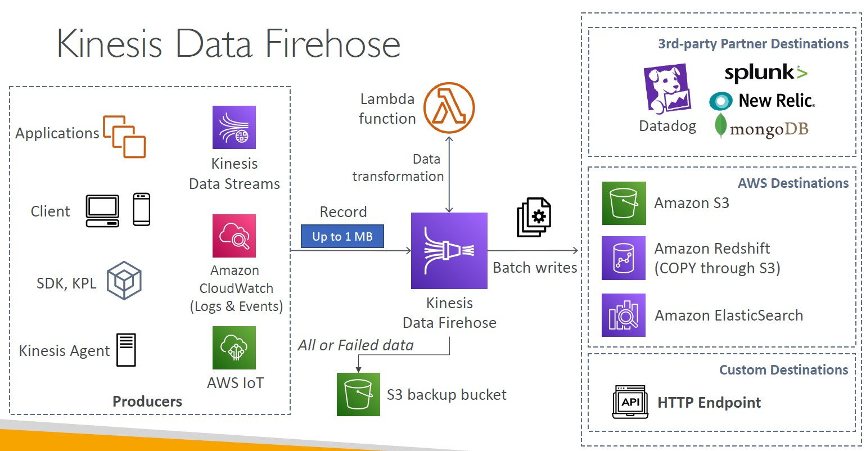

• Fully Managed Service, no administration, automatic scaling, serverless

• AWS: Redshift / Amazon S3 / ElasticSearch

• 3rd party partner: Splunk / MongoDB / DataDog / NewRelic / …

• Custom: send to any HTTP endpoint

• Pay for data going through Firehose

• Near Real Time

• 60 seconds latency minimum for non full batches

• Or minimum 1 MB of data at a time

• Supports many data formats, conversions, transformations, compression

• Supports custom data transformations using AWS Lambda

• Can send failed or all data to a backup S3 bucket

Kinesis Data Streams vs Firehose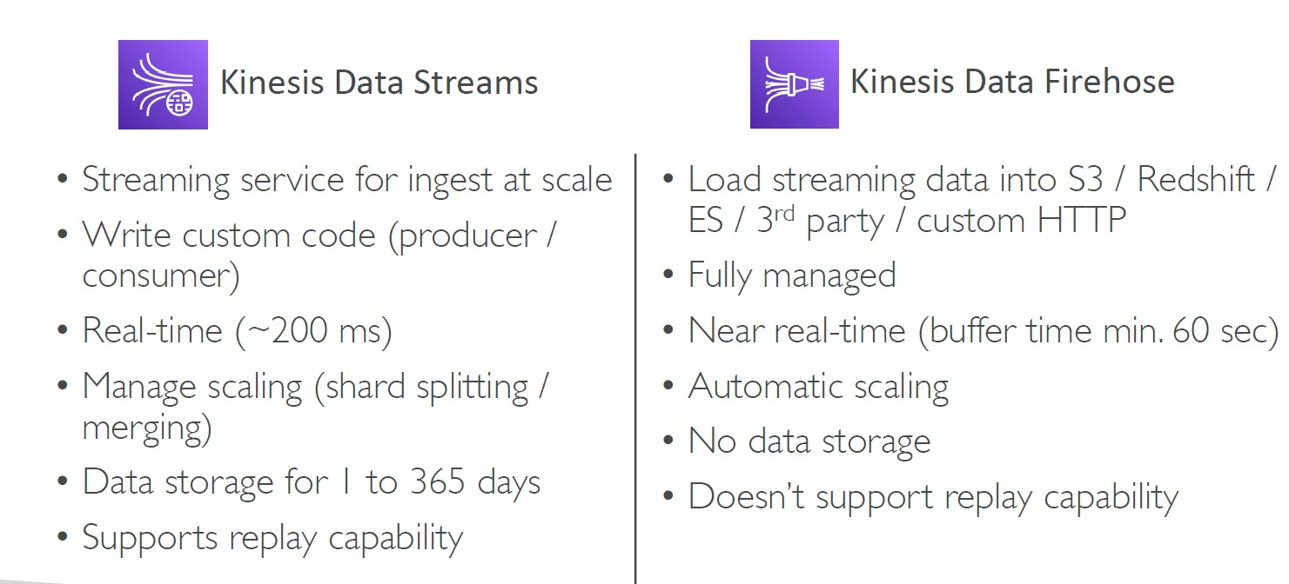

Ordering data into Kinesis

• send using a “Partition Key”

• The same key will always go to the same shard

Ordering data into SQS

• For SQS standard, there is no ordering.

• For SQS FIFO, if you don’t use a Group ID, messages are consumed in the order they are sent, with only one consumer

• You want to scale the number of consumers, but you want messages to be “grouped” when they are related to each other

• Then you use a Group ID (similar to Partition Key in Kinesis)

Kinesis vs SQS ordering

• Let’s assume 100 trucks, 5 kinesis shards, 1 SQS FIFO

- Kinesis Data Streams:

• On average you’ll have 20 trucks per shard

• Trucks will have their data ordered within each shard

• The maximum amount of consumers in parallel we can have is 5

• Can receive up to 5 MB/s of data

-SQS FIFO

• You only have one SQS FIFO queue

• You will have 100 Group ID

• You can have up to 100 Consumers (due to the 100 Group ID)

• You have up to 300 messages per second (or 3000 if using batching)

SQS vs SNS vs Kinesis

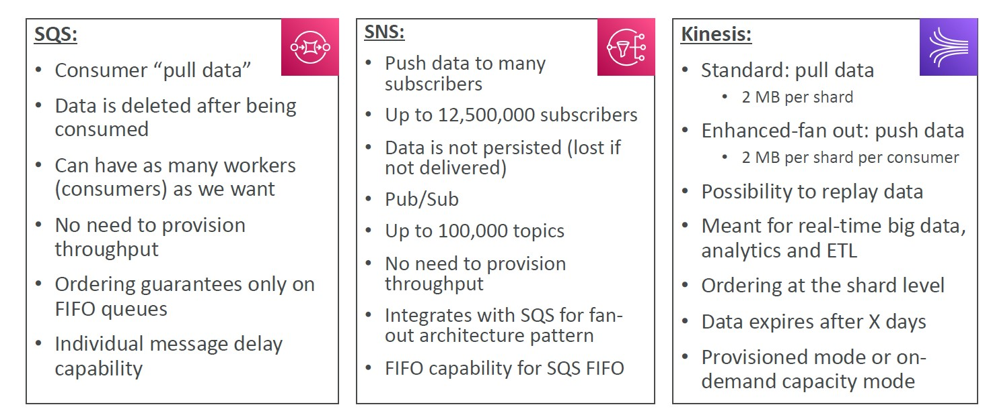

Amazon MQ

• SQS, SNS are “cloud-native” services: proprietary protocols from AWS

• Traditional applications running from on-premises may use open protocols such as: MQTT, AMQP, STOMP, Openwire, WSS

• When migrating to the cloud, instead of re-engineering the application to use SQS and SNS, we can use Amazon MQ

• Amazon MQ is a managed message broker service for RabbitMQ and ActiveMQ

• Amazon MQ doesn’t “scale” as much as SQS / SNS

• Amazon MQ runs on servers, can run in Multi-AZ with failover

• Amazon MQ has both queue feature (~SQS) and topic features (~SNS)

Amazon MQ – High Availability

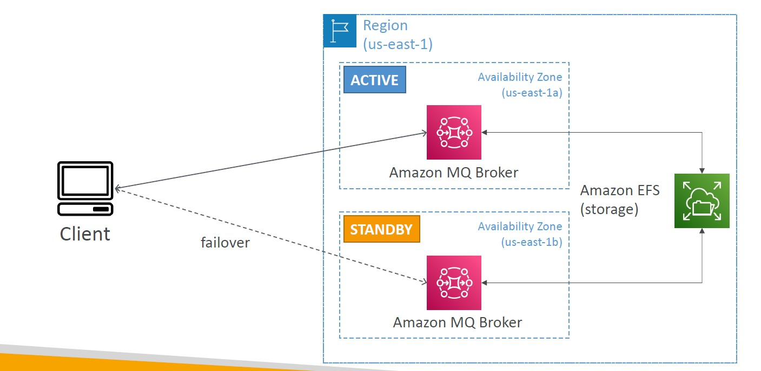

Docker

Where are Docker images stored?

- Docker images are stored in Docker Repositories

1- Docker Hub (https://hub.docker.com)

• Public repository

• Find base images for many technologies or OS (e.g., Ubuntu, MySQL, …)

2- Amazon ECR (Amazon Elastic Container Registry)

• Private repository

• Public repository (Amazon ECR Public Gallery <https://gallery.ecr.aws>)

Docker vs. Virtual Machines

• Docker is ”sort of” a virtualization technology, but not exactly

• Resources are shared with the host => many containers on one server

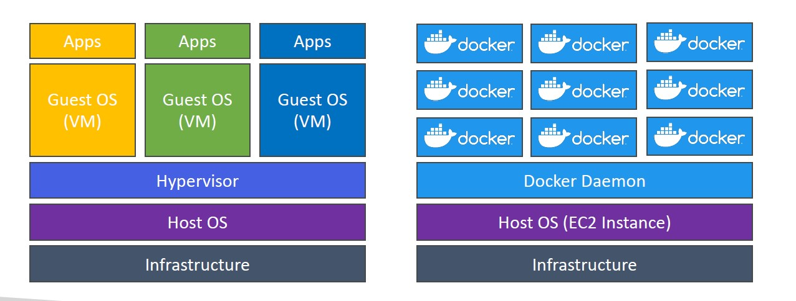

Getting Started with Docker

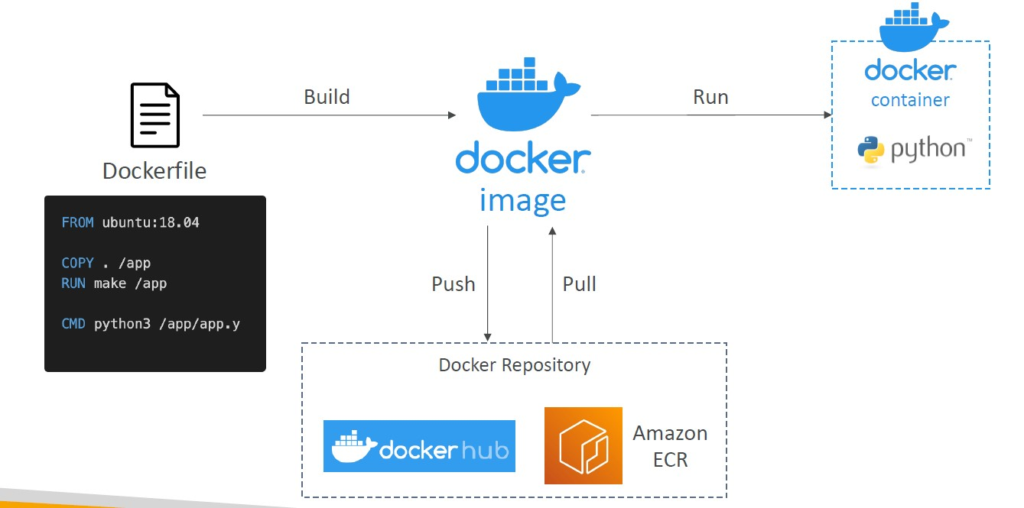

Docker Containers Management on AWS

- Amazon Elastic Container Service (Amazon ECS)

• Amazon’s own container platform

-Amazon Elastic Kubernetes Service (Amazon EKS)

• Amazon’s managed Kubernetes (open source)

- AWS Fargate

• Amazon’s own Serverless container platform

• Works with ECS and with EKS

- Amazon ECR:

• Store container images

Amazon ECS - EC2 Launch Type

• ECS = Elastic Container Service

• Launch Docker containers on AWS = Launch ECS Tasks on ECS Clusters

• EC2 Launch Type: you must provision & maintain the infrastructure (the EC2 instances)

• Each EC2 Instance must run the ECS Agent to register in the ECS Cluster

• AWS takes care of starting / stopping containers

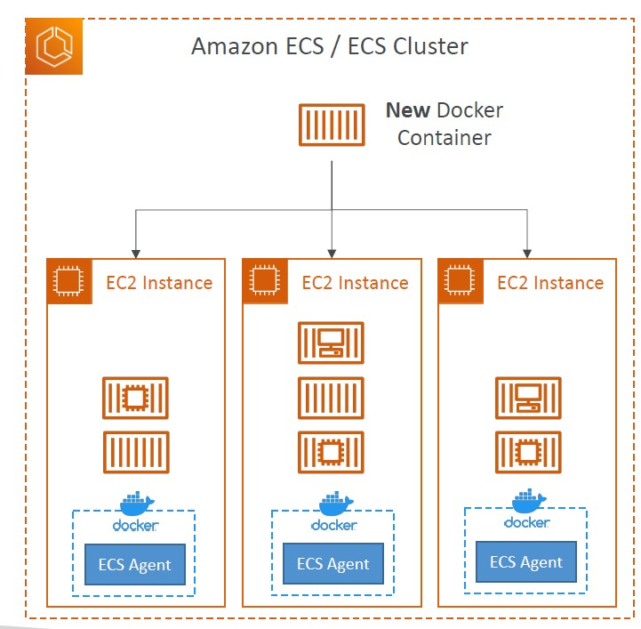

Amazon ECS – Fargate Launch Type

• Launch Docker containers on AWS

• You do not provision the infrastructure (no EC2 instances to manage)

• It’s all Serverless!

• You just create task definitions

• AWS just runs ECS Tasks for you based on the CPU / RAM you need

• To scale, just increase the number of tasks. Simple - no more EC2 instances

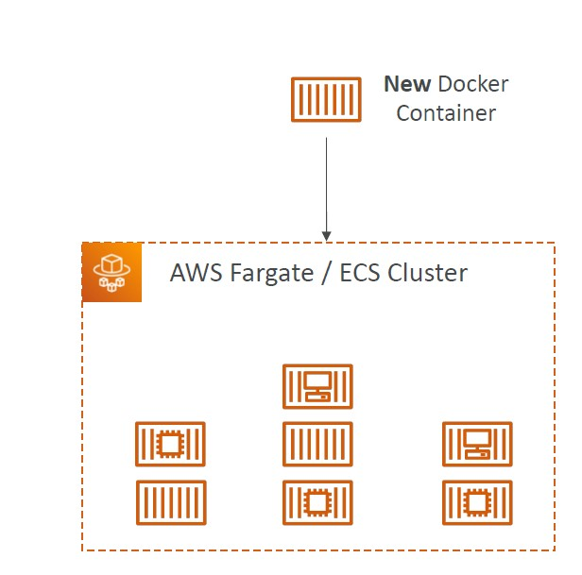

Amazon ECS – IAM Roles for ECS

-EC2 Instance Profile (EC2 Launch Type only):

• Used by the ECS agent

• Makes API calls to ECS service

• Send container logs to CloudWatch Logs

• Pull Docker image from ECR

• Reference sensitive data in Secrets Manager or SSM Parameter Store

-ECS Task Role:

• Allows each task to have a specific role

• Use different roles for the different ECS Services you run

• Task Role is defined in the task definition

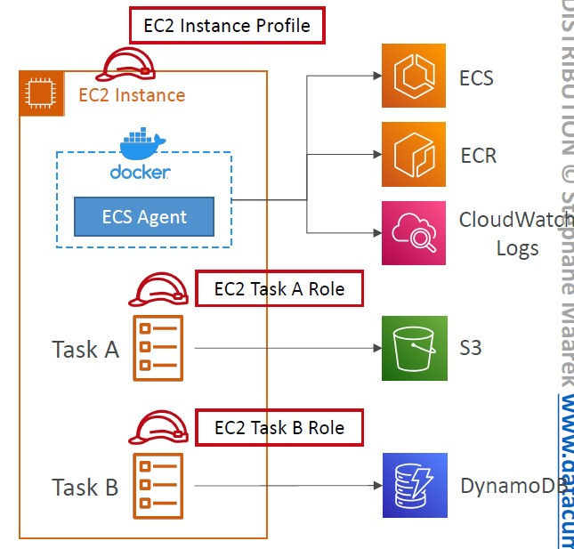

Amazon ECS – Load Balancer Integrations

• Application Load Balancer supported and works for most use cases

• Network Load Balancer recommended only for high throughput / high performance use cases, or to pair it with AWS Private Link

• Elastic Load Balancer supported but not recommended (no advanced features – no Fargate)

Amazon ECS – Data Volumes (EFS)

• Mount EFS file systems onto ECS tasks

• Works for both EC2 and Fargate launch types

• Tasks running in any AZ will share the same data in the EFS file system

• Fargate + EFS = Serverless

• Use cases: persistent multi-AZ shared storage for your containers

• Note:

• Amazon S3 cannot be mounted as a file system

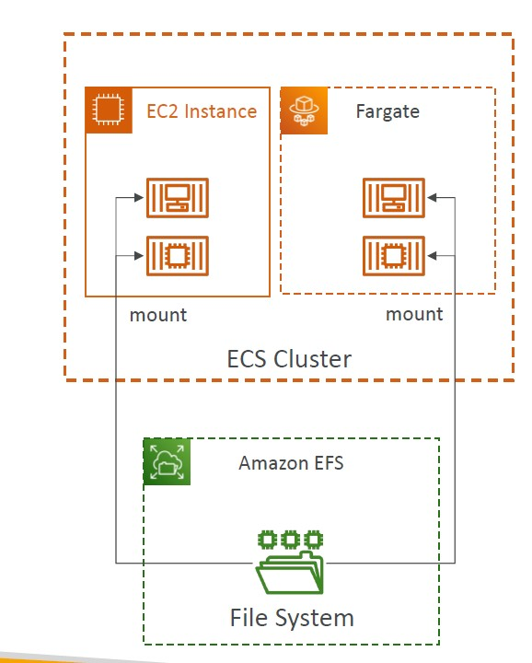

ECS Service Auto Scaling

• Automatically increase/decrease the desired number of ECS tasks

• Amazon ECS Auto Scaling uses AWS Application Auto Scaling

• ECS Service Average CPU Utilization

• ECS Service Average Memory Utilization - Scale on RAM

• ALB Request Count Per Target – metric coming from the ALB

• Target Tracking – scale based on target value for a specific CloudWatch metric

• Step Scaling – scale based on a specified CloudWatch Alarm

• Scheduled Scaling – scale based on a specified date/time (predictable changes)

• ECS Service Auto Scaling (task level) ≠ EC2 Auto Scaling (EC2 instance level)

• Fargate Auto Scaling is much easier to setup (because Serverless)

*Amazon ECS Anywhere is a feature of Amazon ECS that enables you to run and manage container-based applications on-premises, including on your own virtual machines (VMs) and bare metal servers.

EC2 Launch Type – Auto Scaling EC2 Instances

• Accommodate ECS Service Scaling by adding underlying EC2 Instances

-Auto Scaling Group Scaling

• Scale your ASG based on CPU Utilization

• Add EC2 instances over time

- ECS Cluster Capacity Provider

• Used to automatically provision and scale the infrastructure for your ECS Tasks

• Capacity Provider paired with an Auto Scaling Group

• Add EC2 Instances when you’re missing capacity (CPU, RAM…)

ECS tasks invoked by Event Bridge

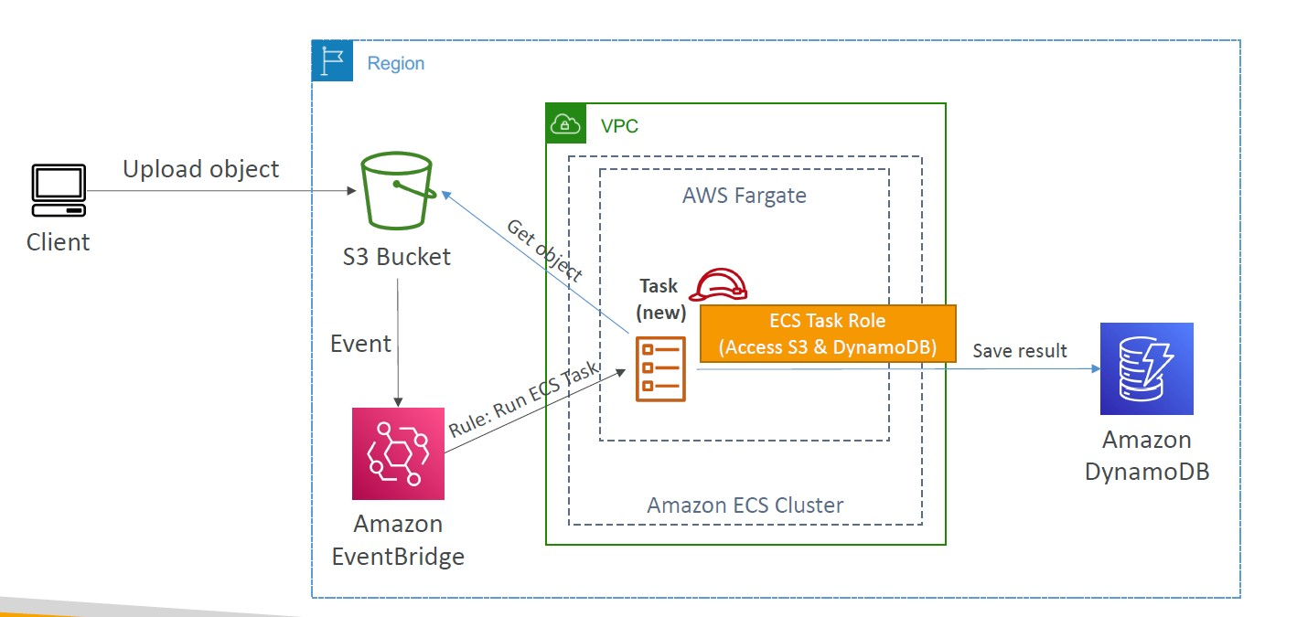

ECS tasks invoked by Event Bridge Schedule

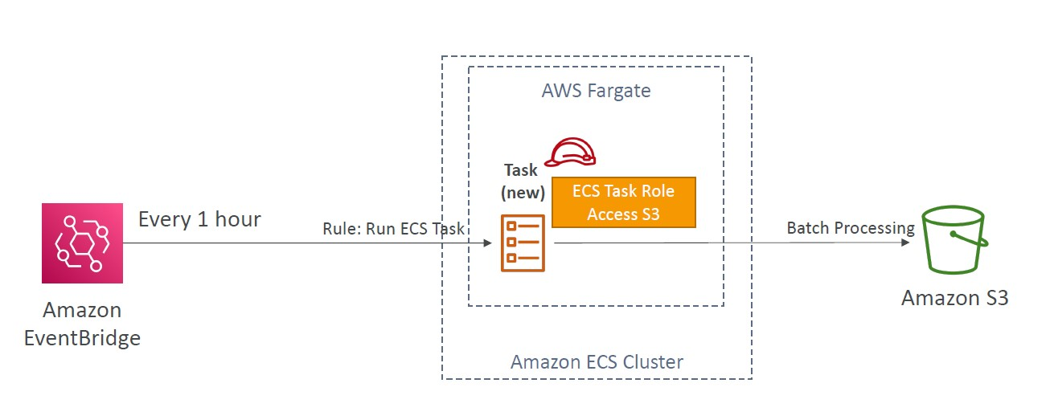

ECS – SQS Queue Example

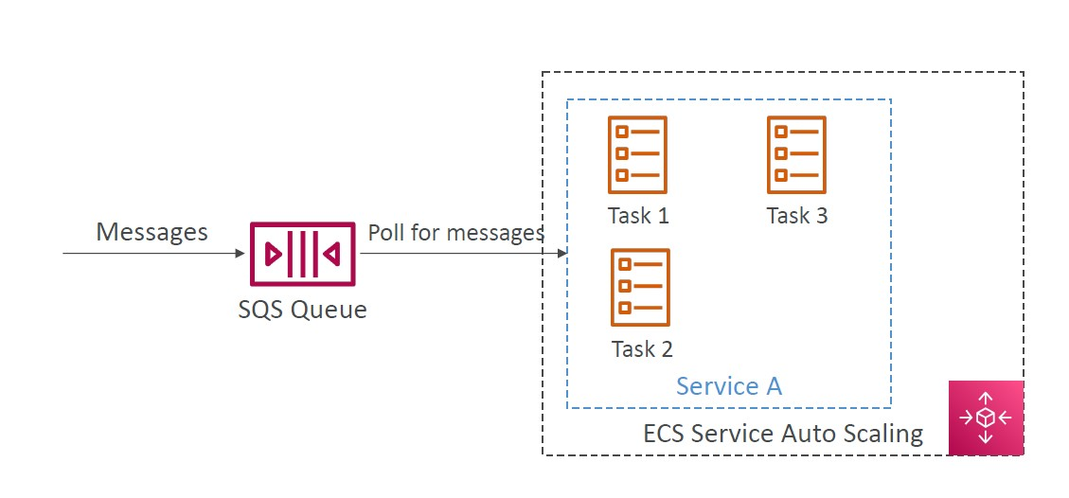

Amazon ECR

• ECR = Elastic Container Registry

• Store and manage Docker images on AWS

• Private and Public repository (Amazon ECR Public Gallery https://gallery.ecr.aws)

• Fully integrated with ECS, backed by Amazon S3

• Access is controlled through IAM (permission errors => policy)

• Supports image vulnerability scanning, versioning, image tags, image lifecycle, …

Amazon EKS Overview

• Amazon EKS = Amazon Elastic Kubernetes Service

• It is a way to launch managed Kubernetes clusters on AWS

• Kubernetes is an open-source system for automatic deployment, scaling and management of containerized (usually Docker) application

• It’s an alternative to ECS, similar goal but different API

• EKS supports EC2 if you want to deploy worker nodes or Fargate to deploy serverless containers

• Use case: if your company is already using Kubernetes on-premises or in another cloud, and wants to migrate to AWS using Kubernetes

• Kubernetes is cloud-agnostic (can be used in any cloud – Azure, GCP…)

• For multiple regions, deploy one EKS cluster per region

• Collect logs and metrics using CloudWatch Container Insights

Amazon EKS – Diagram

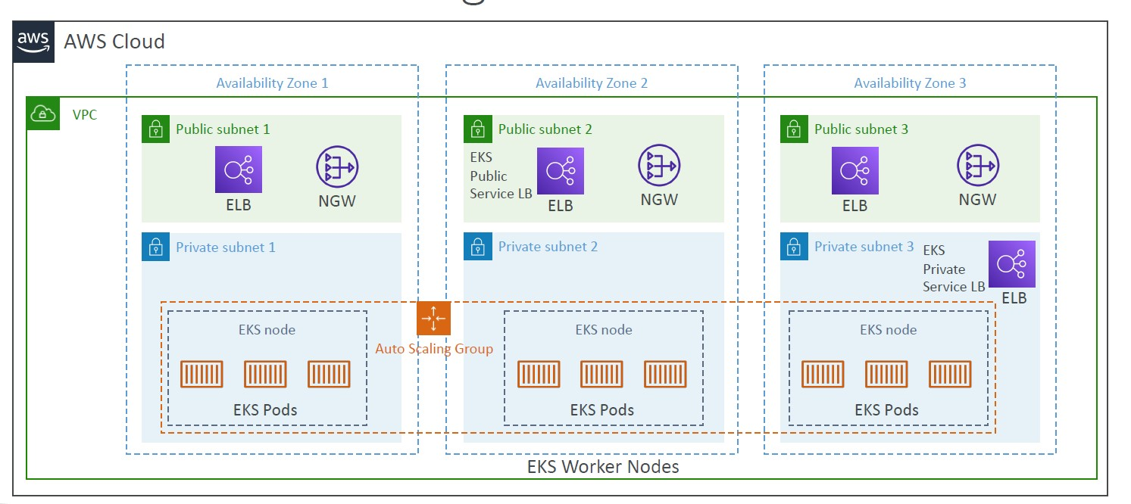

Amazon EKS – Node Types

- Managed Node Groups

• Creates and manages Nodes (EC2 instances) for you

• Nodes are part of an ASG managed by EKS

• Supports On-Demand or Spot Instances

- Self-Managed Nodes

• Nodes created by you and registered to the EKS cluster and managed by an ASG

• You can use prebuilt AMI - Amazon EKS Optimized AMI

• Supports On-Demand or Spot Instances

- AWS Fargate

• No maintenance required; no nodes managed

Amazon EKS – Data Volumes

• Need to specify StorageClass manifest on your EKS cluster

• Leverages a Container Storage Interface (CSI) compliant driver

• Support for…

• Amazon EBS

• Amazon EFS (works with Fargate)

• Amazon FSx for Lustre

• Amazon FSx for NetApp ONTAP

*kube-proxy

kube-proxy is a network proxy that runs on each node in a Kubernetes cluster. The role of kube-proxy is to reflect the services defined in the cluster and manage the networking rules on a node to allow communications to the pods that back a service.This add-on is included with every EKS cluster by default.

*CoreDNS (coredns)

CoreDNS provides DNS services within EKS Kubernetes clusters. DNS allows individual containers to easily discover and connect to other containers within the cluster.This add-on is included with every EKS cluster by default.

*Amazon VPC CNI plugin (vpc-cni)

Amazon EKS supports native VPC networking with the Amazon VPC Container Network Interface (CNI) plugin for Kubernetes. Using this plugin allows Kubernetes pods to have the same IP address inside the pod as they do on the VPC network.

AWS App Runner

• Fully managed service that makes it easy to deploy web applications and APIs at scale

• No infrastructure experience required

• Start with your source code or container image

• Automatically builds and deploy the web app

• Automatic scaling, highly available, load balancer, encryption

• VPC access support

• Connect to database, cache, and message queue services

• Use cases: web apps, APIs, micro services, rapid production deployments

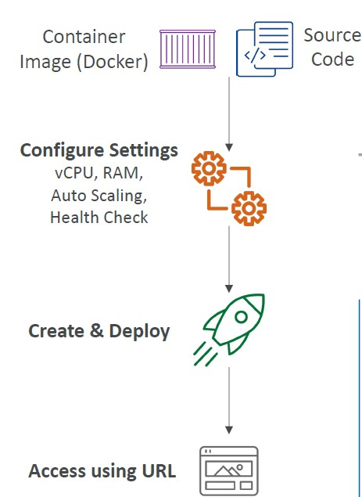

Serverless in AWS

• AWS Lambda

• DynamoDB

• AWS Cognito

• AWS API Gateway

• Amazon S3

• AWS SNS & SQS

• AWS Kinesis Data Firehose

• Aurora Serverless

• Step Functions

• Fargate

AWS Lambda

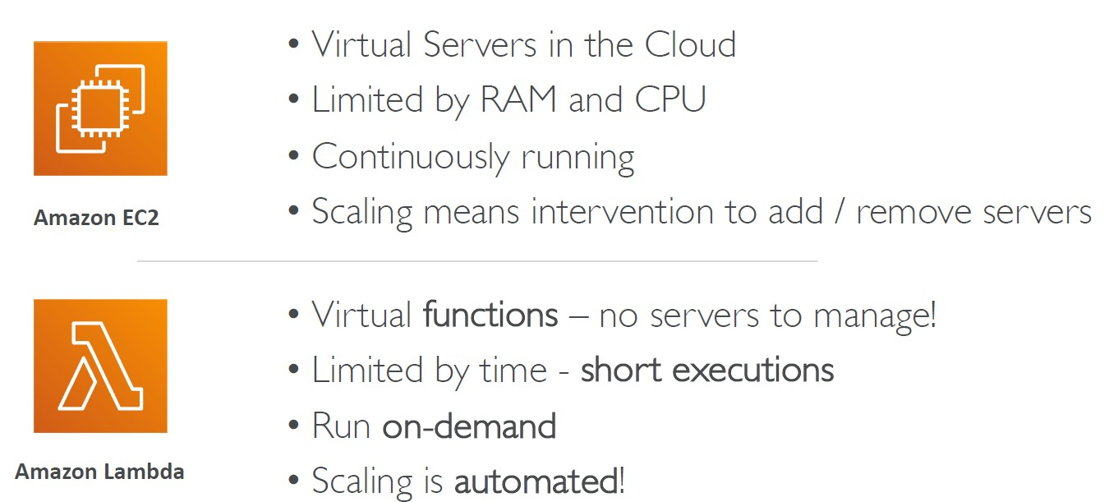

Benefits of AWS Lambda

• Easy Pricing:

• Pay per request and compute time

• Free tier of 1,000,000 AWS Lambda requests and 400,000 GBs of compute time

• Integrated with the whole AWS suite of services

• Integrated with many programming languages

• Easy monitoring through AWS CloudWatch

• Easy to get more resources per functions (up to 10GB of RAM!)

• Increasing RAM will also improve CPU and network

AWS Lambda language support

• Node.js (JavaScript)

• Python

• Java (Java 8 compatible)

• C# (.NET Core)

• Golang

• C# / Powershell

• Ruby

• Custom Runtime API (community supported, example Rust)

- Lambda Container Image

• The container image must implement the Lambda Runtime API

• ECS / Fargate is preferred for running arbitrary Docker images

AWS Lambda Integrations

Main ones

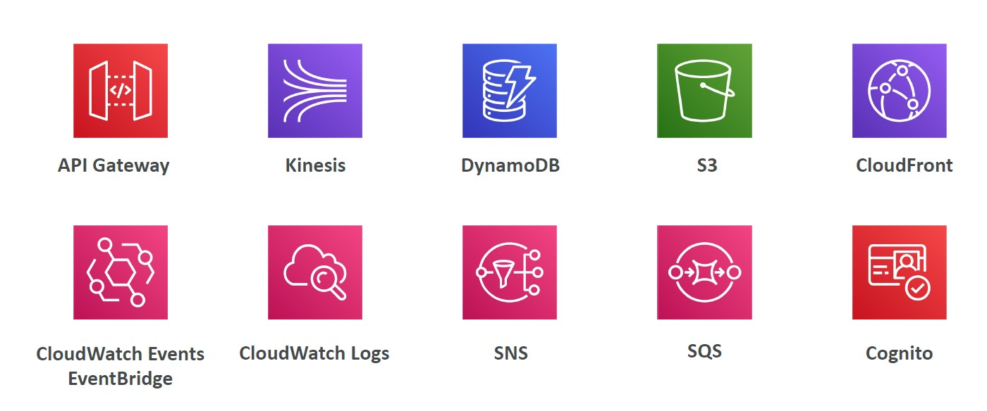

Example: Serverless Thumbnail creation

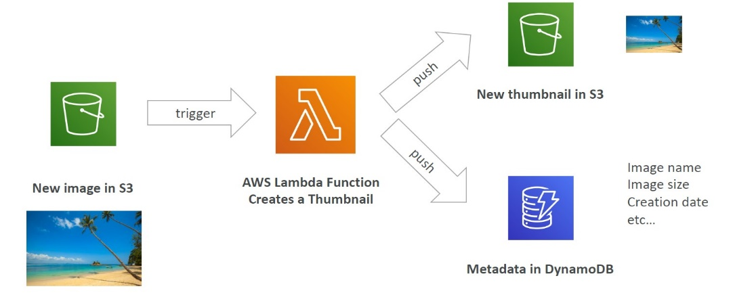

Example: Serverless CRON Job

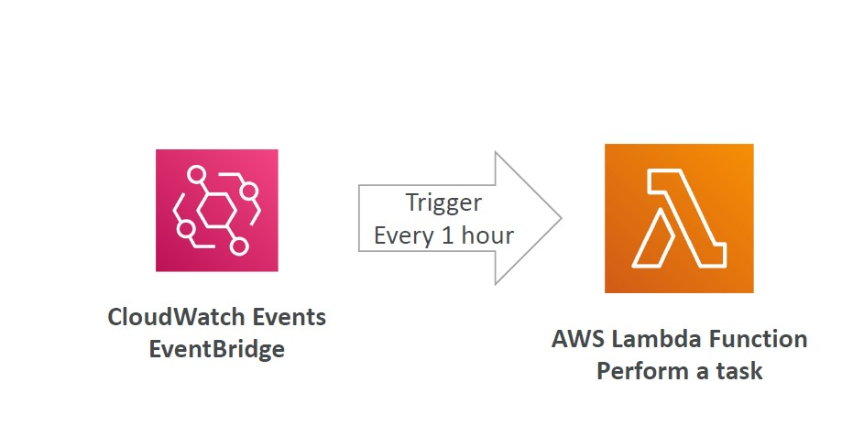

AWS Lambda Pricing: example

• You can find overall pricing information here: https://aws.amazon.com/lambda/pricing/

-Pay per calls:

• First 1,000,000 requests are free

• $0.20 per 1 million requests thereafter ($0.0000002 per request)

-Pay per duration: (in increment of 1 ms)

• 400,000 GB-seconds of compute time per month for FREE

• == 400,000 seconds if function is 1GB RAM

• == 3,200,000 seconds if function is 128 MB RAM

• After that $1.00 for 600,000 GB-seconds

-It is usually very cheap to run AWS Lambda so it’s very popular

AWS Lambda Limits to Know - per region

- Execution:

• Memory allocation: 128 MB – 10GB (1 MB increments)

• Maximum execution time: 900 seconds (15 minutes)

• Environment variables (4 KB)

• Disk capacity in the “function container” (in /tmp): 512 MB to 10GB

• Concurrency executions: 1000 (can be increased)

- Deployment:

• Lambda function deployment size (compressed .zip): 50 MB

• Size of uncompressed deployment (code + dependencies): 250 MB

• Can use the /tmp directory to load other files at startup

• Size of environment variables: 4 KB

Customization At The Edge

• Many modern applications execute some form of the logic at the edge

• Edge Function:

• A code that you write and attach to CloudFront distributions

• Runs close to your users to minimize latency

• CloudFront provides two types: CloudFront Functions & Lambda@Edge

• You don’t have to manage any servers, deployed globally

• Use case: customize the CDN content

• Pay only for what you use

• Fully serverless

CloudFront Functions & Lambda@Edge

Use Cases

• Website Security and Privacy

• Dynamic Web Application at the Edge

• Search Engine Optimization (SEO)

• Intelligently Route Across Origins and Data Centers

• Bot Mitigation at the Edge

• Real-time Image Transformation

• A/B Testing

• User Authentication and Authorization

• User Prioritization

• User Tracking and Analytics

CloudFront Functions

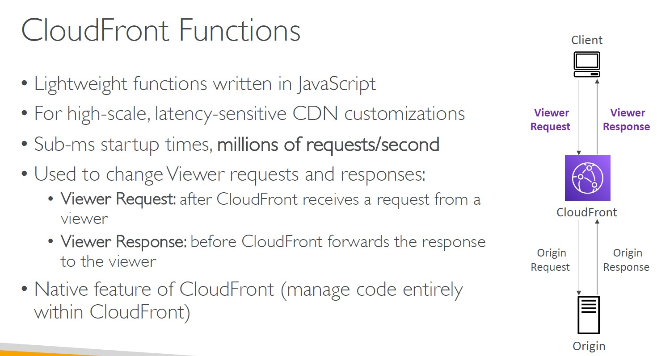

Lambda@Edge

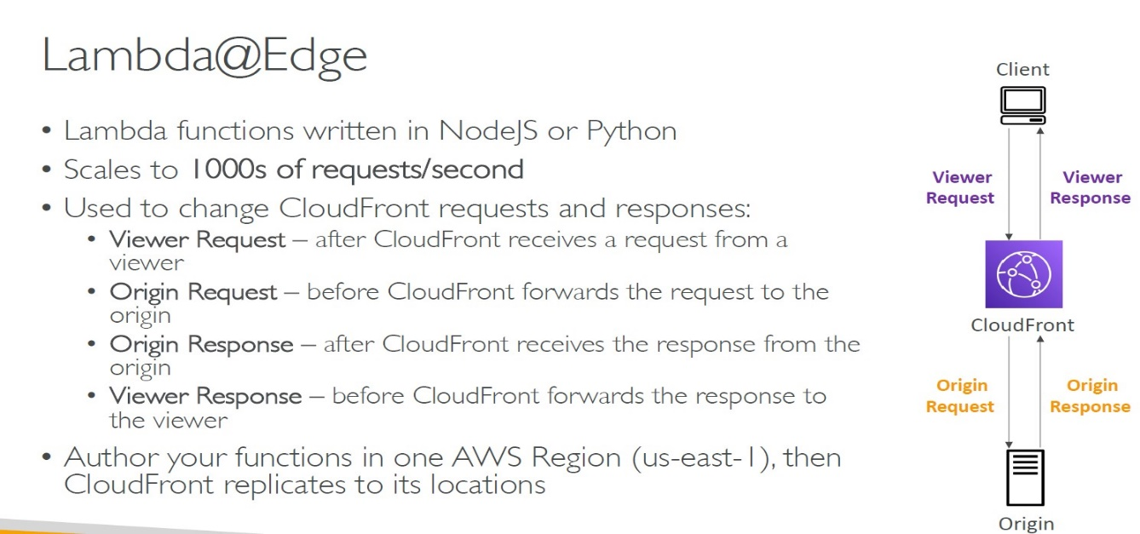

CloudFront Functions vs. Lambda@Edge

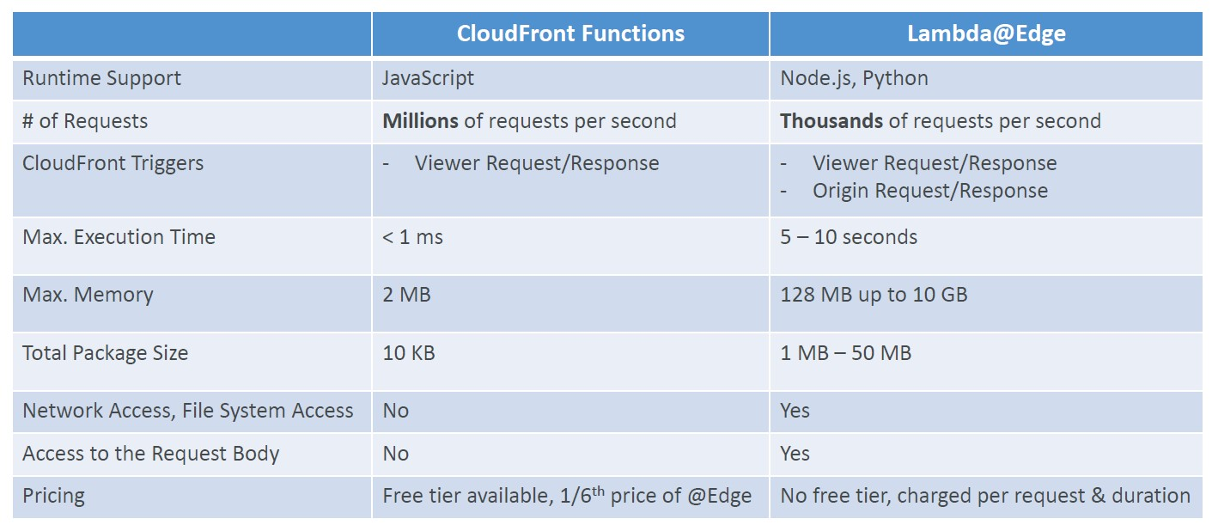

CloudFront Functions vs. Lambda@Edge - Use Cases

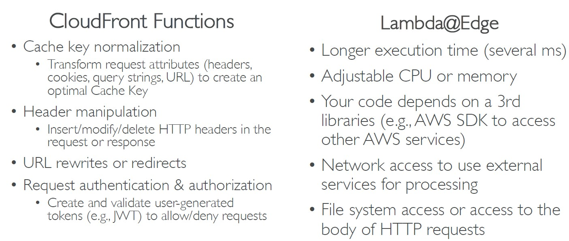

Lambda by default

• By default, your Lambda function is launched outside your own VPC (in an AWS-owned VPC)

• Therefore, it cannot access resources in your VPC (RDS, ElastiCache, internal ELB…)

Lambda in VPC

• You must define the VPC ID, the Subnets and the Security Groups

• Lambda will create an ENI (Elastic Network Interface) in your subnets

Lambda with RDS Proxy

• If Lambda functions directly access your database, they may open too many connections under high load

- RDS Proxy

• Improve scalability by pooling and sharing DB connections

• Improve availability by reducing by 66% the failover time and preserving connections

• Improve security by enforcing IAM authentication and storing credentials in Secrets Manager

- The Lambda function must be deployed in your VPC, because RDS Proxy is never publicly accessible

Amazon DynamoDB

• Fully managed, highly available with replication across multiple AZs

• NoSQL database - not a relational database - with transaction support

• Scales to massive workloads, distributed database

• Millions of requests per seconds, trillions of row, 100s of TB of storage

• Fast and consistent in performance (single-digit millisecond)

• Integrated with IAM for security, authorization and administration

• Low cost and auto-scaling capabilities

• No maintenance or patching, always available

• Standard & Infrequent Access (IA) Table Class

DynamoDB - Basics

• DynamoDB is made of Tables

• Each table has a Primary Key (must be decided at creation time)

-DynamoDB supports two different kinds of primary keys:

1-Partition key – A simple primary key, composed of one attribute known as the partition key.

2-Partition key and sort key – Referred to as a composite primary key, this type of key is composed of two attributes. The first attribute is the partition key, and the second attribute is the sort key.

• Each table can have an infinite number of items (= rows)

• Each item has attributes (can be added over time – can be null)

• Maximum size of an item is 400KB

• Data types supported are:

• Scalar Types – String, Number, Binary, Boolean, Null

• Document Types – List, Map

• Set Types – String Set, Number Set, Binary Set

• Therefore, in DynamoDB you can rapidly evolve schemas

DynamoDB – Read/Write Capacity Modes

• Control how you manage your table’s capacity (read/write throughput)

- Provisioned Mode (default)

• You specify the number of reads/writes per second

• You need to plan capacity beforehand

• Pay for provisioned Read Capacity Units (RCU) & Write Capacity Units (WCU)

• Possibility to add auto-scaling mode for RCU & WCU

- On-Demand Mode

• Read/writes automatically scale up/down with your workloads

• No capacity planning needed

• Pay for what you use, more expensive ($$$)

• Great for unpredictable workloads, steep sudden spikes

DynamoDB Accelerator (DAX)

• Fully-managed, highly available, seamless inmemory cache for DynamoDB

• Help solve read congestion by caching

• Microseconds latency for cached data

• Doesn’t require application logic modification (compatible with existing DynamoDB APIs)

• 5 minutes TTL for cache (default)

DynamoDB – Stream Processing

• Ordered stream of item-level modifications (create/update/delete) in a table

- Use cases:

• React to changes in real-time (welcome email to users)

• Real-time usage analytics

• Insert into derivative tables

• Implement cross-region replication

• Invoke AWS Lambda on changes to your DynamoDB table

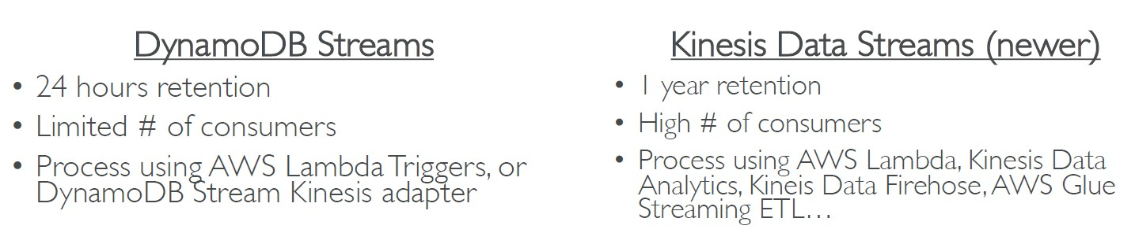

DynamoDB Global Tables

• Make a DynamoDB table accessible with low latency in multiple-regions

• Active-Active replication

• Applications can READ and WRITE to the table in any region

• Must enable DynamoDB Streams as a pre-requisite

DynamoDB – Time To Live (TTL)

• Automatically delete items after an expiry timestamp

• Use cases: reduce stored data by keeping only current items, adhere to regulatory obligations, web session handling…

DynamoDB – Backups for disaster recovery

- Continuous backups using point-in-time recovery (PITR)

• Optionally enabled for the last 35 days

• Point-in-time recovery to any time within the backup window

• The recovery process creates a new table

-On-demand backups

• Full backups for long-term retention, until explicitely deleted

• Doesn’t affect performance or latency

• Can be configured and managed in AWS Backup (enables cross-region copy)

• The recovery process creates a new table

DynamoDB – Integration with Amazon S3

- Export to S3 (must enable PITR)

• Works for any point of time in the last 35 days

• Doesn’t affect the read capacity of your table

• Perform data analysis on top of DynamoDB

• Retain snapshots for auditing

• ETL on top of S3 data before importing back into DynamoDB

• Export in DynamoDB JSON or ION format

- Import from S3

• Import CSV, DynamoDB JSON or ION format

• Doesn’t consume any write capacity

• Creates a new table

• Import errors are logged in CloudWatch Logs

AWS API Gateway

• AWS Lambda + API Gateway: No infrastructure to manage

• Support for the WebSocket Protocol

• Handle API versioning (v1, v2…)

• Handle different environments (dev, test, prod…)

• Handle security (Authentication and Authorization)

• Create API keys, handle request throttling

• Swagger / Open API import to quickly define APIs

• Transform and validate requests and responses

• Generate SDK and API specifications

• Cache API responses

API Gateway – Integrations High Level

• Lambda Function

• Invoke Lambda function

• Easy way to expose REST API backed by AWS Lambda

• HTTP

• Expose HTTP endpoints in the backend

• Example: internal HTTP API on premise, Application Load Balancer…

• Why? Add rate limiting, caching, user authentications, API keys, etc…

• AWS Service

• Expose any AWS API through the API Gateway

• Example: start an AWS Step Function workflow, post a message to SQS

• Why? Add authentication, deploy publicly, rate control…

API Gateway – AWS Service Integration

Kinesis Data Streams example

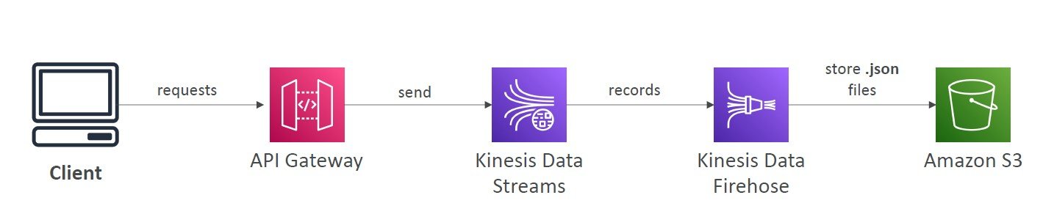

API Gateway - Endpoint Types

- Edge-Optimized (default): For global clients

• Requests are routed through the CloudFront Edge locations (improves latency)

• The API Gateway still lives in only one region

- Regional:

• For clients within the same region

• Could manually combine with CloudFront (more control over the caching strategies and the distribution)

- Private:

• Can only be accessed from your VPC using an interface VPC endpoint (ENI)

• Use a resource policy to define access

API Gateway – Security

- User Authentication through

• IAM Roles (useful for internal applications)

• Cognito (identity for external users – example mobile users)

• Custom Authorizer (your own logic)

- Custom Domain Name HTTPS security through integration with AWS Certificate Manager (ACM)

• If using Edge-Optimized endpoint, then the certificate must be in us-east-1

• If using Regional endpoint, the certificate must be in the API Gateway region

• Must setup CNAME or A-alias record in Route 53

AWS Step Functions

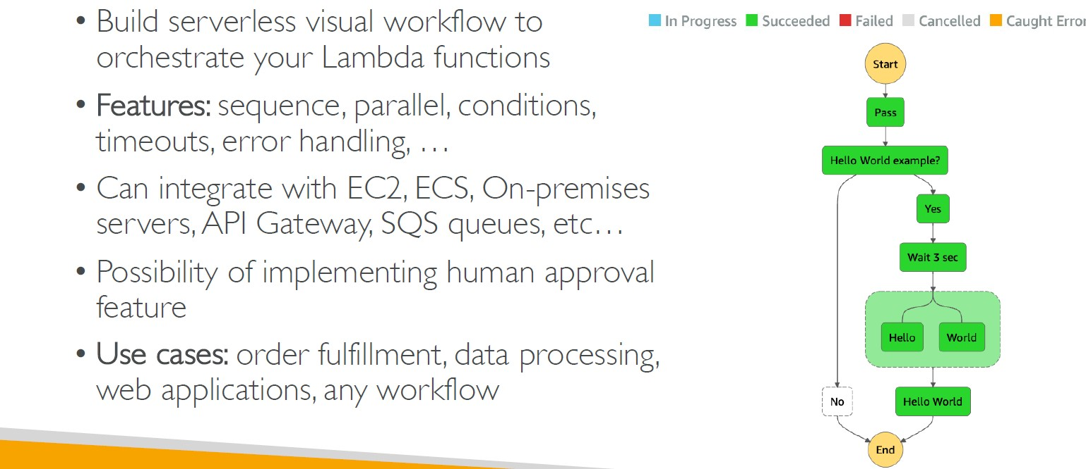

*-AWS provides AWS Security Token Service (AWS STS) as a web service that enables you to request temporary, limited-privilege credentials for AWS Identity and Access Management (IAM) users or for users you authenticate (federated users). By default, AWS Security Token Service (AWS STS) is available as a global service, and all AWS STS requests go to a single endpoint at https://sts.amazonaws.com. Global requests map to the US East (N. Virginia) Region. AWS recommends using Regional AWS STS endpoints instead of the global endpoint to reduce latency

-OLAP (Online analytical processing) is a system for performing multi-dimensional analysis at high speeds on large volumes of data. Typically, this data is from a data warehouse, data mart or some other centralized data store. OLAP is ideal for data mining, business intelligence and complex analytical calculations, as well as business reporting functions like financial analysis, budgeting and sales forecasting

The core of most OLAP databases is the OLAP cube, which allows you to quickly query, report on and analyze multidimensional data. What’s a data dimension? It’s simply one element of a particular dataset. For example, sales figures might have several dimensions related to region, time of year, product models and more.

The OLAP cube extends the row-by-column format of a traditional relational database schema and adds layers for other data dimensions. For example, while the top layer of the cube might organize sales by region, data analysts can also “drill-down” into layers for sales by state/province, city and/or specific stores. This historical, aggregated data for OLAP is usually stored in a star schema or snowflake schema.

The following graphic shows the OLAP cube for sales data in multiple dimensions — by region, by quarter and by product:

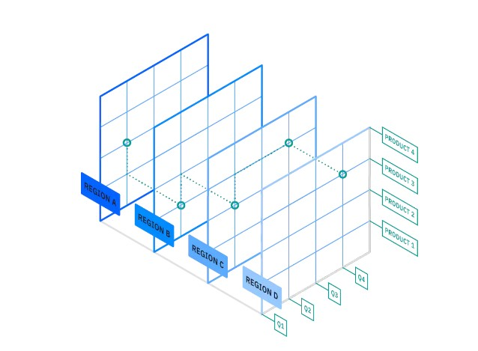

-OLTP (Online transactional processing) enables the real-time execution of large numbers of database transactions by large numbers of people, typically over the Internet. OLTP systems are behind many of our everyday transactions, from ATMs to in-store purchases to hotel reservations. OLTP can also drive non-financial transactions, including password changes and text messages.

OLTP systems use a relational database that can do the following:

Process a large number of relatively simple transactions — usually insertions, updates and deletions to data.

Enable multi-user access to the same data, while ensuring data integrity.

Support very rapid processing, with response times measured in milliseconds.

Provide indexed data sets for rapid searching, retrieval and querying.

Be available 24/7/365, with constant incremental backups.

Many organizations use OLTP systems to provide data for OLAP. In other words, a combination of both OLTP and OLAP are essential in our data-driven world.

Database Types

• RDBMS (= SQL / OLTP): RDS, Aurora – great for joins

• NoSQL database – no joins, no SQL : DynamoDB (~JSON), ElastiCache (key /value pairs), Neptune (graphs), DocumentDB (for MongoDB), Keyspaces (for Apache Cassandra)

• Object Store: S3 (for big objects) / Glacier (for backups / archives)

• Data Warehouse (= SQL Analytics / BI): Redshift (OLAP), Athena, EMR

• Search: OpenSearch (JSON) – free text, unstructured searches

• Graphs: Amazon Neptune – displays relationships between data

• Ledger: Amazon Quantum Ledger Database

• Time series: Amazon Timestream

Amazon RDS – Summary

• Managed PostgreSQL / MySQL / Oracle / SQL Server / MariaDB / Custom

• Provisioned RDS Instance Size and EBS Volume Type & Size

• Auto-scaling capability for Storage

• Support for Read Replicas and Multi AZ

• Security through IAM, Security Groups, KMS , SSL in transit

• Automated Backup with Point in time restore feature (up to 35 days)

• Manual DB Snapshot for longer-term recovery

• Managed and Scheduled maintenance (with downtime)

• Support for IAM Authentication, integration with Secrets Manager

• RDS Custom for access to and customize the underlying instance (Oracle & SQL Server)

• Use case: Store relational datasets (RDBMS / OLTP), perform SQL queries, transactions

Amazon Aurora – Summary

• Compatible API for PostgreSQL / MySQL, separation of storage and compute

• Storage: data is stored in 6 replicas, across 3 AZ – highly available, self-healing, auto-scaling

• Compute: Cluster of DB Instance across multiple AZ, auto-scaling of Read Replicas

• Cluster: Custom endpoints for writer and reader DB instances

• Same security / monitoring / maintenance features as RDS

• Know the backup & restore options for Aurora

• Aurora Serverless – for unpredictable / intermittent workloads, no capacity planning

• Aurora Multi-Master – for continuous writes failover (high write availability)

• Aurora Global: up to 16 DB Read Instances in each region, < 1 second storage replication

• Aurora Machine Learning: perform ML using SageMaker & Comprehend on Aurora

• Aurora Database Cloning: new cluster from existing one, faster than restoring a snapshot

• Use case: same as RDS, but with less maintenance / more flexibility / more performance / more features

Amazon ElastiCache – Summary

• Managed Redis / Memcached (similar offering as RDS, but for caches)

• In-memory data store, sub-millisecond latency

• Must provision an EC2 instance type

• Support for Clustering (Redis) and Multi AZ, Read Replicas (sharding)

• Security through IAM, Security Groups, KMS, Redis Auth

• Backup / Snapshot / Point in time restore feature

• Managed and Scheduled maintenance

• Requires some application code changes to be leveraged

• Use Case: Key/Value store, Frequent reads, less writes, cache results for DB queries, store session data for websites, cannot use SQL.

Amazon DynamoDB – Summary

• AWS proprietary technology, managed serverless NoSQL database, millisecond latency

• Capacity modes: provisioned capacity with optional auto-scaling or on-demand capacity

• Can replace ElastiCache as a key/value store (storing session data for example, using TTL feature)

• Highly Available, Multi AZ by default, Read and Writes are decoupled, transaction capability

• DAX cluster for read cache, microsecond read latency

• Security, authentication and authorization is done through IAM

• Event Processing: DynamoDB Streams to integrate with AWS Lambda, or Kinesis Data Streams

• Global Table feature: active-active setup

• Automated backups up to 35 days with PITR (restore to new table), or on-demand backups

• Export to S3 without using RCU within the PITR window, import from S3 without using WCU

• Great to rapidly evolve schemas

• Use Case: Serverless applications development (small documents 100s KB), distributed serverless cache, doesn’t have SQL query language available

Amazon S3 – Summary

• S3 is a… key / value store for objects

• Great for bigger objects, not so great for many small objects

• Serverless, scales infinitely, max object size is 5 TB, versioning capability

• Tiers: S3 Standard, S3 Infrequent Access, S3 Intelligent, S3 Glacier + lifecycle policy

• Features: Versioning, Encryption, Replication, MFA-Delete, Access Logs…

• Security: IAM, Bucket Policies, ACL, Access Points, Object Lambda, CORS, Object/Vault Lock

• Encryption: SSE-S3, SSE-KMS, SSE-C, client-side, TLS in transit, default encryption

• Batch operations on objects using S3 Batch, listing files using S3 Inventory

• Performance: Multi-part upload, S3 Transfer Acceleration, S3 Select

• Automation: S3 Event Notifications (SNS, SQS, Lambda, EventBridge)

• Use Cases: static files, key value store for big files, website hosting

DocumentDB

• Aurora is an “AWS-implementation” of PostgreSQL / MySQL …

• DocumentDB is the same for MongoDB (which is a NoSQL database)

• MongoDB is used to store, query, and index JSON data

• Similar “deployment concepts” as Aurora

• Fully Managed, highly available with replication across 3 AZ

• DocumentDB storage automatically grows in increments of 10GB, up to 64 TB.

• Automatically scales to workloads with millions of requests per seconds

Amazon Neptune

• Fully managed graph database

• A popular graph dataset would be a social network:

Users have friends, Posts have comments, Comments have likes from users, Users share and like posts…

• Highly available across 3 AZ, with up to 15 read replicas

• Build and run applications working with highly connected datasets – optimized for these complex and hard queries

• Can store up to billions of relations and query the graph with milliseconds latency

• Highly available with replications across multiple AZs

• Great for knowledge graphs (Wikipedia), fraud detection,recommendation engines, social networking

Amazon Keyspaces (for Apache Cassandra)

• Apache Cassandra is an open-source NoSQL distributed database

• A managed Apache Cassandra-compatible database service

• Serverless, Scalable, highly available, fully managed by AWS

• Automatically scale tables up/down based on the application’s traffic

• Tables are replicated 3 times across multiple AZ

• Using the Cassandra Query Language (CQL)

• Single-digit millisecond latency at any scale, 1000s of requests per second

• Capacity: On-demand mode or provisioned mode with auto-scaling

• Encryption, backup, Point-In-Time Recovery (PITR) up to 35 days

• Use cases: store IoT devices info, time-series data, …

Amazon QLDB

• QLDB stands for ”Quantum Ledger Database”

• A ledger is a book recording financial transactions

• Fully Managed, Serverless, High available, Replication across 3 AZ

• Used to review history of all the changes made to your application data over time

• Immutable system: no entry can be removed or modified, cryptographically verifiable

• 2-3x better performance than common ledger blockchain frameworks, manipulate data using SQL

• Difference with Amazon Managed Blockchain: no decentralization component, in accordance with

financial regulation rules

Amazon Timestream

• Fully managed, fast, scalable, serverless time series database

• Automatically scales up/down to adjust capacity

• Store and analyze trillions of events per day

• 1000s times faster & 1/10th the cost of relational databases

• Scheduled queries, multi-measure records, SQL compatibility

• Data storage tiering: recent data kept in memory and

historical data kept in a cost-optimized storage

• Built-in time series analytics functions (helps you identify

patterns in your data in near real-time)

• Encryption in transit and at rest

• Use cases: IoT apps, operational applications, real-time

analytics, …

Amazon Athena

• Serverless query service to analyze data stored in Amazon S3

• Uses standard SQL language to query the files (built on Presto)

• Supports CSV, JSON, ORC, Avro, and Parquet

• Pricing: $5.00 per TB of data scanned

• Commonly used with Amazon Quicksight for

reporting/dashboards

• Use cases: Business intelligence / analytics / reporting, analyze &

query VPC Flow Logs, ELB Logs, CloudTrail trails, etc...

• Exam Tip: analyze data in S3 using serverless SQL, use Athena

*S3 Select allows you to retrieve a subset of data from a single object in S3.

Athena allows you to define tables that represent many objects in S3 and perform aggregations, joins, etc. across tables.

Athena is the service with more features and capabilities, but that doesn't make it a better option if you only need the capabilities of S3 Select.

you could use Athena for the same use-case as S3 Select, but then you would have to create tables for each individual object. With S3 Select there are no tables to create, you just specify the object key in the API call. So for such a use case S3 Select would be quicker and less effort.

*S3 Select requirements and limitations:

You must have s3:GetObject permission for the object you are querying.

If the object you are querying is encrypted with a customer-provided encryption key (SSE-C), you must use https, and you must provide the encryption key in the request.

-The following limits apply when using Amazon S3 Select:

The maximum length of a SQL expression is 256 KB.

The maximum length of a record in the input or result is 1 MB.

Amazon S3 Select can only emit nested data using the JSON output format.

You cannot specify the S3 Glacier Flexible Retrieval, S3 Glacier Deep Archive, or REDUCED_REDUNDANCY storage classes.

-Additional limitations apply when using Amazon S3 Select with Parquet objects:

Amazon S3 Select supports only columnar compression using GZIP or Snappy. Amazon S3 Select doesn't support whole-object compression for Parquet objects.

Amazon S3 Select doesn't support Parquet output. You must specify the output format as CSV or JSON.

The maximum uncompressed row group size is 512 MB.

You must use the data types specified in the object's schema.

Selecting on a repeated field returns only the last value.

Amazon Athena – Performance Improvement

• Use columnar data for cost-savings (less scan)

• Apache Parquet or ORC is recommended

• Huge performance improvement

• Use Glue to convert your data your Parquet or ORC

• Compress data for smaller retrievals (bzip2, gzip, lz4, snappy, zlip, zstd…)

• Partition datasets in S3 for easy querying on virtual columns

• s3://yourBucket/pathToTable

/<PARTITION_COLUMN_NAME>=<VALUE>

/<PARTITION_COLUMN_NAME>=<VALUE>

/<PARTITION_COLUMN_NAME>=<VALUE>

• Example: s3://athena-examples/flight/parquet/year=1991/month=1/day=1/

• Use larger files (> 128 MB) to minimize overhead

Amazon Athena – Federated Query

• Allows you to run SQL queries across data stored in relational, non-relational, object, and custom data sources (AWS or on-premises)

• Uses Data Source Connectors that run on AWS Lambda to run Federated Queries (e.g., CloudWatch Logs, DynamoDB, RDS, …)

• Store the results back in Amazon S3

Redshift Overview

• Redshift is based on PostgreSQL, but it’s not used for OLTP

• It’s OLAP – online analytical processing (analytics and data warehousing)

• 10x better performance than other data warehouses, scale to PBs of data

• Columnar storage of data (instead of row based) & parallel query engine

• Pay as you go based on the instances provisioned

• Has a SQL interface for performing the queries

• BI tools such as Amazon Quicksight or Tableau integrate with it

• vs Athena: faster queries / joins / aggregations thanks to indexes

Redshift Cluster

• Leader node: for query planning, results aggregation

• Compute node: for performing the queries, send results to leader

• You provision the node size in advance

• You can used Reserved Instances for cost savings

Loading data into Redshift:

Large inserts are MUCH better

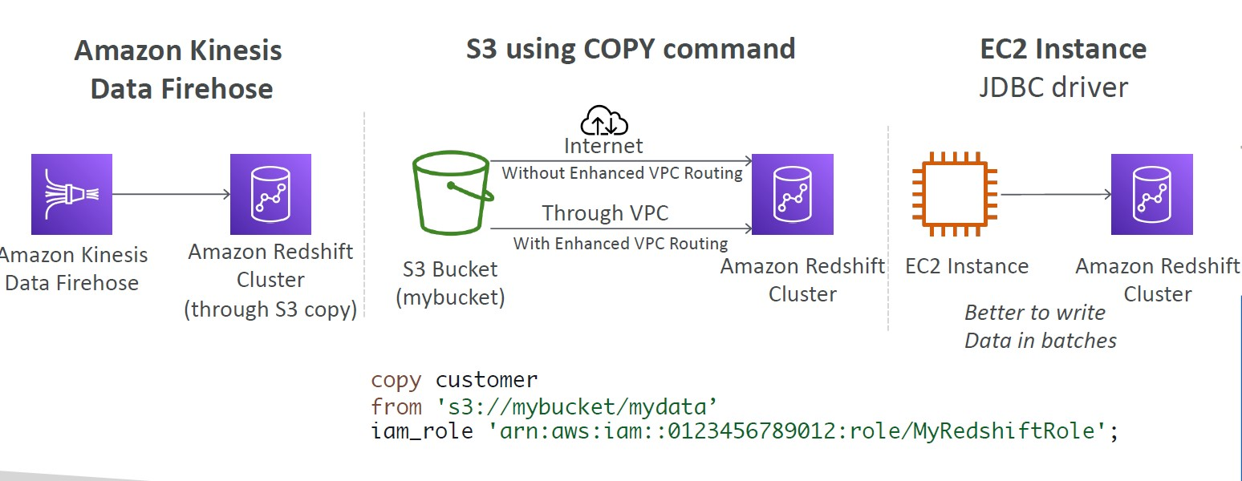

Redshift Spectrum

• Query data that is already in S3 without loading it

• Must have a Redshift cluster available to start the query

• The query is then submitted to thousands of Redshift Spectrum nodes

Amazon OpenSearch Service

• Amazon OpenSearch is successor to Amazon ElasticSearch

• In DynamoDB, queries only exist by primary key or indexes…

• With OpenSearch, you can search any field, even partially matches

• It’s common to use OpenSearch as a complement to another database

• OpenSearch requires a cluster of instances (not serverless)

• Does not support SQL (it has its own query language)

• Ingestion from Kinesis Data Firehose, AWS IoT, and CloudWatch Logs

• Security through Cognito & IAM, KMS encryption, TLS

• Comes with OpenSearch Dashboards (visualization)

Amazon EMR

• EMR stands for “Elastic MapReduce”

• EMR helps creating Hadoop clusters (Big Data) to analyze and process vast amount of data

• The clusters can be made of hundreds of EC2 instances

• EMR comes bundled with Apache Spark, HBase, Presto, Flink…

• EMR takes care of all the provisioning and configuration

• Auto-scaling and integrated with Spot instances

• Use cases: data processing, machine learning, web indexing, big data…

Amazon EMR – Node types & purchasing

• Master Node: Manage the cluster, coordinate, manage health – long running

• Core Node: Run tasks and store data – long running

• Task Node (optional): Just to run tasks – usually Spot

• Purchasing options:

• On-demand: reliable, predictable, won’t be terminated

• Reserved (min 1 year): cost savings (EMR will automatically use if available)

• Spot Instances: cheaper, can be terminated, less reliable

• Can have long-running cluster, or transient (temporary) cluster

Amazon QuickSight

• Serverless machine learning-powered business intelligence service to create interactive dashboards

• Fast, automatically scalable, embeddable, with per-session pricing

-Use cases:

• Business analytics

• Building visualizations

• Perform ad-hoc analysis

• Get business insights using data

• Integrated with RDS, Aurora, Athena, Redshift, S3…

• In-memory computation using SPICE engine if data is imported into QuickSight

• Enterprise edition: Possibility to setup Column-Level security (CLS)

QuickSight – Dashboard & Analysis

• Define Users (standard versions) and Groups (enterprise version)

• These users & groups only exist within QuickSight, not IAM

• A dashboard is a read-only snapshot of an analysis that you can share ,preserves the configuration of the analysis (filtering, parameters, controls, sort)

• You can share the analysis or the dashboard with Users or Groups

• To share a dashboard, you must first publish it

• Users who see the dashboard can also see the underlying data

AWS Glue

• Managed extract, transform, and load (ETL) service

• Useful to prepare and transform data for analytics

• Fully serverless service

Glue Data Catalog: catalog of datasets

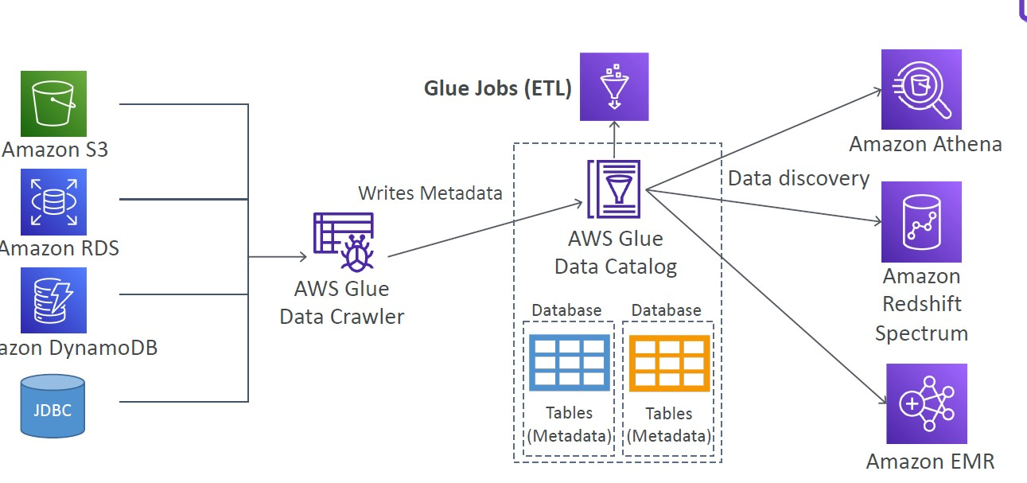

Glue – things to know at a high-level

• Glue Job Bookmarks: prevent re-processing old data

• Glue Elastic Views:

• Combine and replicate data across multiple data stores using SQL

• No custom code, Glue monitors for changes in the source data, serverless

• Leverages a “virtual table” (materialized view)

• Glue DataBrew: clean and normalize data using pre-built transformation

• Glue Studio: new GUI to create, run and monitor ETL jobs in Glue

• Glue Streaming ETL (built on Apache Spark Structured Streaming):

compatible with Kinesis Data Streaming, Kafka, MSK (managed Kafka)

AWS Lake Formation

• Data lake = central place to have all your data for analytics purposes

• Fully managed service that makes it easy to setup a data lake in days

• Discover, cleanse, transform, and ingest data into your Data Lake

• It automates many complex manual steps (collecting, cleansing, moving, cataloging data, …) and de-duplicate (using ML Transforms)

• Combine structured and unstructured data in the data lake

• Out-of-the-box source blueprints: S3, RDS, Relational & NoSQL DB…

• Fing-grained Access Control for your applications (row and column-level)

• Built on top of AWS Glue

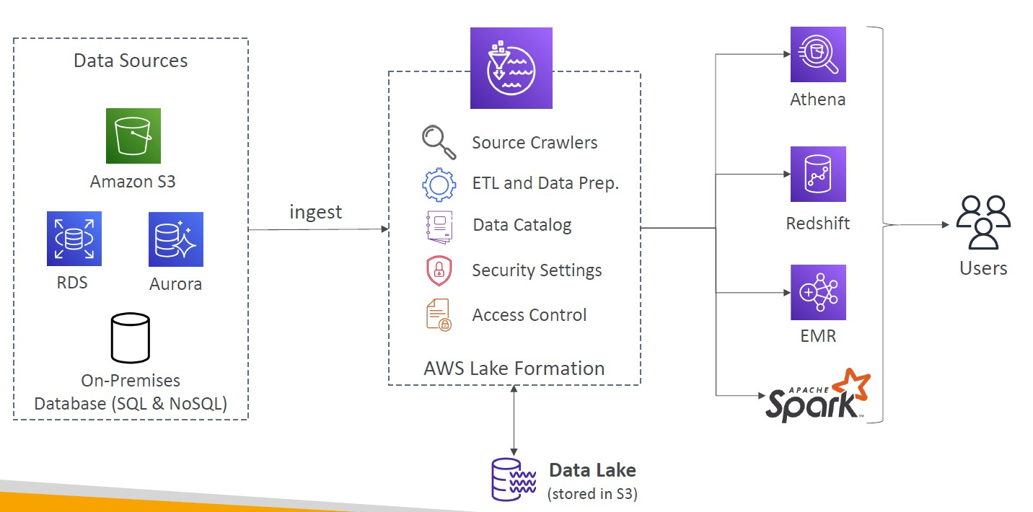

*A data lake contains all an organization's data in a raw, unstructured form, and can store the data indefinitely — for immediate or future use. A data warehouse contains structured data that has been cleaned and processed, ready for strategic analysis based on predefined business needs

AWS Lake Formation

Centralized Permissions Example

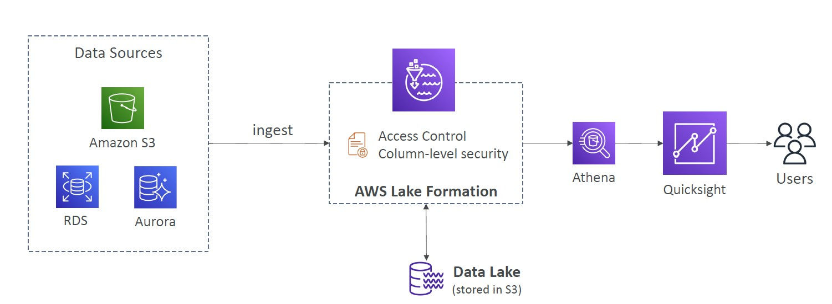

Kinesis Data Analytics for SQL applications

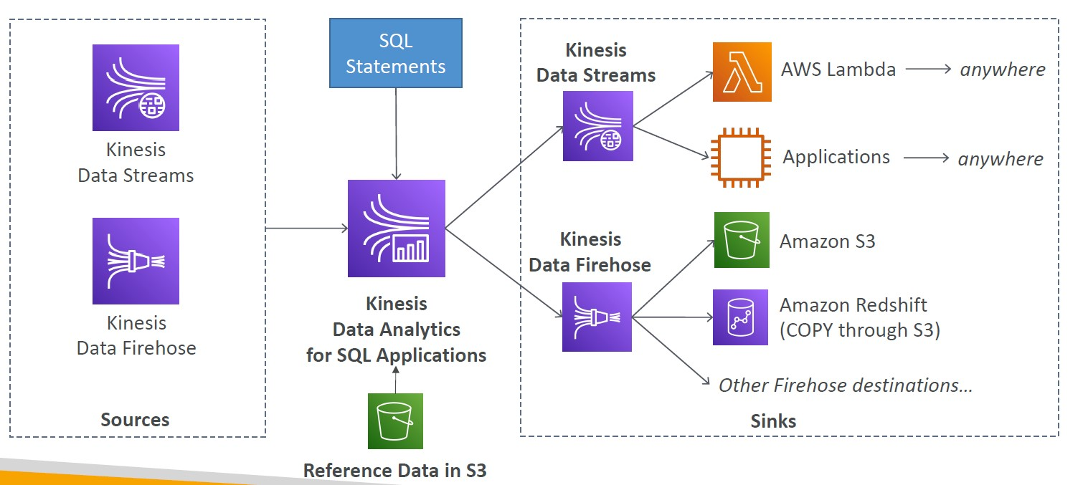

Kinesis Data Analytics (SQL application)

• Real-time analytics on Kinesis Data Streams & Firehose using SQL

• Add reference data from Amazon S3 to enrich streaming data

• Fully managed, no servers to provision

• Automatic scaling

• Pay for actual consumption rate

• Output:

• Kinesis Data Streams: create streams out of the real-time analytics queries

• Kinesis Data Firehose: send analytics query results to destinations

• Use cases:

• Time-series analytics

• Real-time dashboards

• Real-time metrics

Kinesis Data Analytics for Apache Flink

• Use Flink (Java, Scala or SQL) to process and analyze streaming data

• Run any Apache Flink application on a managed cluster on AWS

• provisioning compute resources, parallel computation, automatic scaling

• application backups (implemented as checkpoints and snapshots)

• Use any Apache Flink programming features

• Flink does not read from Firehose (use Kinesis Analytics for SQL instead)

Amazon Managed Streaming for Apache Kafka (Amazon MSK)

• Alternative to Amazon Kinesis

• Fully managed Apache Kafka on AWS

• Allow you to create, update, delete clusters

• MSK creates & manages Kafka brokers nodes & Zookeeper nodes for you

• Deploy the MSK cluster in your VPC, multi-AZ (up to 3 for HA)

• Automatic recovery from common Apache Kafka failures

• Data is stored on EBS volumes for as long as you want

• MSK Serverless

• Run Apache Kafka on MSK without managing the capacity

• MSK automatically provisions resources and scales compute & storage

*Apache Kafka is an open-source distributed event streaming platform used for high-performance data pipelines, streaming analytics, data integration

*Streaming data is data that is generated continuously by thousands of data sources, which typically send in the data records simultaneously, and in small sizes (order of Kilobytes). Streaming data includes a wide variety of data such as log files generated by customers using your mobile or web applications, ecommerce purchases, in-game player activity, information from social networks, financial trading floors, or geospatial services

Apache Kafka at a high level

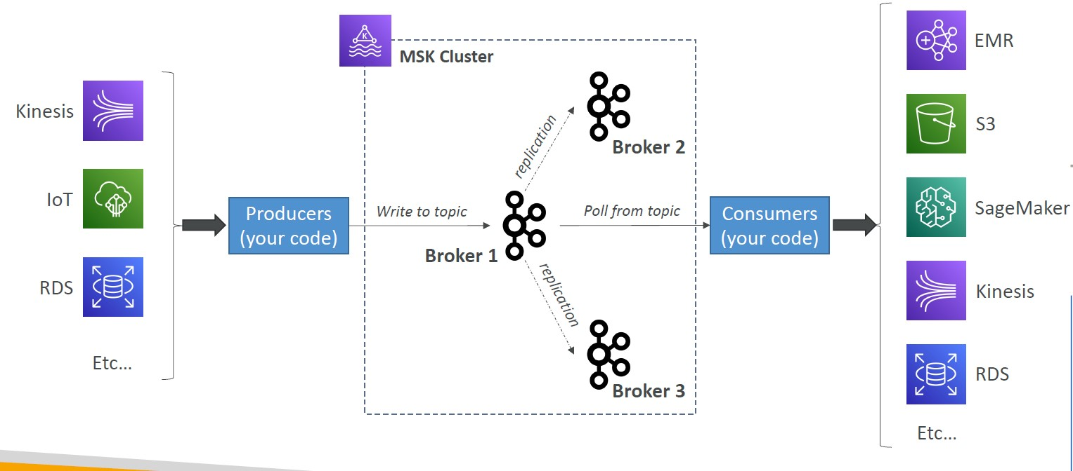

Kinesis Data Streams vs. Amazon MSK

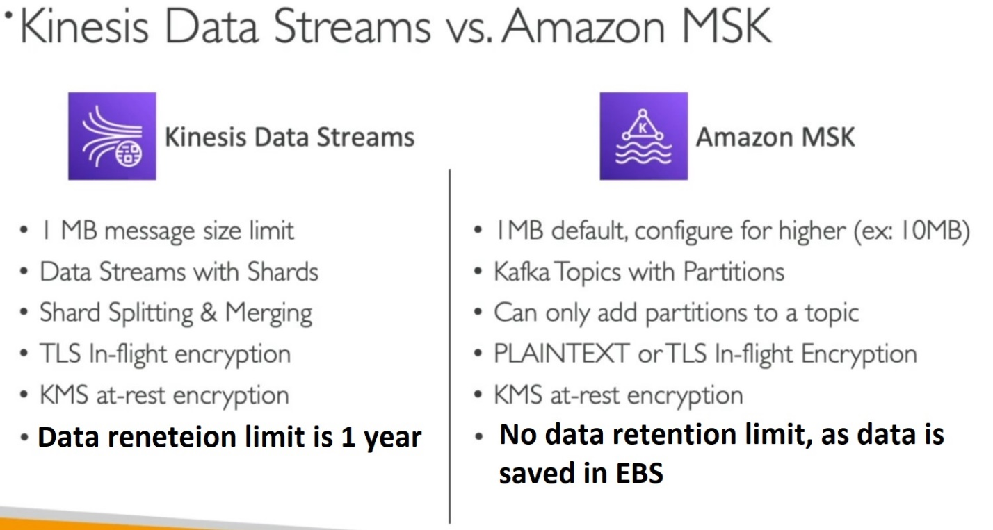

Amazon MSK Consumers

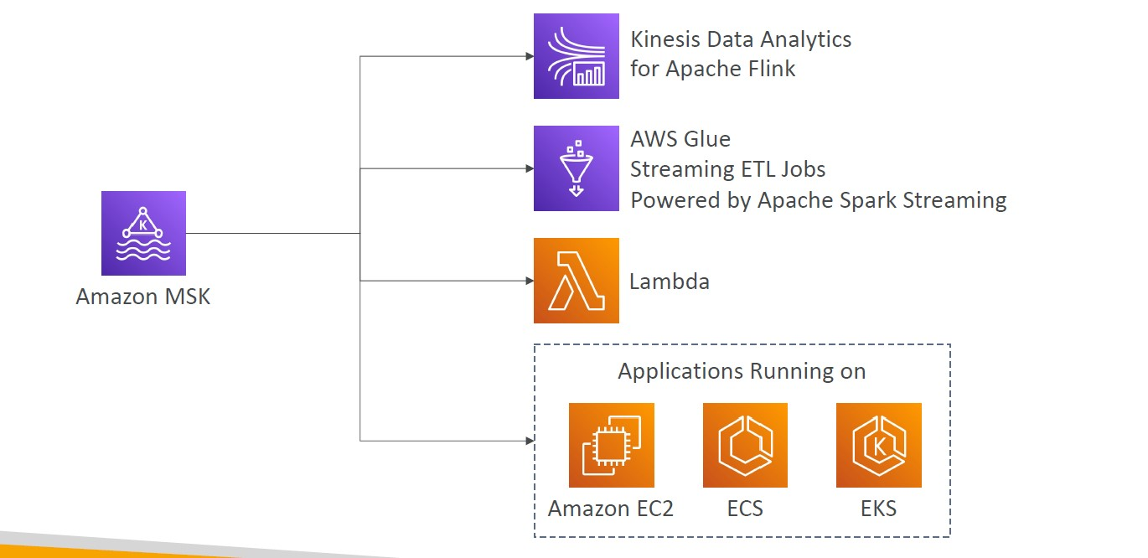

Amazon Rekognition

• Find objects, people, text, scenes in images and videos using ML

• Facial analysis and facial search to do user verification, people counting

• Create a database of “familiar faces” or compare against celebrities

-Use cases:

• Labeling

• Content Moderation

• Text Detection

• Face Detection and Analysis (gender, age range, emotions…)

• Face Search and Verification

• Celebrity Recognition

• Pathing (ex: for sports game analysis)

Amazon Rekognition – Content Moderation

• Detect content that is inappropriate, unwanted, or offensive (image and videos)

• Used in social media, broadcast media, advertising, and e-commerce situations to create a safer user experience

• Set a Minimum Confidence Threshold for items that will be flagged

• Flag sensitive content for manual review in Amazon Augmented AI (A2I)

• Help comply with regulations

Amazon Transcribe

• Automatically convert speech to text

• Uses a deep learning process called automatic speech recognition (ASR) to convert speech to text quickly and accurately

• Automatically remove Personally Identifiable Information (PII) using Redaction

• Supports Automatic Language Identification for multi-lingual audio

- Use cases:

• transcribe customer service calls

• automate closed captioning and subtitling

• generate metadata for media assets to create a fully searchable archive

Amazon Polly

• Turn text into lifelike speech using deep learning

• Allowing you to create applications that talk

Amazon Polly – Lexicon & SSML

• Customize the pronunciation of words with Pronunciation lexicons

• Stylized words: St3ph4ne => “Stephane”

• Acronyms: AWS => “Amazon Web Services”

• Upload the lexicons and use them in the SynthesizeSpeech operation

• Generate speech from plain text or from documents marked up with Speech Synthesis Markup Language (SSML) – enables more customization

• emphasizing specific words or phrases

• using phonetic pronunciation

• including breathing sounds, whispering

• using the Newscaster speaking style

Amazon Translate

• Natural and accurate language translation

• Amazon Translate allows you to localize content - such as websites and applications - for international users, and to easily translate large volumes of text efficiently.

Amazon Lex & Connect

-Amazon Lex: (same technology that powers Alexa)

• Automatic Speech Recognition (ASR) to convert speech to text

• Natural Language Understanding to recognize the intent of text, callers

• Helps build chatbots, call center bots

- Amazon Connect:

• Receive calls, create contact flows, cloud-based virtual contact center

• Can integrate with other CRM systems or AWS

• No upfront payments, 80% cheaper than traditional contact center solutions

Amazon Comprehend

• For Natural Language Processing – NLP

• Fully managed and serverless service

- Uses machine learning to find insights and relationships in text

• Language of the text

• Extracts key phrases, places, people, brands, or events

• Understands how positive or negative the text is

• Analyzes text using tokenization and parts of speech

• Automatically organizes a collection of text files by topic

- Sample use cases:

• analyze customer interactions (emails) to find what leads to a positive or negative experience

• Create and groups articles by topics that Comprehend will uncover

Amazon Comprehend Medical

- Amazon Comprehend Medical detects and returns useful information in unstructured clinical text:

• Physician’s notes

• Discharge summaries

• Test results

• Case notes

• Uses NLP to detect Protected Health Information (PHI) – DetectPHI API

• Store your documents in Amazon S3, analyze real-time data with Kinesis Data Firehose, or use Amazon Transcribe to transcribe patient narratives into text that can be analyzed by Amazon Comprehend Medical.

Amazon SageMaker

• Fully managed service for developers / data scientists to build ML models

• Typically, difficult to do all the processes in one place + provision servers

• Machine learning process (simplified): predicting your exam score

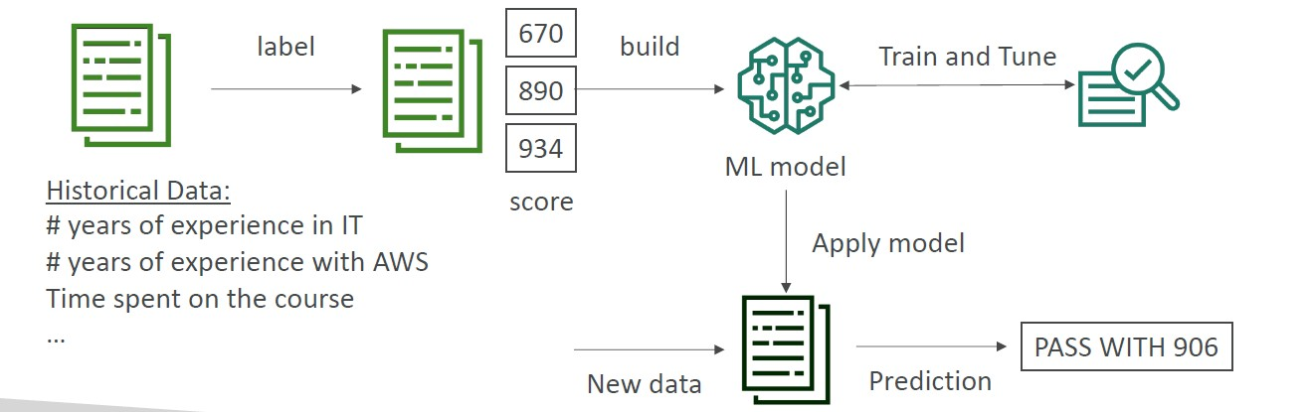

Amazon Forecast

• Fully managed service that uses ML to deliver highly accurate forecasts

• Example: predict the future sales of a raincoat

• 50% more accurate than looking at the data itself

• Reduce forecasting time from months to hours

• Use cases: Product Demand Planning, Financial Planning, Resource Planning, …

Amazon Kendra

• Fully managed document search service powered by Machine Learning

• Extract answers from within a document (text, pdf, HTML, PowerPoint, MS Word, FAQs…)

• Natural language search capabilities

• Learn from user interactions/feedback to promote preferred results (Incremental Learning)

• Ability to manually fine-tune search results (importance of data, freshness, custom, …)

Amazon Personalize

• Fully managed ML-service to build apps with real-time personalized recommendations

• Example: personalized product recommendations/re-ranking, customized direct marketing

• Example: User bought gardening tools, provide recommendations on the next one to buy

• Same technology used by Amazon.com

• Integrates into existing websites, applications, SMS, email marketing systems, …

• Implement in days, not months (you don’t need to build, train, and deploy ML solutions)

• Use cases: retail stores, media and entertainment…

Amazon Textract

• Automatically extracts text, handwriting, and data from any scanned documents using AI and ML

• Extract data from forms and tables

• Read and process any type of document (PDFs, images, …)

- Use cases:

• Financial Services (e.g., invoices, financial reports)

• Healthcare (e.g., medical records, insurance claims)

• Public Sector (e.g., tax forms, ID documents, passports)

AWS Machine Learning - Summary

• Rekognition: face detection, labeling, celebrity recognition

• Transcribe: audio to text (ex: subtitles)

• Polly: text to audio

• Translate: translations

• Lex: build conversational bots – chatbots

• Connect: cloud contact center

• Comprehend: natural language processing

• SageMaker: machine learning for every developer and data scientist

• Forecast: build highly accurate forecasts

• Kendra: ML-powered search engine

• Personalize: real-time personalized recommendations

• Textract: detect text and data in documents

Amazon CloudWatch Metrics

• CloudWatch provides metrics for every services in AWS

• Metric is a variable to monitor (CPUUtilization, NetworkIn…)

• Metrics belong to namespaces

• Dimension is an attribute of a metric (instance id, environment, etc…).

• Up to 10 dimensions per metric

• Metrics have timestamps

• Can create CloudWatch dashboards of metrics

• Can create CloudWatch Custom Metrics (for the RAM for example)

CloudWatch Metric Streams

• Continually stream CloudWatch metrics to a destination of your choice, with near-real-time delivery and low latency.

• Amazon Kinesis Data Firehose (and then its destinations)

• 3rd party service provider: Datadog, Dynatrace, New Relic, Splunk, Sumo Logic…

• Option to filter metrics to only stream a subset of them

CloudWatch Logs

• Log groups: arbitrary name, usually representing an application

• Log stream: instances within application / log files / containers

• Can define log expiration policies (never expire, 30 days, etc..)

• CloudWatch Logs can send logs to:

• Amazon S3 (exports)

• Kinesis Data Streams

• Kinesis Data Firehose

• AWS Lambda

• ElasticSearch

CloudWatch Logs - Sources

• SDK, CloudWatch Logs Agent, CloudWatch Unified Agent

• Elastic Beanstalk: collection of logs from application

• ECS: collection from containers

• AWS Lambda: collection from function logs

• VPC Flow Logs: VPC specific logs

• API Gateway

• CloudTrail based on filter

• Route53: Log DNS queries

CloudWatch Logs Metric Filter & Insights

• CloudWatch Logs can use filter expressions

• For example, find a specific IP inside of a log

• Or count occurrences of “ERROR” in your logs

• Metric filters can be used to trigger CloudWatch alarms

• CloudWatch Logs Insights can be used to query logs and add queries to CloudWatch Dashboards

CloudWatch Logs – S3 Export

• Log data can take up to 12 hours to become available for export

• The API call is CreateExportTask

• Not near-real time or real-time… use Logs Subscriptions instead

CloudWatch Logs Aggregation Multi-Account & Multi Region

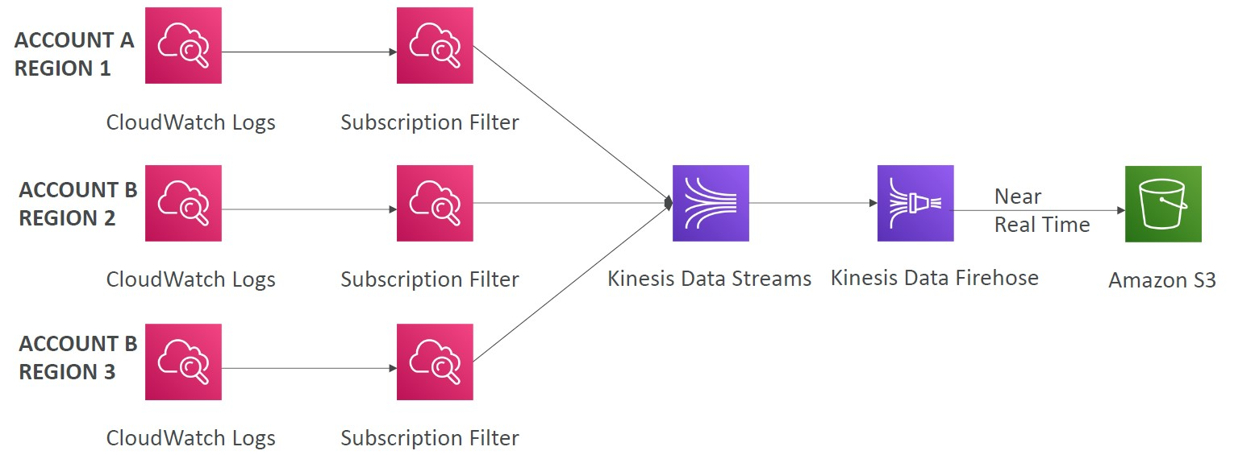

CloudWatch Logs for EC2

• By default, no logs from your EC2 machine will go to CloudWatch

• You need to run a CloudWatch agent on EC2 to push the log files you want

• Make sure IAM permissions are correct

• The CloudWatch log agent can be setup on-premises too

CloudWatch Logs Agent & Unified Agent

• For virtual servers (EC2 instances, on-premises servers…)

- CloudWatch Logs Agent

• Old version of the agent

• Can only send to CloudWatch Logs

- CloudWatch Unified Agent

• Collect additional system-level metrics such as RAM, processes, etc…

• Collect logs to send to CloudWatch Logs

• Centralized configuration using SSM Parameter Store

CloudWatch Unified Agent – Metrics

• Collected directly on your Linux server / EC2 instance

• CPU (active, guest, idle, system, user, steal)

• Disk metrics (free, used, total), Disk IO (writes, reads, bytes, iops)

• RAM (free, inactive, used, total, cached)

• Netstat (number of TCP and UDP connections, net packets, bytes)

• Processes (total, dead, bloqued, idle, running, sleep)

• Swap Space (free, used, used %)

• Reminder: out-of-the box metrics for EC2 – disk, CPU, network (high level)

CloudWatch Alarms

• Alarms are used to trigger notifications for any metric

• Various options (sampling, %, max, min, etc…)

- Alarm States:

• OK

• INSUFFICIENT_DATA

• ALARM

- Period:

• Length of time in seconds to evaluate the metric

• High resolution custom metrics: 10 sec, 30 sec or multiples of 60 sec

CloudWatch Alarm Targets

• Stop, Terminate, Reboot, or Recover an EC2 Instance

• Trigger Auto Scaling Action

• Send notification to SNS (from which you can do pretty much anything)

CloudWatch Alarms – Composite Alarms

• CloudWatch Alarms are on a single metric

• Composite Alarms are monitoring the states of multiple other alarms

• AND and OR conditions

• Helpful to reduce “alarm noise” by creating complex composite alarms

EC2 Instance Recovery

• Status Check:

• Instance status = check the EC2 VM

• System status = check the underlying hardware

• Recovery: Same Private, Public, Elastic IP, metadata, placement group

CloudWatch Alarm: good to know

• Alarms can be created based on CloudWatch Logs Metrics Filters

• To test alarms and notifications, set the alarm state to Alarm using CLI

aws cloudwatch set-alarm-state --alarm-name "myalarm" --state-value ALARM --state-reason "testing purposes"

Amazon EventBridge (formerly CloudWatch Events)

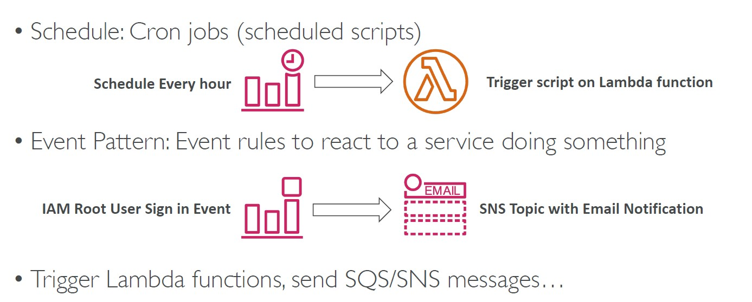

Amazon EventBridge Bus

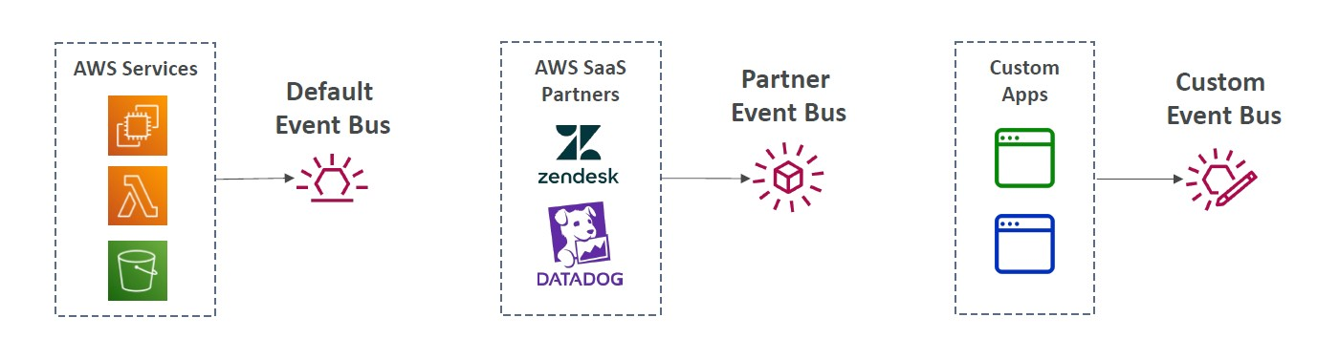

• Event buses can be accessed by other AWS accounts using Resource-based Policies

• You can archive events (all/filter) sent to an event bus (indefinitely or set period)

• Ability to replay archived events

Amazon EventBridge – Schema Registry

• EventBridge can analyze the events in your bus and infer the schema

• The Schema Registry allows you to generate code for your application, that will know in advance how data is structured in the event bus

• Schema can be versioned

Amazon EventBridge – Resource-based Policy

• Manage permissions for a specific Event Bus

• Example: allow/deny events from another AWS account or AWS region

• Use case: aggregate all events from your AWS Organization in a single AWS account or AWS region

CloudWatch Container Insights

• Collect, aggregate, summarize metrics and logs from containers

• Available for containers on…

• Amazon Elastic Container Service (Amazon ECS)

• Amazon Elastic Kubernetes Services (Amazon EKS)

• Kubernetes platforms on EC2

• Fargate (both for ECS and EKS)

• In Amazon EKS and Kubernetes, CloudWatch Insights is using a containerized version of the CloudWatch Agent to discover containers

CloudWatch Lambda Insights

• Monitoring and troubleshooting solution for serverless applications running on AWS Lambda

• Collects, aggregates, and summarizes system-level metrics including CPU time, memory, disk, and network

• Collects, aggregates, and summarizes diagnostic information such as cold starts and Lambda worker shutdowns

• Lambda Insights is provided as a Lambda Layer

CloudWatch Contributor Insights

• Analyze log data and create time series that display contributor data.

• See metrics about the top-N contributors

• The total number of unique contributors, and their usage.

• This helps you find top talkers and understand who or what is impacting system performance.

• Works for any AWS-generated logs (VPC, DNS, etc..)

• For example, you can find bad hosts, identify the heaviest network users, or find the URLs that generate the most errors.

• You can build your rules from scratch, or you can also use sample rules that AWS has created – leverages your CloudWatch Logs

• CloudWatch also provides built-in rules that you can use to analyze metrics from other AWS services.

CloudWatch Application Insights

• Provides automated dashboards that show potential problems with monitored applications, to help isolate ongoing issues

• Your applications run on Amazon EC2 Instances with select technologies only (Java, .NET, Microsoft IIS Web Server, databases…)

• And you can use other AWS resources such as Amazon EBS, RDS, ELB, ASG, Lambda, SQS, DynamoDB, S3 bucket, ECS, EKS, SNS, API Gateway…

• Powered by SageMaker

• Enhanced visibility into your application health to reduce the time it will take you to troubleshoot and repair your applications

• Findings and alerts are sent to Amazon EventBridge and SSM OpsCenter

CloudWatch Insights and Operational Visibility

• CloudWatch Container Insights

• ECS, EKS, Kubernetes on EC2, Fargate, needs agent for Kubernetes

• Metrics and logs

• CloudWatch Lambda Insights

• Detailed metrics to troubleshoot serverless applications

• CloudWatch Contributors Insights

• Find “Top-N” Contributors through CloudWatch Logs

• CloudWatch Application Insights

• Automatic dashboard to troubleshoot your application and related AWS services

AWS CloudTrail

• Provides governance, compliance and audit for your AWS Account

• CloudTrail is enabled by default!

• Get an history of events / API calls made within your AWS Account by:

• Console

• SDK

• CLI

• AWS Services

• Can put logs from CloudTrail into CloudWatch Logs or S3

• A trail can be applied to All Regions (default) or a single Region.

• If a resource is deleted in AWS, investigate CloudTrail first

CloudTrail Events

1-Management Events:

• Operations that are performed on resources in your AWS account

• Examples:

• Configuring security (IAM AttachRolePolicy)

• Configuring rules for routing data (Amazon EC2 CreateSubnet)

• Setting up logging (AWS CloudTrail CreateTrail)

• By default, trails are configured to log management events.

• Can separate Read Events (that don’t modify resources) from Write Events (that may modify resources)

2-Data Events:

• By default, data events are not logged (because high volume operations)

• Amazon S3 object-level activity (ex: GetObject, DeleteObject, PutObject): can separate Read and Write Events

• AWS Lambda function execution activity (the Invoke API)

3-CloudTrail Insights

• Enable CloudTrail Insights to detect unusual activity in your account:

• inaccurate resource provisioning

• hitting service limits

• Bursts of AWS IAM actions

• Gaps in periodic maintenance activity

• CloudTrail Insights analyzes normal management events to create a baseline

• And then continuously analyzes write events to detect unusual patterns

• Anomalies appear in the CloudTrail console

• Event is sent to Amazon S3

• An EventBridge event is generated (for automation needs)

CloudTrail Events Retention

• Events are stored for 90 days in CloudTrail

• To keep events beyond this period, log them to S3 and use Athena

AWS Config

• Helps with auditing and recording compliance of your AWS resources

• Helps record configurations and changes over time

• Questions that can be solved by AWS Config:

• Is there unrestricted SSH access to my security groups?

• Do my buckets have any public access?

• How has my ALB configuration changed over time?

• You can receive alerts (SNS notifications) for any changes

• AWS Config is a per-region service

• Can be aggregated across regions and accounts

• Possibility of storing the configuration data into S3 (analyzed by Athena)

Config Rules

• Can use AWS managed config rules (over 75)

• Can make custom config rules (must be defined in AWS Lambda)

• Ex: evaluate if each EBS disk is of type gp2

• Ex: evaluate if each EC2 instance is t2.micro

• Rules can be evaluated / triggered:

• For each config change

• And / or: at regular time intervals

• AWS Config Rules does not prevent actions from happening (no deny)

• Pricing: no free tier, $0.003 per configuration item recorded per region, $0.001 per config rule evaluation per region

AWS Config Resource

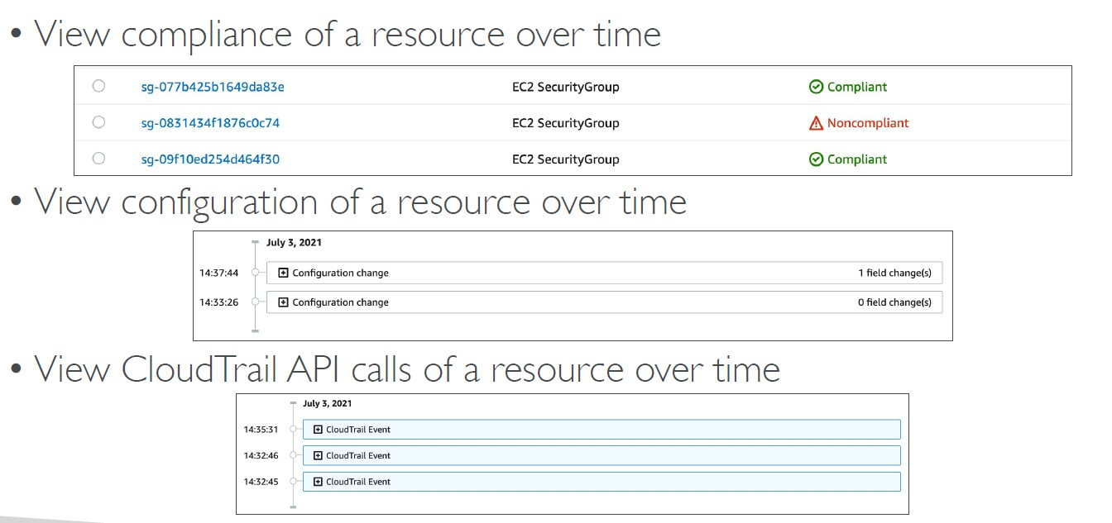

Config Rules – Remediations

• Automate remediation of non-compliant resources using SSM Automation Documents

• Use AWS-Managed Automation Documents or create custom Automation Documents

• Tip: you can create custom Automation Documents that invokes Lambda function

• You can set Remediation Retries if the resource is still non-compliant after auto remediation

Config Rules – Notifications

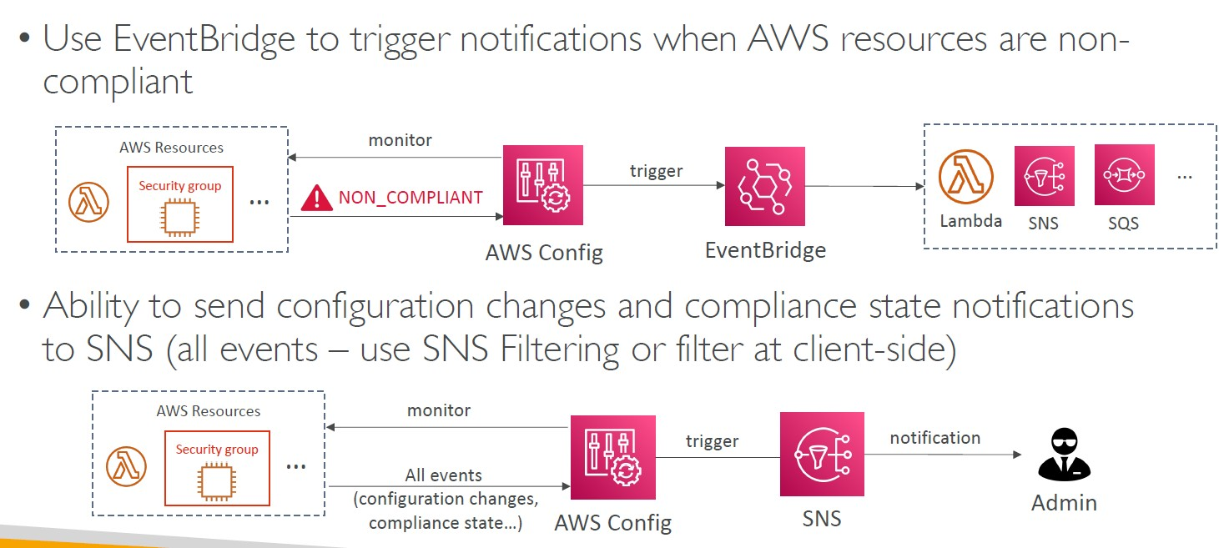

CloudWatch vs CloudTrail vs Config

- CloudWatch

• Performance monitoring (metrics, CPU, network, etc…) & dashboards

• Events & Alerting

• Log Aggregation & Analysis

-CloudTrail

• Record API calls made within your Account by everyone

• Can define trails for specific resources

• Global Service

- Config

• Record configuration changes

• Evaluate resources against compliance rules

• Get timeline of changes and compliance

For an Elastic Load Balancer

- CloudWatch:

• Monitoring Incoming connections metric

• Visualize error codes as % over time

• Make a dashboard to get an idea of your load balancer performance

- Config:

• Track security group rules for the Load Balancer

• Track configuration changes for the Load Balancer

• Ensure an SSL certificate is always assigned to the Load Balancer (compliance)

- CloudTrail:

• Track who made any changes to the Load Balancer with API calls

AWS Organizations

• Global service

• Allows to manage multiple AWS accounts

• The main account is the management account

• Other accounts are member accounts

• Member accounts can only be part of one organization

• Consolidated Billing across all accounts - single payment method

• Pricing benefits from aggregated usage (volume discount for EC2, S3…)

• Shared reserved instances and Savings Plans discounts across accounts

• API is available to automate AWS account creation

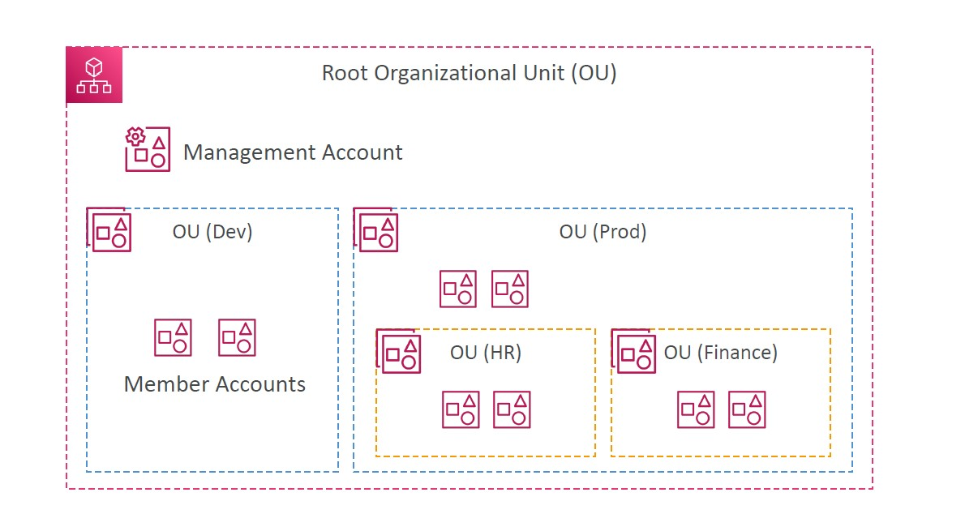

- Advantages

• Multi Account vs One Account Multi VPC

• Use tagging standards for billing purposes

• Enable CloudTrail on all accounts, send logs to central S3 account

• Send CloudWatch Logs to central logging account

• Establish Cross Account Roles for Admin purposes

- Security: Service Control Policies (SCP)

• IAM policies applied to OU or Accounts to restrict Users and Roles

• They do not apply to the management account (full admin power)

• Must have an explicit allow (does not allow anything by default – like IAM)

SCP Hierarchy

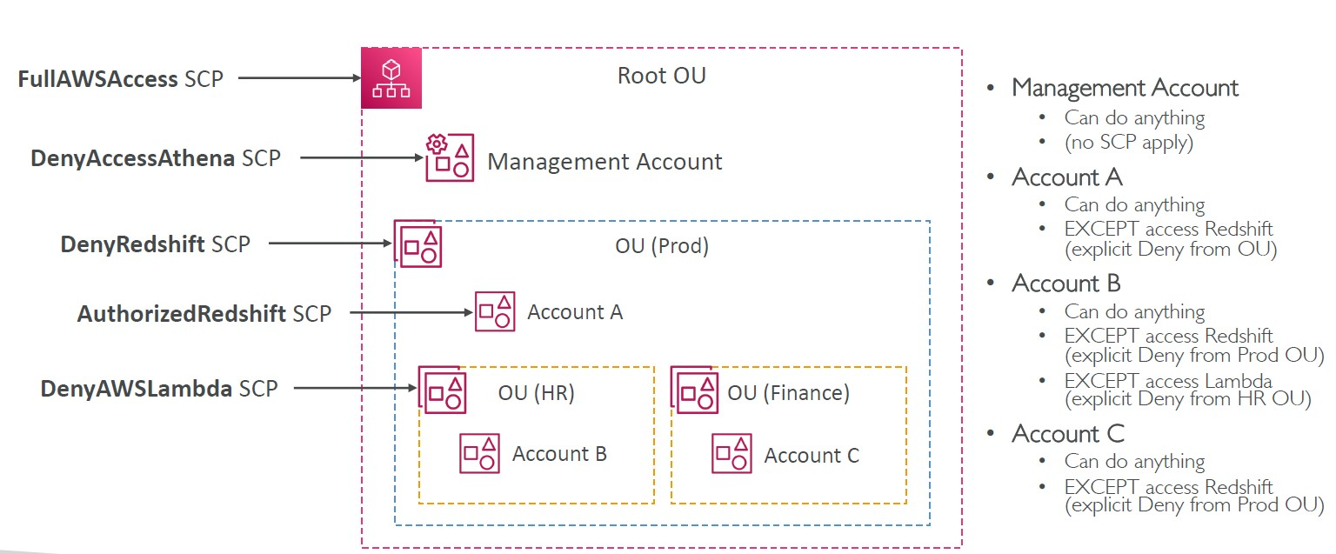

SCP Examples

Blocklist and Allowlist strategies

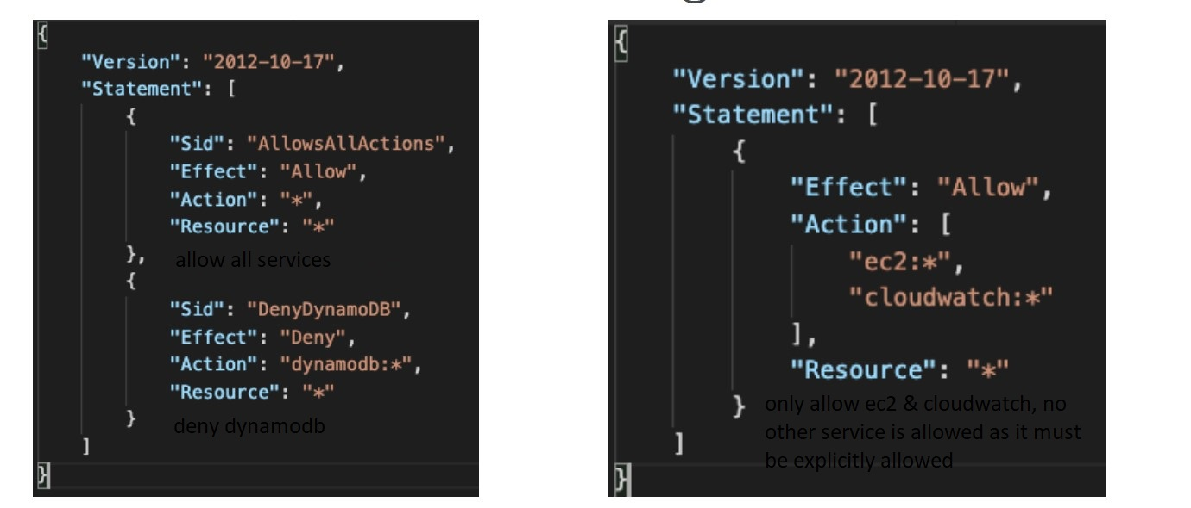

IAM Conditions

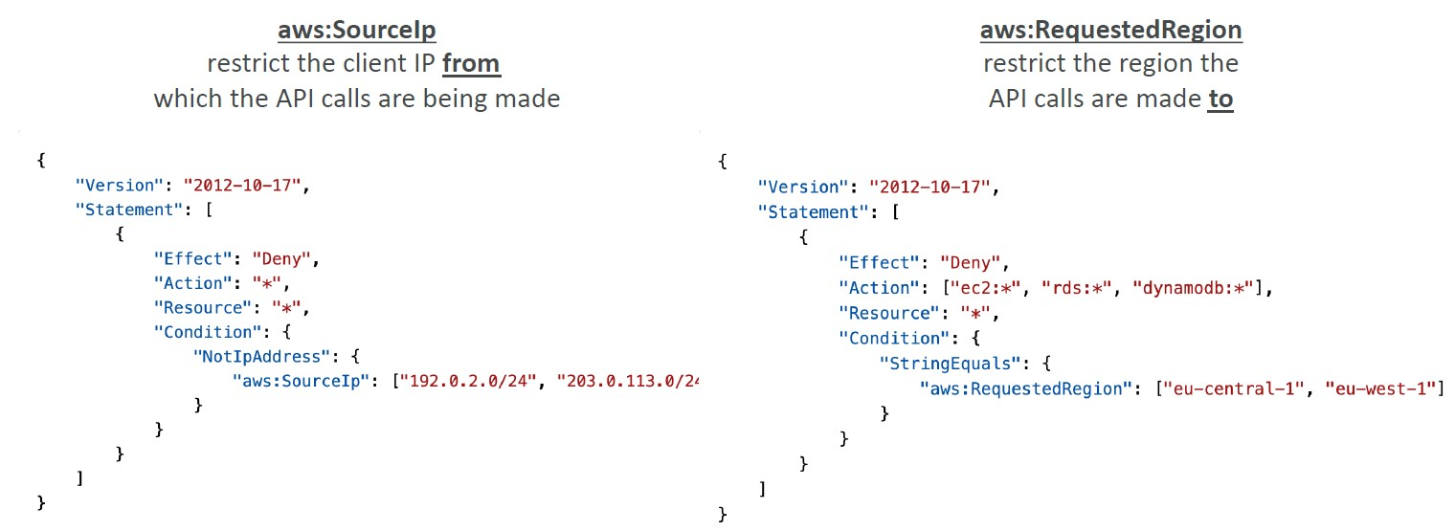

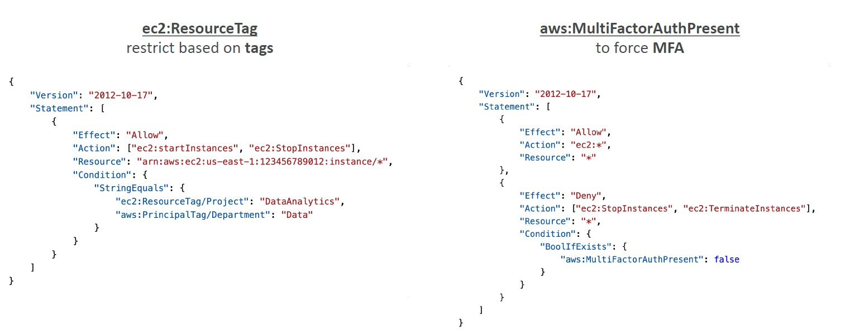

IAM for S3

• s3:ListBucket permission applies to arn:aws:s3:::test => bucket level permission

• s3:GetObject, s3:PutObject, s3:DeleteObject applies to arn:awn:s3:::test/* => object level permission

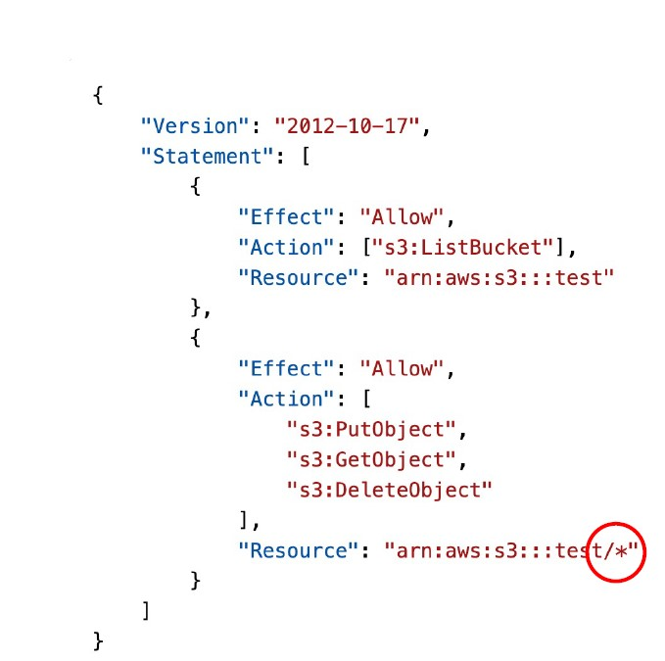

Resource Policies & aws:PrincipalOrgID

aws:PrincipalOrgID can be used in any resource policies to restrict access to accounts that are member of an AWS Organization

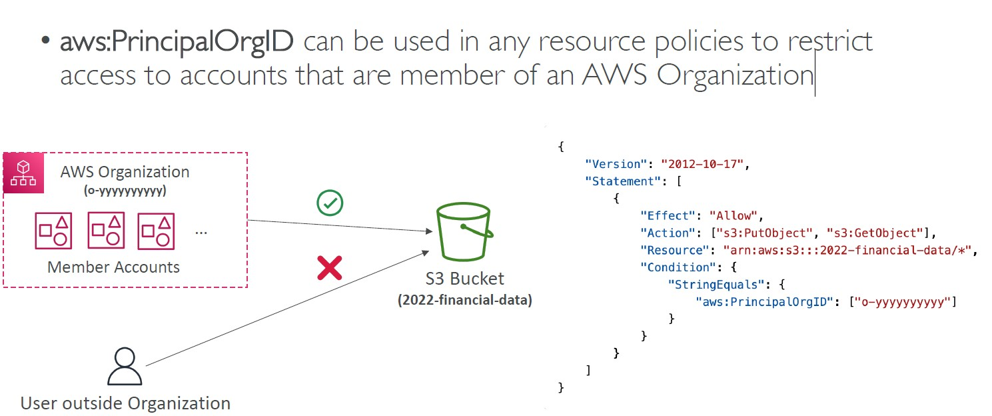

IAM Roles vs Resource-Based Policies

• When you assume a role (user, application or service), you give up your original permissions and take the permission assigned to the role

• When using a resource-based policy, the principal doesn’t have to give up his permissions

• Example: User in account A needs to scan a DynamoDB table in Account A and dump it in an S3 bucket in Account B.

• Supported by: Amazon S3 buckets, SNS topics, SQS queues, etc…

Amazon EventBridge – Security

• When a rule runs, it needs permissions on the target

• Resource-based policy: Lambda, SNS, SQS, CloudWatch Logs, API Gateway…

• IAM role: Kinesis stream, Systems Manager Run Command, ECS task…

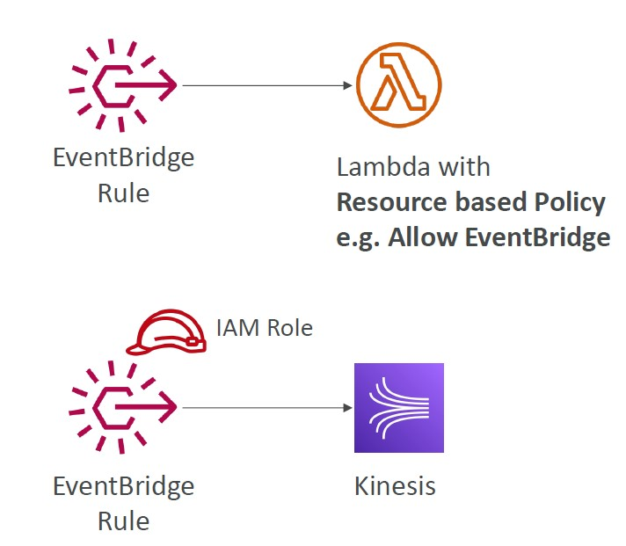

IAM Permission Boundaries

• IAM Permission Boundaries are supported for users and roles (not groups)

• Advanced feature to use a managed policy to set the maximum permissions an IAM entity can get.

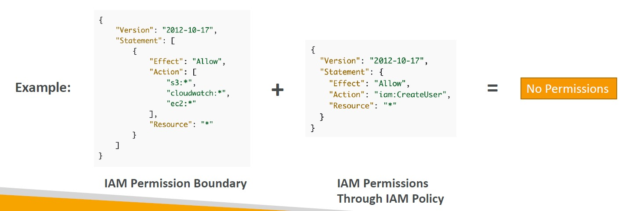

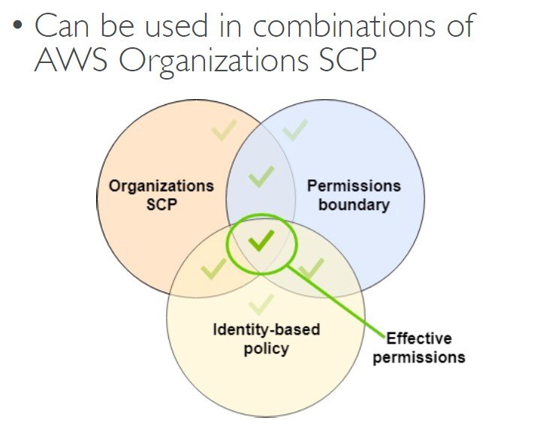

IAM Policy Evaluation Logic

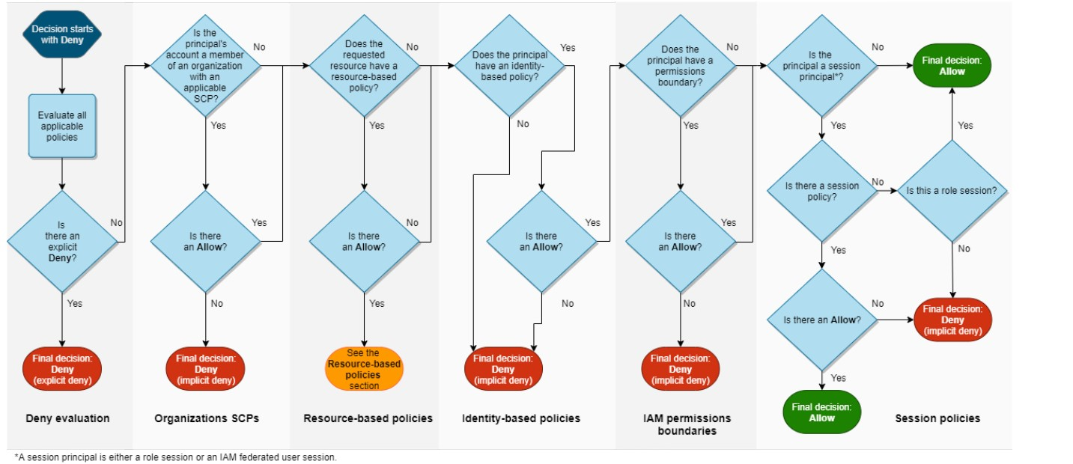

Example IAM Policy

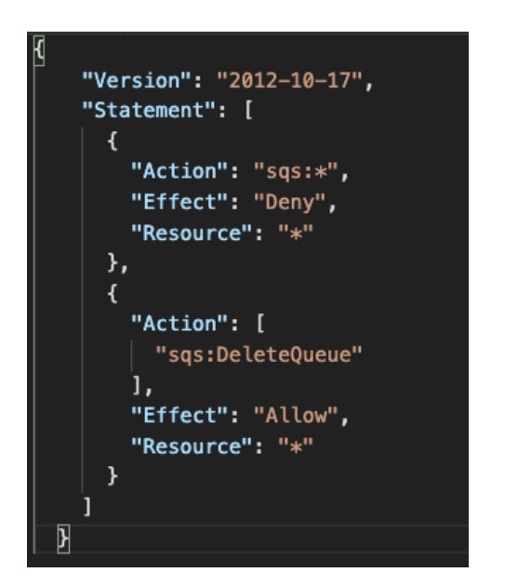

• Can you perform sqs:CreateQueue?

No, there is a deny for all actions”*” on sqs service

• Can you perform sqs:DeleteQueue?

No, there is a deny for all actions”*” on sqs service and it overrides the allow action on sqs:DeleteQueue

• Can you perform ec2:DescribeInstances?

No, there is on explicit allow to do this action

Amazon Cognito

• Give users an identity to interact with our web or mobile application

- Cognito User Pools:

• Sign in functionality for app users

• Integrate with API Gateway & Application Load Balancer

-Cognito Identity Pools (Federated Identity):

• Provide AWS credentials to users so they can access AWS resources directly

• Integrate with Cognito User Pools as an identity provider

- Cognito vs IAM: “hundreds of users”, ”mobile users”, “authenticate with SAML”

Cognito User Pools (CUP) – User Features

• Create a serverless database of user for your web & mobile apps

• Simple login: Username (or email) / password combination

• Password reset

• Email & Phone Number Verification

• Multi-factor authentication (MFA)

• Federated Identities: users from Facebook, Google, SAML…

Cognito User Pools (CUP) - Integrations

• CUP integrates with API Gateway and Application Load Balancer

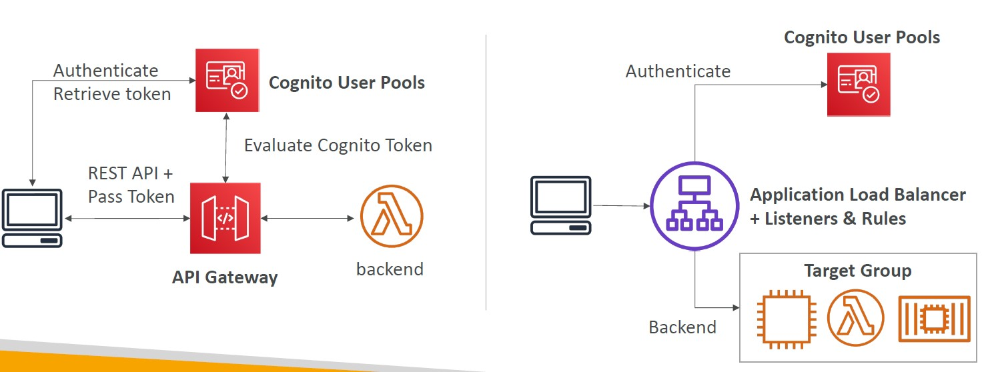

Cognito Identity Pools (Federated Identities)

• Get identities for “users” so they obtain temporary AWS credentials

• Users source can be Cognito User Pools, 3rd party logins, etc…

• Users can then access AWS services directly or through API Gateway

• The IAM policies applied to the credentials are defined in Cognito

• They can be customized based on the user_id for fine grained control

• Default IAM roles for authenticated and guest users

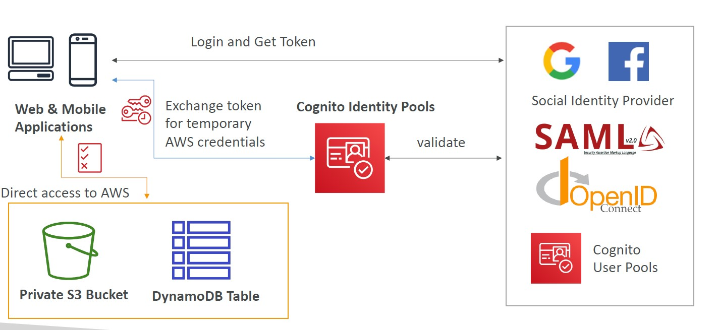

Cognito Identity Pools

Row Level Security in DynamoDB

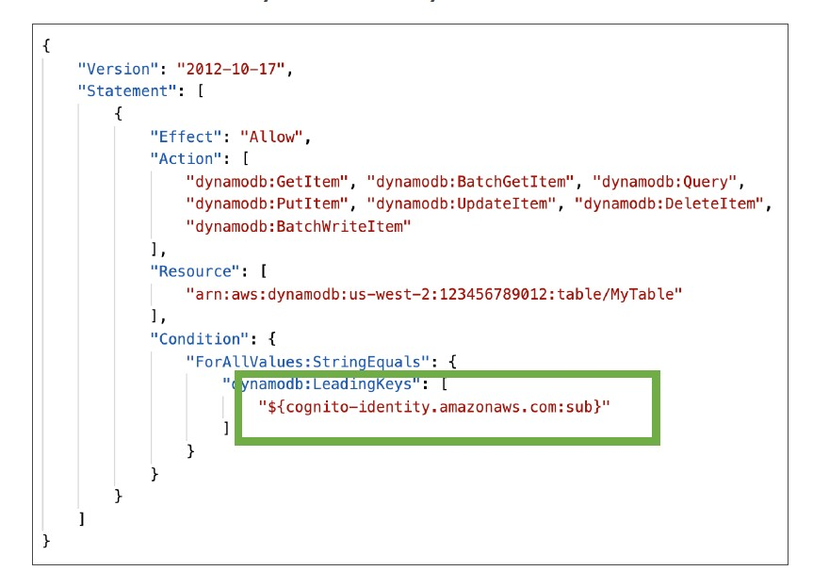

AWS IAM Identity Center (successor to AWS Single Sign-On)

• One login (single sign-on) for all your

• AWS accounts in AWS Organizations

• Business cloud applications (e.g., Salesforce, Box, Microsoft 365, …)

• SAML2.0-enabled applications

• EC2 Windows Instances

• Identity providers

• Built-in identity store in IAM Identity Center

• 3rd party: Active Directory (AD), OneLogin, Okta…

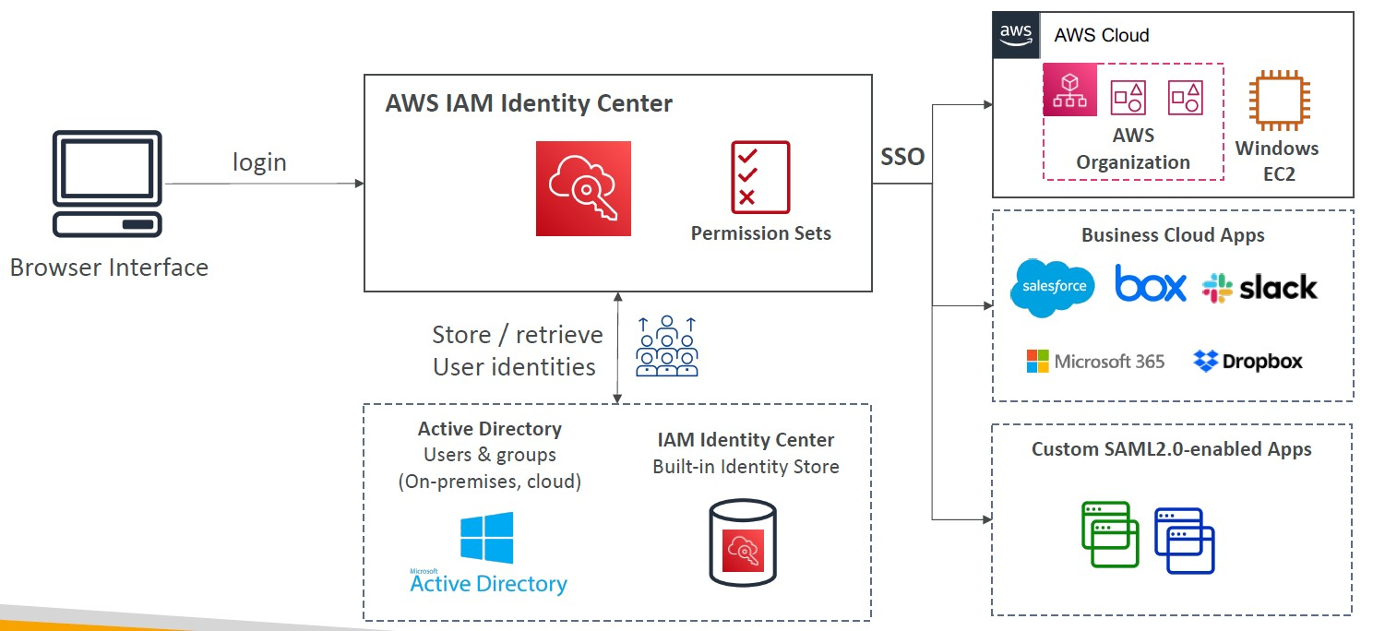

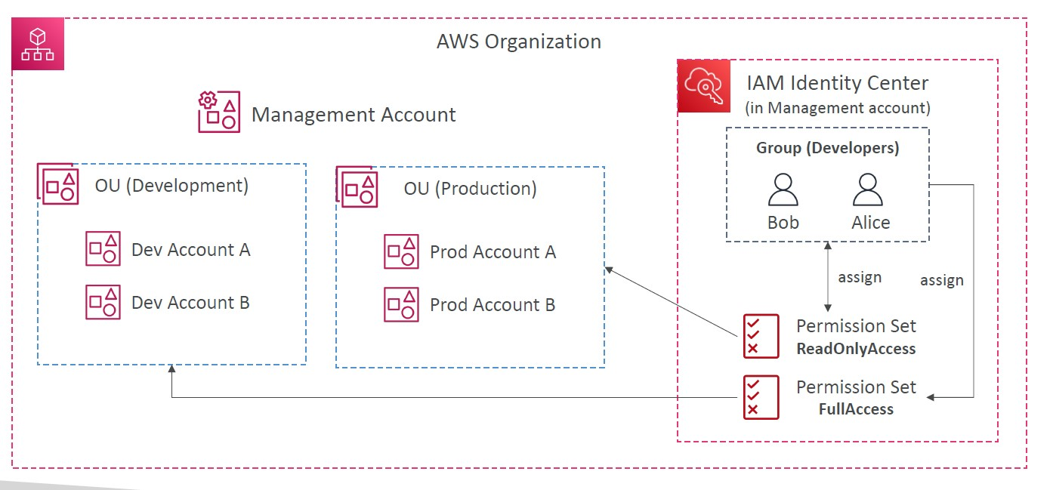

AWS IAM Identity Center Fine-grained Permissions and Assignments

• Multi-Account Permissions

• Manage access across AWS accounts in your AWS Organization

• Permission Sets – a collection of one or more IAM Policies assigned to users and groups to define AWS access

• Application Assignments

• SSO access to many SAML 2.0 business applications (Salesforce, Box, Microsoft 365, …)

• Provide required URLs, certificates, and metadata

• Attribute-Based Access Control (ABAC)

• Fine-grained permissions based on users’ attributes stored in IAM Identity Center Identity Store

• Example: cost center, title, locale, …

• Use case: Define permissions once, then modify AWS access by changing the attributes

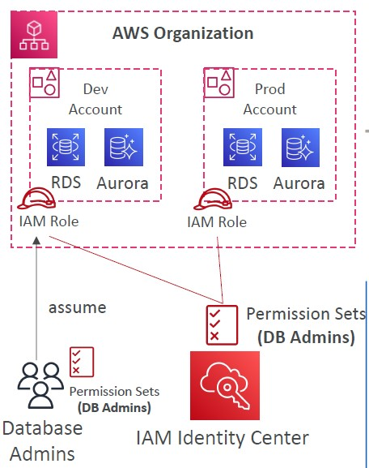

AWS Directory Services

- AWS Managed Microsoft AD

• Create your own AD in AWS, manage users locally, supports MFA

• Establish “trust” connections with your onpremises AD

- AD Connector

• Directory Gateway (proxy) to redirect to onpremises AD, supports MFA

• Users are managed on the on-premises AD

- Simple AD

• AD-compatible managed directory on AWS

• Cannot be joined with on-premises AD

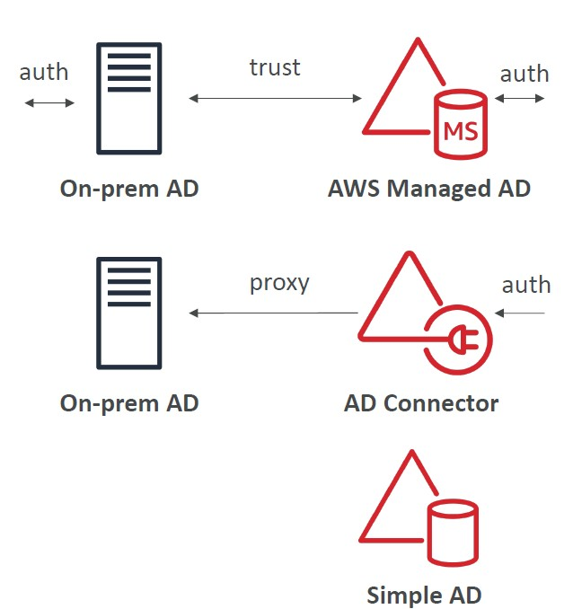

IAM Identity Center – Active Directory Setup

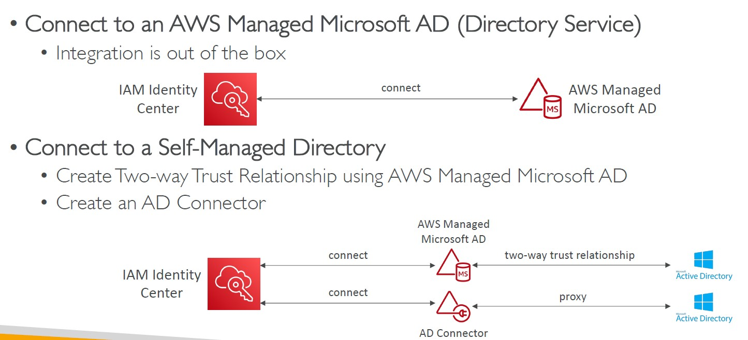

AWS Control Tower

• Easy way to set up and govern a secure and compliant multi-account AWS environment based on best practices

• AWS Control Tower uses AWS Organizations to create accounts

• Benefits:

• Automate the set up of your environment in a few clicks

• Automate ongoing policy management using guardrails

• Detect policy violations and remediate them

• Monitor compliance through an interactive dashboard

AWS Control Tower – Guardrails

• Provides ongoing governance for your Control Tower environment (AWS Accounts)

• Preventive Guardrail – using SCPs (e.g., Restrict Regions across all your accounts)

• Detective Guardrail – using AWS Config (e.g., identify untagged resources)

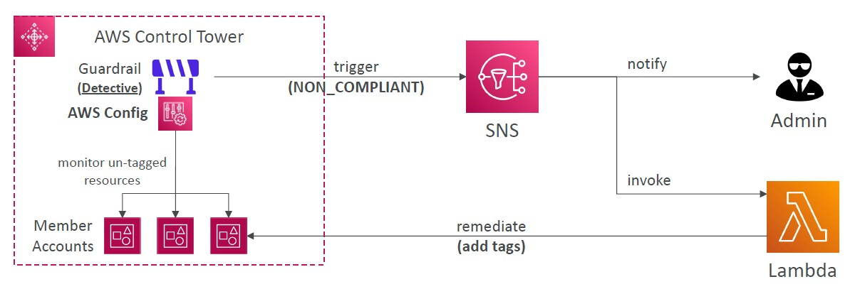

AWS KMS (Key Management Service)

• AWS manages encryption keys for us

• Fully integrated with IAM for authorization

• Easy way to control access to your data

• Able to audit KMS Key usage using CloudTrail

• Seamlessly integrated into most AWS services (EBS, S3, RDS, SSM…)

• Never ever store your secrets in plaintext, especially in your code

• KMS Key Encryption also available through API calls (SDK, CLI)

• Encrypted secrets can be stored in the code / environment variables

KMS Keys Types

• KMS Keys is the new name of KMS Customer Master Key

- Symmetric (AES-256 keys)

• Single encryption key that is used to Encrypt and Decrypt

• AWS services that are integrated with KMS use Symmetric CMKs

• You never get access to the KMS Key unencrypted (must call KMS API to use)

- Asymmetric (RSA & ECC key pairs)

• Public (Encrypt) and Private Key (Decrypt) pair

• Used for Encrypt/Decrypt, or Sign/Verify operations

• The public key is downloadable, but you can’t access the Private Key unencrypted

• Use case: encryption outside of AWS by users who can’t call the KMS API

AWS KMS (Key Management Service)

• Three types of KMS Keys:

1- AWS Managed Key: free (aws/service-name, example: aws/rds or aws/ebs)

2- Customer Managed Keys (CMK) created in KMS: $1 / month

3- Customer Managed Keys imported (must be 256-bit symmetric key): $1 / month

• + pay for API call to KMS ($0.03 / 10000 calls)

- Automatic Key rotation:

• AWS-managed KMS Key: automatic every 1 year

• Customer-managed KMS Key: (must be enabled) automatic every 1 year

• Imported KMS Key: only manual rotation possible using alias

Copying Snapshots across regions

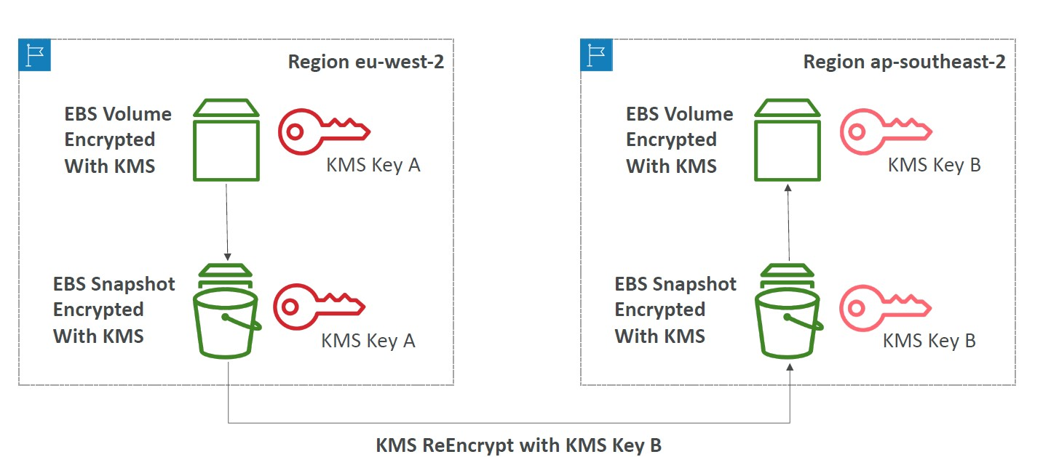

KMS Key Policies

• Control access to KMS keys, “similar” to S3 bucket policies

• Difference: you cannot control access without them

• Default KMS Key Policy:

• Created if you don’t provide a specific KMS Key Policy

• Complete access to the key to the root user = entire AWS account

• Custom KMS Key Policy:

• Define users, roles that can access the KMS key

• Define who can administer the key

• Useful for cross-account access of your KMS key

Copying Snapshots across accounts

1. Create a Snapshot, encrypted with your own KMS Key (Customer Managed Key)

2. Attach a KMS Key Policy to authorize cross-account access

3. Share the encrypted snapshot

4. (in target) Create a copy of the Snapshot, encrypt it with a CMK in your account

5. Create a volume from the snapshot

KMS Multi-Region Keys

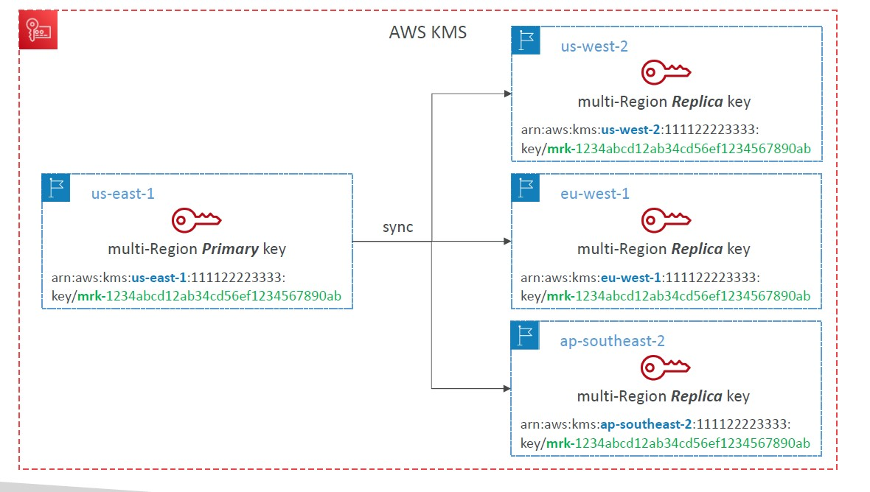

• Identical KMS keys in different AWS Regions that can be used interchangeably

• Multi-Region keys have the same key ID, key material, automatic rotation…

• Encrypt in one Region and decrypt in other Regions

• No need to re-encrypt or making cross-Region API calls

• KMS Multi-Region are NOT global (Primary + Replicas)

• Each Multi-Region key is managed independently

• Use cases: global client-side encryption, encryption on Global DynamoDB, Global Aurora

DynamoDB Global Tables and KMS Multi- Region Keys Client-Side encryption

• We can encrypt specific attributes client-side in our DynamoDB table using the Amazon DynamoDB Encryption Client

• Combined with Global Tables, the client-side encrypted data is replicated to other regions

• If we use a multi-region key, replicated in the same region as the DynamoDB Global table, then clients in these regions can use low latency API calls to KMS in their region to decrypt the data client-side

• Using client-side encryption we can protect specific fields and guarantee only decryption if the client has access to an API key

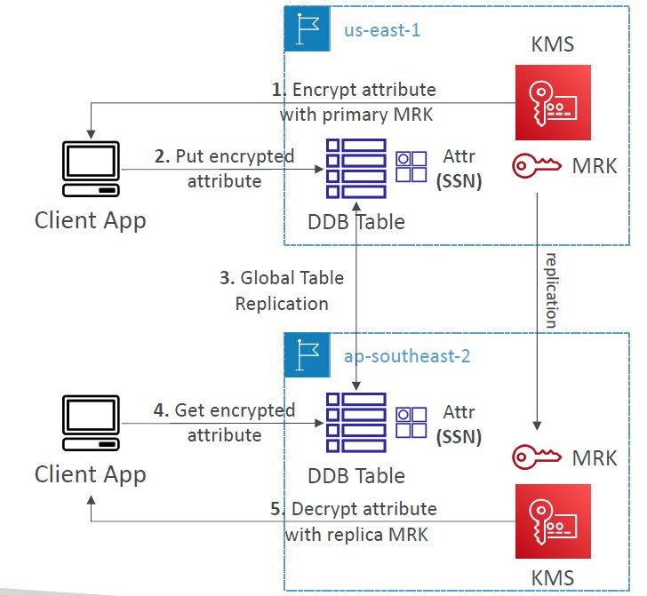

Global Aurora and KMS Multi-Region Keys Client-Side encryption

• We can encrypt specific attributes client-side in our Aurora table using the AWS Encryption SDK

• Combined with Aurora Global Tables, the client-side encrypted data is replicated to other regions

• If we use a multi-region key, replicated in the same region as the Global Aurora DB, then clients in these regions can use low-latency API calls to KMS in their region to decrypt the data client-side

• Using client-side encryption we can protect specific fields and guarantee only decryption if the client has access to an API key, we can protect specific fields even from database admins

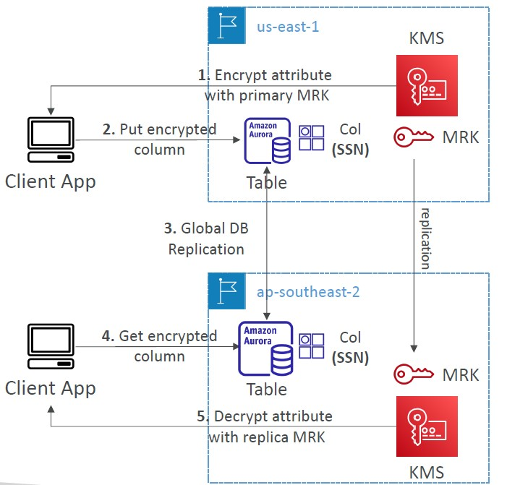

S3 Replication Encryption Considerations

• objects in S3 are encrypted with SSE-S3 by default

• objects encrypted with SSE-S3 are replicated by default

• Objects encrypted with SSE-C (customer provided key) are never replicated

- For objects encrypted with SSE-KMS, you need to enable the option

• Specify which KMS Key to encrypt the objects within the target bucket

• Adapt the KMS Key Policy for the target key

• An IAM Role with kms:Decrypt for the source KMS Key and kms:Encrypt for the target KMS Key

• You might get KMS throttling errors, in which case you can ask for a Service Quotas increase

• You can use multi-region AWS KMS Keys, but they are currently treated as independent keys by Amazon S3 (the object will still be decrypted and then encrypted)

AMI Sharing Process Encrypted via KMS

1. AMI in Source Account is encrypted with KMS Key from Source Account

2. Must modify the image attribute to add a Launch Permission which corresponds to the specified target AWS account

3. Must share the KMS Keys used to encrypted the snapshot the AMI references with the target account / IAM Role

4. The IAM Role/User in the target account must have the permissions to DescribeKey, ReEncrypted, CreateGrant, Decrypt

5. When launching an EC2 instance from the AMI, optionally the target account can specify a new KMS key in its own account to re-encrypt the volumes

SSM Parameter Store

• Secure storage for configuration and secrets

• Optional Seamless Encryption using KMS

• Serverless, scalable, durable, easy SDK

• Version tracking of configurations / secrets

• Security through IAM

• Notifications with Amazon EventBridge

• Integration with CloudFormation

SSM Parameter Store Hierarchy

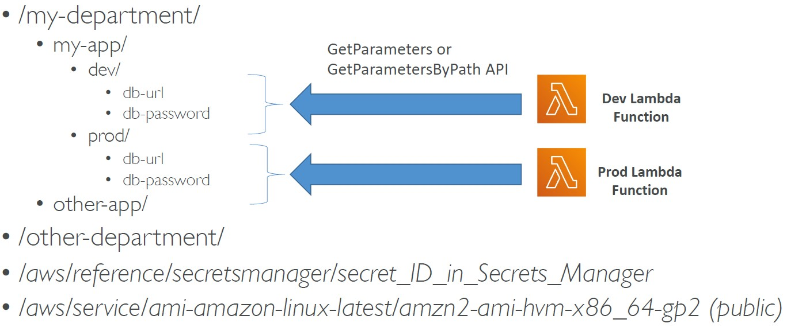

Standard and advanced parameter tiers

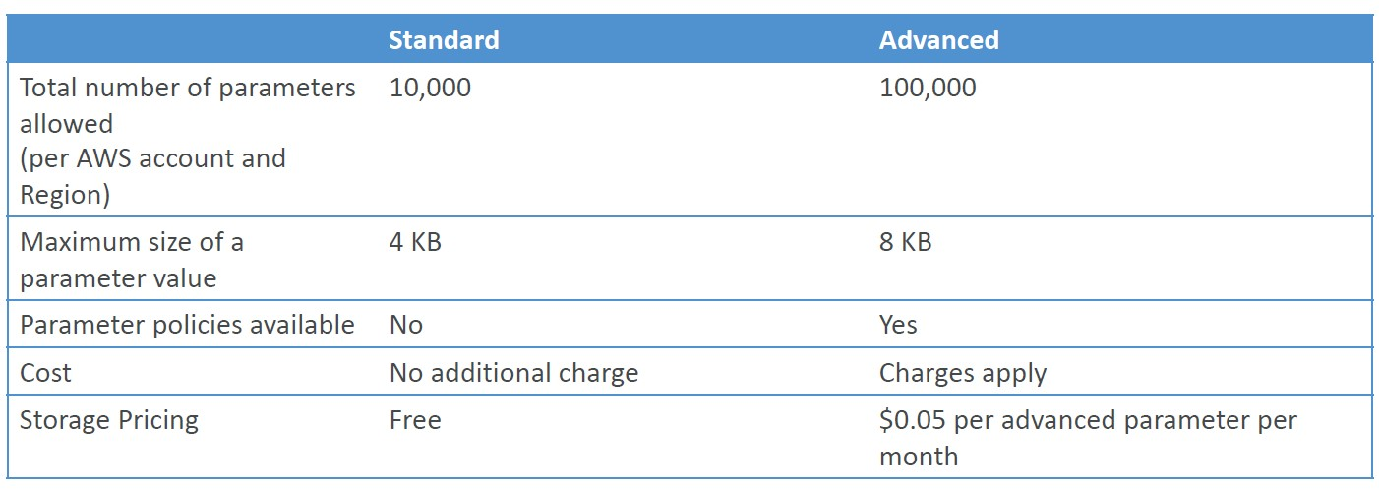

Parameters Policies (for advanced parameters)

• Allow to assign a TTL to a parameter (expiration date) to force updating or deleting sensitive data such as passwords

• Can assign multiple policies at a time

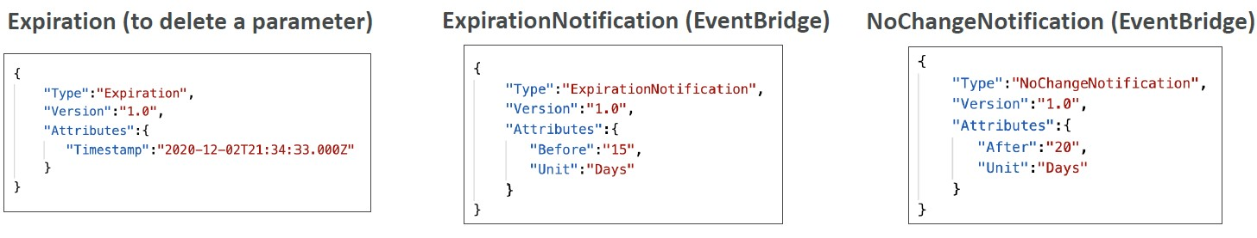

AWS Secrets Manager

• Newer service, meant for storing secrets

• Capability to force rotation of secrets every X days

• Automate generation of secrets on rotation (uses Lambda)

• Integration with Amazon RDS (MySQL, PostgreSQL, Aurora)

• Secrets are encrypted using KMS

• Mostly meant for RDS integration

AWS Secrets Manager – Multi-Region Secrets

• Replicate Secrets across multiple AWS Regions

• Secrets Manager keeps read replicas in sync with the primary Secret

• Ability to promote a read replica Secret to a standalone Secret

• Use cases: multi-region apps, disaster recovery strategies, multi-region DB…

AWS Certificate Manager (ACM)

• Easily provision, manage, and deploy TLS Certificates

• Provide in-flight encryption for websites (HTTPS)

• Supports both public and private TLS certificates

• Free of charge for public TLS certificates

• Automatic TLS certificate renewal

• Integrations with (load TLS certificates on)

• Elastic Load Balancers (CLB, ALB, NLB)

• CloudFront Distributions

• APIs on API Gateway

• Cannot use ACM with EC2 (can’t be extracted)

ACM – Requesting Public Certificates

1. List domain names to be included in the certificate

• Fully Qualified Domain Name (FQDN): corp.example.com

• Wildcard Domain: *.example.com

2. Select Validation Method: DNS Validation or Email validation

• DNS Validation is preferred for automation purposes

• Email validation will send emails to contact addresses in the WHOIS database

• DNS Validation will leverage a CNAME record to DNS config (ex: Route 53)

3. It will take a few hours to get verified

4. The Public Certificate will be enrolled for automatic renewal

• ACM automatically renews ACM-generated certificates 60 days before expiry

ACM – Importing Public Certificates

• Option to generate the certificate outside of ACM and then import it

• No automatic renewal, must import a new certificate before expiry

• ACM sends daily expiration events starting 45 days prior to expiration

• The # of days can be configured

• Events are appearing in EventBridge

• AWS Config has a managed rule named acm-certificate-expiration-check to check for expiring certificates (configurable number of days)

ACM – Integration with ALB

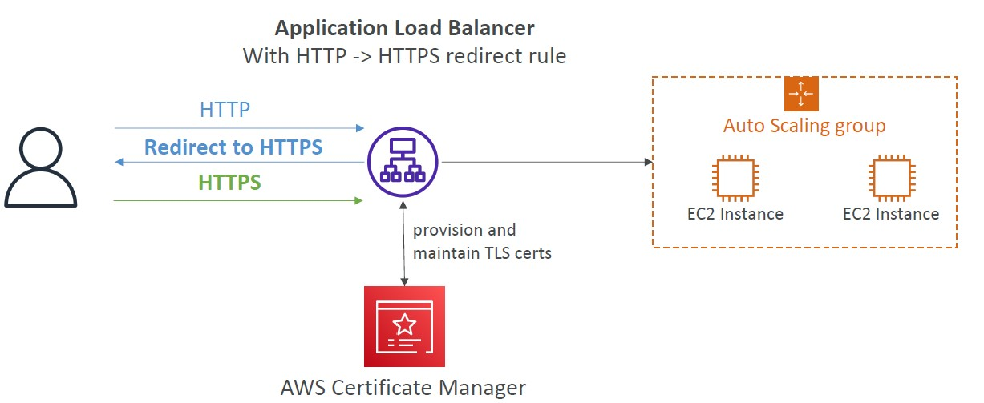

API Gateway - Endpoint Types

- Edge-Optimized (default): For global clients

• Requests are routed through the CloudFront Edge locations (improves latency)

• The API Gateway still lives in only one region

- Regional:

• For clients within the same region

• Could manually combine with CloudFront (more control over the caching

strategies and the distribution)

- Private:

• Can only be accessed from your VPC using an interface VPC endpoint (ENI)

• Use a resource policy to define access

ACM – Integration with API Gateway

• Create a Custom Domain Name in API Gateway

• Edge-Optimized (default): For global clients

• Requests are routed through the CloudFront Edge locations (improves latency)

• The API Gateway still lives in only one region

• The TLS Certificate must be in the same region as CloudFront, in us-east-1

• Then setup CNAME or (better) A-Alias record in Route 53

• Regional:

• For clients within the same region

• The TLS Certificate must be imported on API Gateway, in the same region as the API Stage

• Then setup CNAME or (better) A-Alias record in Route 53

AWS WAF – Web Application Firewall

• Protects your web applications from common web exploits (Layer 7)

• Layer 7 is HTTP (vs Layer 4 is TCP/UDP)

- Deploy on

• Application Load Balancer

• API Gateway

• CloudFront

• AppSync GraphQL API

• Cognito User Pool

AWS WAF – Web Application Firewall

• Define Web ACL (Web Access Control List) Rules:

• IP Set: up to 10,000 IP addresses – use multiple Rules for more IPs

• HTTP headers, HTTP body, or URI strings Protects from common attack – SQL injection and Cross-Site Scripting (XSS)

• Size constraints, geo-match (block countries)

• Rate-based rules (to count occurrences of events) – for DDoS protection

• Web ACL are Regional except for CloudFront

• A rule group is a reusable set of rules that you can add to a web ACL

WAF – Fixed IP while using WAF with a Load Balancer

• WAF does not support the Network Load Balancer (Layer 4)

• We can use Global Accelerator for fixed IP and WAF on the ALB

AWS Shield: protect from DDoS attack

• DDoS: Distributed Denial of Service – many requests at the same time

- AWS Shield Standard:

• Free service that is activated for every AWS customer

• Provides protection from attacks such as SYN/UDP Floods, Reflection attacks and other layer 3/layer 4 attacks

- AWS Shield Advanced:

• Optional DDoS mitigation service ($3,000 per month per organization)

• Protect against more sophisticated attack on Amazon EC2, Elastic Load Balancing (ELB), Amazon CloudFront, AWS Global Accelerator, and Route 53

• 24/7 access to AWS DDoS response team (DRP)

• Protect against higher fees during usage spikes due to DDoS

• Shield Advanced automatic application layer DDoS mitigation automatically creates, evaluates and deploys AWS WAF rules to mitigate layer 7 attacks

AWS Firewall Manager

• Manage rules in all accounts of an AWS Organization

• Security policy: common set of security rules

• WAF rules (Application Load Balancer, API Gateways, CloudFront)

• AWS Shield Advanced (ALB, CLB, NLB, Elastic IP, CloudFront)

• Security Groups for EC2, Application Load BAlancer and ENI resources in VPC

• AWS Network Firewall (VPC Level)

• Amazon Route 53 Resolver DNS Firewall

• Policies are created at the region level

• Rules are applied to new resources as they are created (good for compliance) across all and future accounts in your Organization

WAF vs. Firewall Manager vs. Shield

• WAF, Shield and Firewall Manager are used together for comprehensive protection

• Define your Web ACL rules in WAF

• For granular protection of your resources, WAF alone is the correct choice

• If you want to use AWS WAF across accounts, accelerate WAF configuration,

automate the protection of new resources, use Firewall Manager with AWS WAF

• Shield Advanced adds additional features on top of AWS WAF, such as dedicated

support from the Shield Response Team (SRT) and advanced reporting.

• If you’re prone to frequent DDoS attacks, consider purchasing Shield Advanced

AWS Best Practices for DDoS Resiliency Edge Location Mitigation (BP1, BP3)

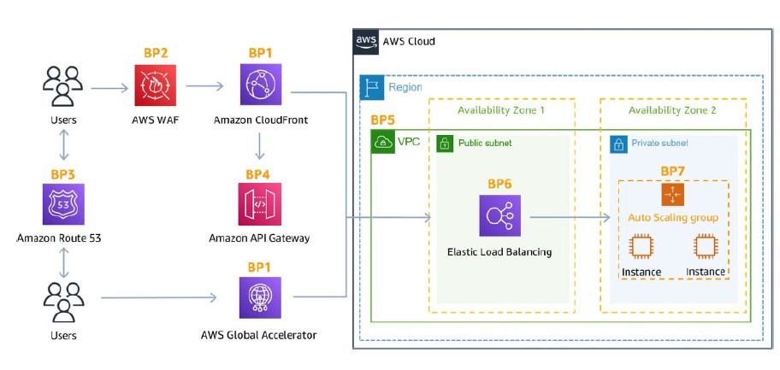

- BP1 – CloudFront

• Web Application delivery at the edge

• Protect from DDoS Common Attacks (SYN floods, UDP reflection…)

- BP1 – Global Accelerator

• Access your application from the edge

• Integration with Shield for DDoS protection

• Helpful if your backend is not compatible with CloudFront

- BP3 – Route 53

• Domain Name Resolution at the edge

• DDoS Protection mechanism

- Infrastructure layer defense (BP1, BP3, BP6)

• Protect Amazon EC2 against high traffic

• That includes using Global Accelerator, Route 53, CloudFront, Elastic Load Balancing

- Amazon EC2 with Auto Scaling (BP7)

• Helps scale in case of sudden traffic surges including a flash crowd or a DDoS attack

- Elastic Load Balancing (BP6)

• Elastic Load Balancing scales with the traffic increases and will distribute the traffic to many EC2 instances

- Detect and filter malicious web requests (BP1, BP2)

• CloudFront cache static content and serve it from edge locations, protecting your backend

• AWS WAF is used on top of CloudFront and Application Load Balancer to filter and block requests based on request signatures

• WAF rate-based rules can automatically block the IPs of bad actors

• Use managed rules on WAF to block attacks based on IP reputation, or block anonymous Ips

• CloudFront can block specific geographies

- Shield Advanced (BP1, BP2, BP6)

• Shield Advanced automatic application layer DDoS mitigation automatically creates, evaluates and deploys AWS WAF rules to mitigate layer 7 attacks

- Obfuscating AWS resources (BP1, BP4, BP6)

• Using CloudFront, API Gateway, ElasticLoad Balancing to hide your backend resources (Lambda functions, EC2 instances)

- Security groups and Network ACLs (BP5)

• Use security groups and NACLs to filter traffic based on specific IP at the subnet or ENI-level

• Elastic IP are protected by AWS Shield Advanced

-Protecting API endpoints (BP4)

• Hide EC2, Lambda, elsewhere

• Edge-optimized mode, or CloudFront + regional mode (more control for DDoS)

• WAF + API Gateway: burst limits, headers filtering, use API keys

Amazon GuardDuty

• Intelligent Threat discovery to protect your AWS Account

• Uses Machine Learning algorithms, anomaly detection, 3rd party data

• One click to enable (30 days trial), no need to install software

• Input data includes:

• CloudTrail Events Logs – unusual API calls, unauthorized deployments

• CloudTrail Management Events – create VPC subnet, create trail, …

• CloudTrail S3 Data Events – get object, list objects, delete object, …

• VPC Flow Logs – unusual internal traffic, unusual IP address

• DNS Logs – compromised EC2 instances sending encoded data within DNS queries

• Kubernetes Audit Logs – suspicious activities and potential EKS cluster compromises

• Can setup EventBridge rules to be notified in case of findings

• EventBridge rules can target AWS Lambda or SNS

• Can protect against CryptoCurrency attacks (has a dedicated “finding” for it)

Amazon Inspector

• Automated Security Assessments

• For EC2 instances

• Leveraging the AWS System Manager (SSM) agent

• Analyze against unintended network accessibility

• Analyze the running OS against known vulnerabilities

• For Container Images push to Amazon ECR

• Assessment of Container Images as they are pushed

• For Lambda Functions

• Identifies software vulnerabilities in function code and package dependencies

• Assessment of functions as they are deployed

• Reporting & integration with AWS Security Hub

• Send findings to Amazon Event Bridge

What does Amazon Inspector evaluate?

• only for EC2 instances, Container Images & Lambda functions

• Continuous scanning of the infrastructure, only when needed

• Package vulnerabilities (EC2, ECR & Lambda) – database of CVE

• Network reachability (EC2)

• A risk score is associated with all vulnerabilities for prioritization

AWS Macie

• Amazon Macie is a fully managed data security and data privacy service that uses machine learning and pattern matching to discover and protect your sensitive data in AWS.

• Macie helps identify and alert you to sensitive data, such as personally identifiable information (PII)

Understanding CIDR – IPv4

• Classless Inter-Domain Routing – a method for allocating IP addresses

• A CIDR consists of two components

• Base IP

• Represents an IP contained in the range (XX.XX.XX.XX)

• Example: 10.0.0.0, 192.168.0.0, …

• Subnet Mask

• Defines how many bits can change in the IP

• Example: /0, /24, /32

• Can take two forms:

• /8 -> 255.0.0.0

• /16 -> 255.255.0.0

• /24 -> 255.255.255.0

• /32 -> 255.255.255.255

Public vs. Private IP (IPv4)

• The Internet Assigned Numbers Authority (IANA) established certain blocks of IPv4 addresses for the use of private (LAN) and public (Internet) addresses

• Private IP can only allow certain values:

• 10.0.0.0 – 10.255.255.255 (10.0.0.0/8) <-in big networks

• 172.16.0.0 – 172.31.255.255 (172.16.0.0/12) <- AWS default VPC in that range

• 192.168.0.0 – 192.168.255.255 (192.168.0.0/16) <- e.g., home networks

• All the rest of the IP addresses on the Internet are Public

Default VPC Walkthrough

• All new AWS accounts have a default VPC

• New EC2 instances are launched into the default VPC if no subnet is specified

• Default VPC has Internet connectivity and all EC2 instances inside it have public IPv4 addresses

• We also get a public and a private IPv4 DNS names

VPC in AWS – IPv4

• VPC = Virtual Private Cloud

• You can have multiple VPCs in an AWS region (max. 5 per region – soft limit)

• Max. CIDR per VPC is 5, for each CIDR:

• Min. size is /28 (16 IP addresses)

• Max. size is /16 (65536 IP addresses)

• Because VPC is private, only the Private IPv4 ranges are allowed:

• 10.0.0.0 – 10.255.255.255 (10.0.0.0/8)

• 172.16.0.0 – 172.31.255.255 (172.16.0.0/12)

• 192.168.0.0 – 192.168.255.255 (192.168.0.0/16)

• Your VPC CIDR should NOT overlap with your other networks (e.g., corporate)

VPC – Subnet (IPv4)

• AWS reserves 5 IP addresses (first 4 & last 1) in each subnet

• These 5 IP addresses are not available for use and can’t be assigned to an EC2 instance

- Example: if CIDR block 10.0.0.0/24, then reserved IP addresses are:

• 10.0.0.0 – Network Address

• 10.0.0.1 – reserved by AWS for the VPC router

• 10.0.0.2 – reserved by AWS for mapping to Amazon-provided DNS

• 10.0.0.3 – reserved by AWS for future use

• 10.0.0.255 – Network Broadcast Address. AWS does not support broadcast in a VPC, therefore the address is reserved

-Exam Tip, if you need 29 IP addresses for EC2 instances:

• You can’t choose a subnet of size /27 (32 IP addresses, 32 – 5 = 27 < 29)

• You need to choose a subnet of size /26 (64 IP addresses, 64 – 5 = 59 > 29)

Internet Gateway (IGW)

• Allows resources (e.g., EC2 instances) in a VPC connect to the Internet

• It scales horizontally and is highly available and redundant

• Must be created separately from a VPC

• One VPC can only be attached to one IGW and vice versa

• Internet Gateways on their own do not allow Internet access…

• Route tables must also be edited

Bastion Hosts

• We can use a Bastion Host to SSH into our private EC2 instances

• The bastion is in the public subnet which is then connected to all other private subnets

• Bastion Host security group must allow inbound from the internet on port 22 from restricted CIDR, for example the public

CIDR of your corporation

• Security Group of the EC2 Instances must allow the Security Group of the Bastion Host, or the private IP of the Bastion host

NAT Instance (outdated)

• NAT = Network Address Translation

• Allows EC2 instances in private subnets to connect to the Internet

• Must be launched in a public subnet

• Must disable EC2 setting: Source /destination Check

• Must have Elastic IP attached to it

• Route Tables must be configured to route traffic from private subnets to the NAT Instance

• Pre-configured Amazon Linux AMI is available

• Reached the end of standard support on December 31, 2020

• Not highly available / resilient setup out of the box

• You need to create an ASG in multi-AZ + resilient user-data script

• Internet traffic bandwidth depends on EC2 instance type

-You must manage Security Groups & rules:

- Inbound:

• Allow HTTP / HTTPS traffic coming from Private Subnets

• Allow SSH from your home network (access is provided through Internet Gateway)

- Outbound: Allow HTTP / HTTPS traffic to the Internet

NAT Gateway

• AWS-managed NAT, higher bandwidth, high availability, no administration

• Pay per hour for usage and bandwidth

• NATGW is created in a specific Availability Zone, uses an Elastic IP

• Can’t be used by EC2 instance in the same subnet (only from other subnets)

• Requires an IGW (Private Subnet => NATGW => IGW)

• 5 Gbps of bandwidth with automatic scaling up to 45 Gbps

• No Security Groups to manage / required

NAT Gateway with High Availability

• NAT Gateway is resilient within a single Availability Zone

• Must create multiple NAT Gateways in multiple AZs for fault-tolerance

• There is no cross-AZ failover needed because if an AZ goes down it doesn't need NAT

NAT Gateway vs. NAT Instance

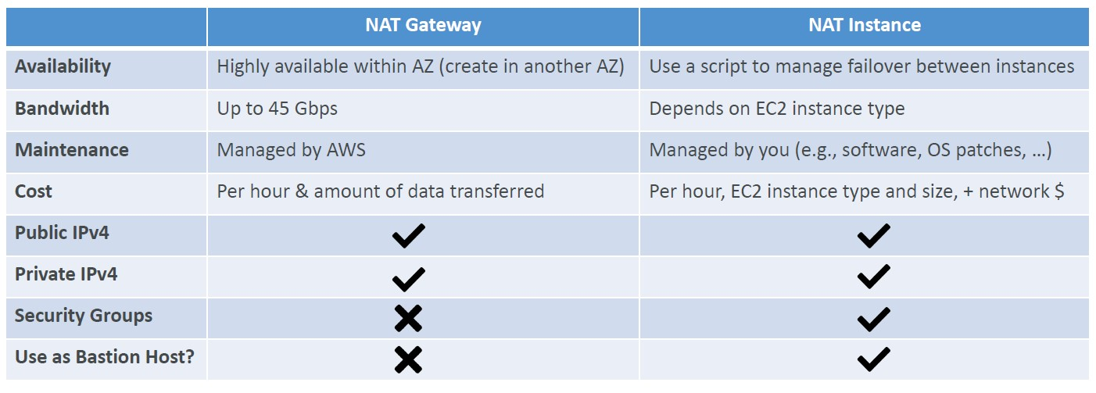

Security Groups & NACLs

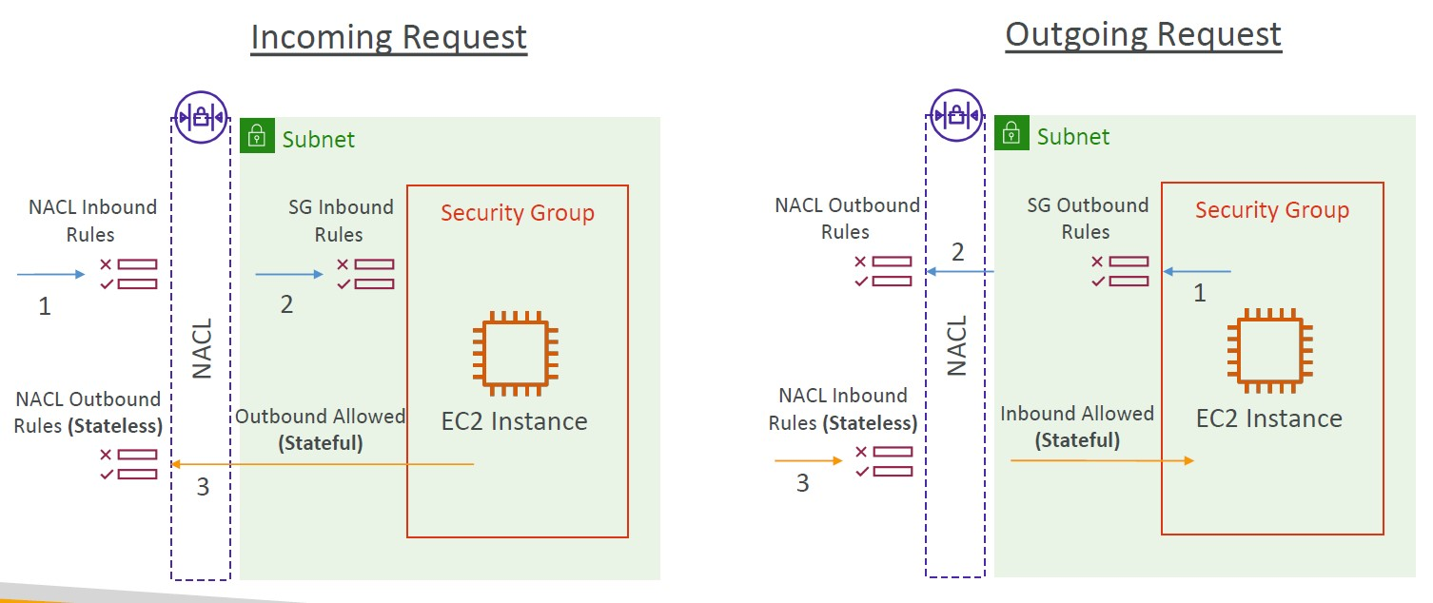

Network Access Control List (NACL)

• NACL are like a firewall which control traffic from and to subnets

• One NACL per subnet, new subnets are assigned the Default NACL

- You define NACL Rules:

• Rules have a number (1-32766), higher precedence with a lower number

• First rule match will drive the decision

• Example: if you define #100 ALLOW 10.0.0.10/32 and #200 DENY 10.0.0.10/32, the IP

address will be allowed because 100 has a higher precedence over 200

• The last rule is an asterisk (*) and denies a request in case of no rule match

• AWS recommends adding rules by increment of 100

- Newly created NACLs will deny everything

- NACL are a great way of blocking a specific IP address at the subnet level

Default NACL

• Accepts everything inbound/outbound with the subnets it’s associated with

• Do NOT modify the Default NACL, instead create custom NACLs

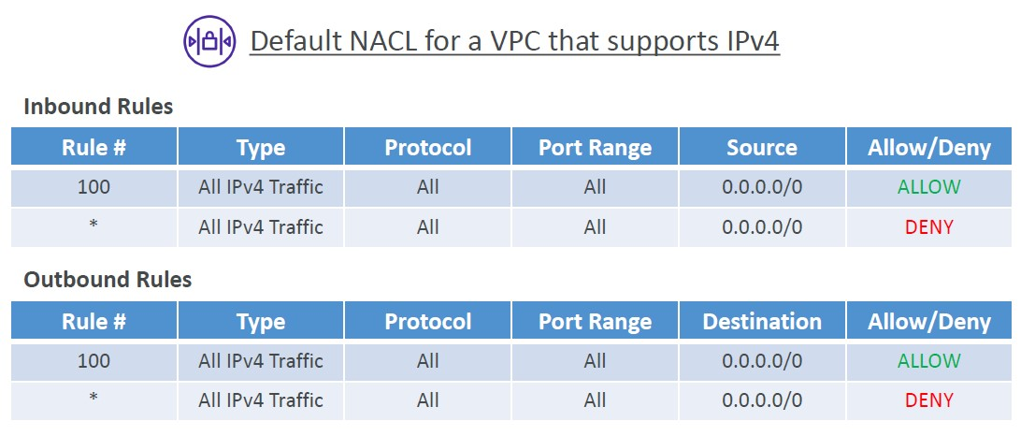

Ephemeral Ports

• For any two endpoints to establish a connection, they must use ports

• Clients connect to a defined port, and expect a response on an ephemeral port

• Different Operating Systems use different port ranges, examples:

• IANA & MS Windows 10 è 49152 – 65535

• Many Linux Kernels è 32768 – 60999

Ephemeral Ports

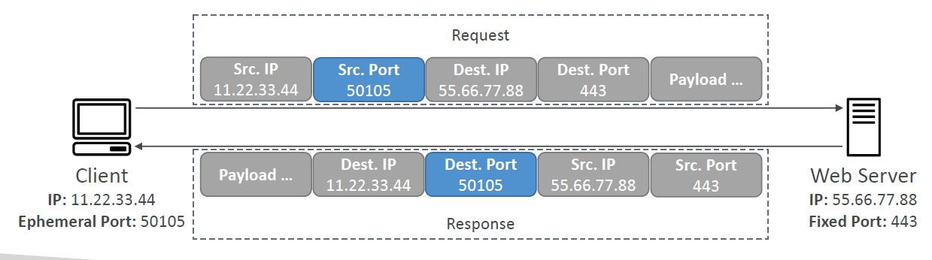

NACL with Ephemeral Ports

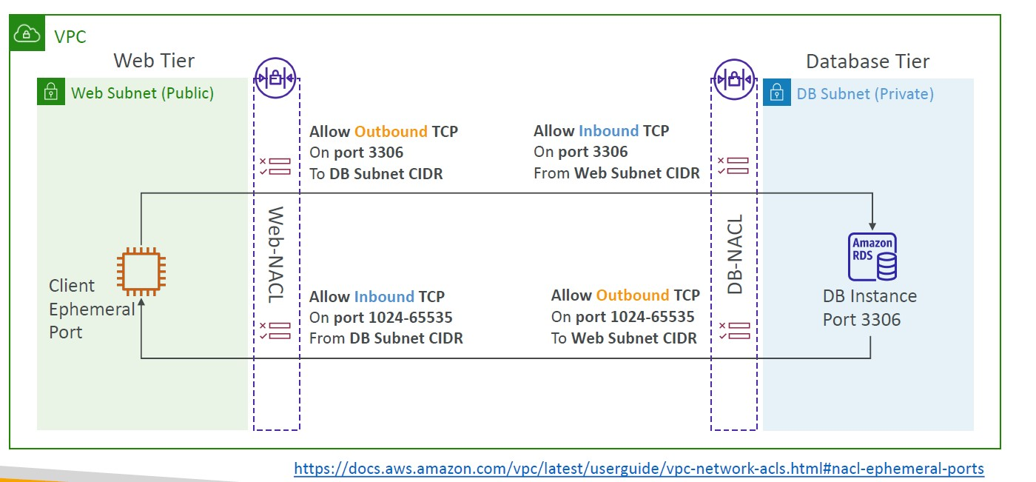

Create NACL rules for each target subnets CIDR

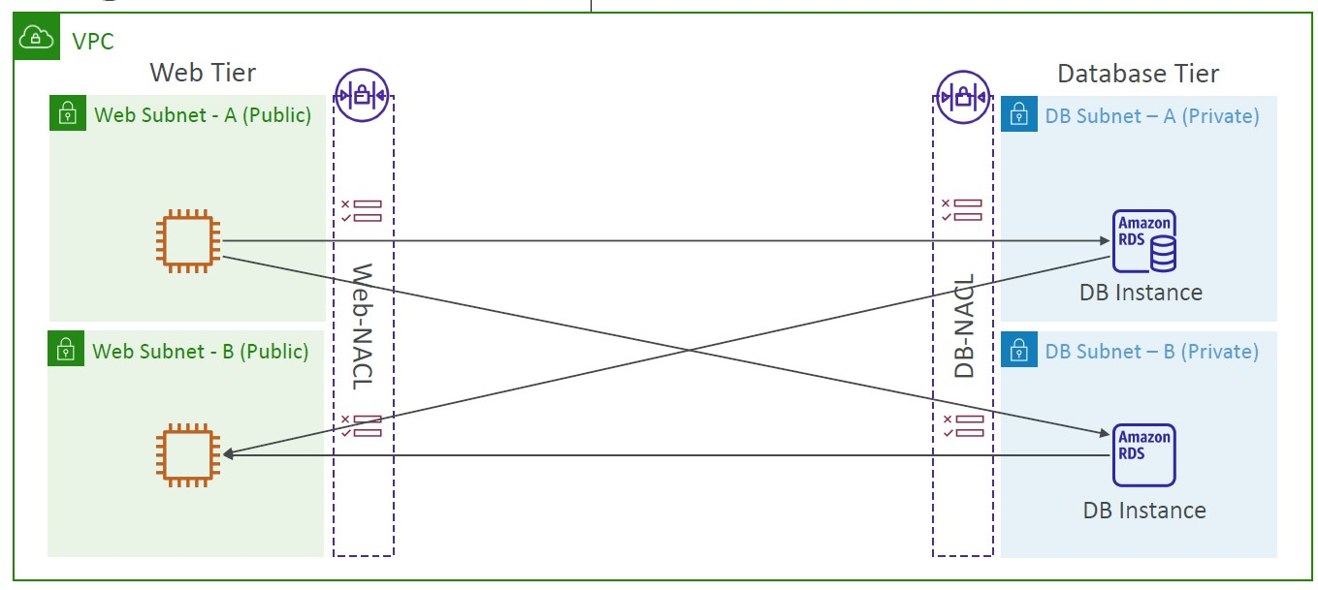

Security Group vs. NACLs

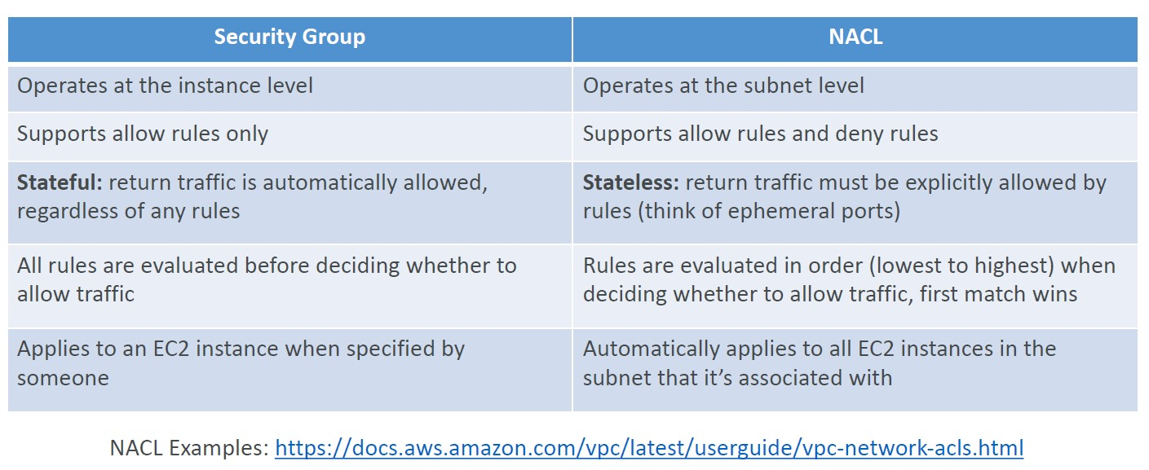

VPC Peering

• Privately connect two VPCs using AWS’ network

• Make them behave as if they were in the same network

• Must not have overlapping CIDRs

• VPC Peering connection is NOT transitive (must be established for each VPC that need to communicate with one another)

• You must update route tables in each VPC’s subnets to ensure EC2 instances can communicate with each other

VPC Peering – Good to know

• You can create VPC Peering connection between VPCs in different AWS accounts/regions

• You can reference a security group in a peered VPC (works cross accounts – same region)

VPC Endpoints (AWS PrivateLink)

• Every AWS service is publicly exposed (public URL)

• VPC Endpoints (powered by AWSPrivateLink) allows you to connect to AWS services using a private network instead of

using the public Internet

• They’re redundant and scale horizontally

• They remove the need of IGW, NATGW, …to access AWS Services

- In case of issues:

• Check DNS Setting Resolution in your VPC

• Check Route Tables

Types of Endpoints

- Interface Endpoints (powered by PrivateLink)

• Provisions an ENI (private IP address) as an entry point (must attach a Security Group)

• Supports most AWS services

• $ per hour + $ per GB of data processed

- Gateway Endpoints

• Provisions a gateway and must be used as a target in a route table (does not use security groups)

• Supports both S3 and DynamoDB

• Free

Gateway or Interface Endpoint for S3?

• Gateway is most likely going to be preferred all the time at the exam

• Cost: free for Gateway, $ for interface endpoint

• Interface Endpoint is preferred access is required from on premises (Site to Site VPN or Direct Connect), a different VPC

or a different region

Lambda in VPC accessing DynamoDB

• DynamoDB is a public service from AWS

- Option 1: Access from the public internet

• Because Lambda is in a VPC, it needs a NAT Gateway in a public subnet and an internet gateway

- Option 2 (better & free): Access from the private VPC network

• Deploy a VPC Gateway endpoint for DynamoDB

• Change the Route Tables

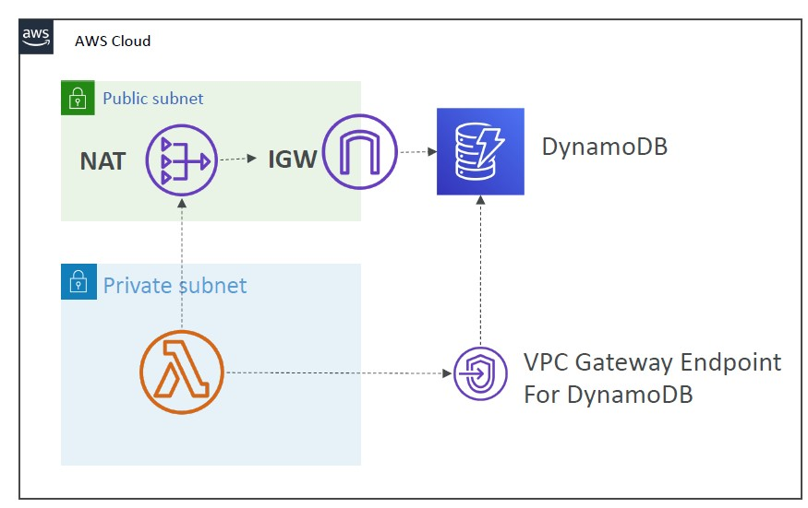

VPC Flow Logs

• Capture information about IP traffic going into your interfaces:

• VPC Flow Logs

• Subnet Flow Logs

• Elastic Network Interface (ENI) Flow Logs

• Helps to monitor & troubleshoot connectivity issues

• Flow logs data can go to S3 / CloudWatch Logs

• Captures network information from AWS managed interfaces too: ELB, RDS, ElastiCache, Redshift, WorkSpaces, NATGW, Transit Gateway…

VPC Flow Logs Syntax

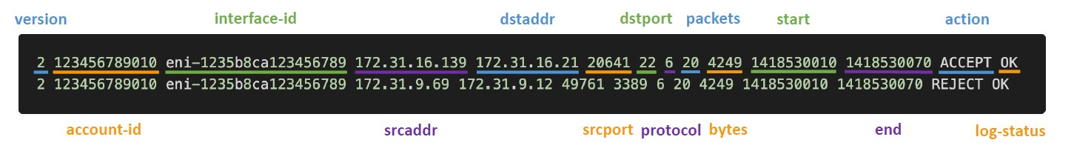

• srcaddr & dstaddr – help identify problematic IP

• srcport & dstport – help identity problematic ports

• Action – success or failure of the request due to Security Group / NACL

• Can be used for analytics on usage patterns, or malicious behavior

• Query VPC flow logs using Athena on S3 or CloudWatch Logs Insights

• Flow Logs examples: <https://docs.aws.amazon.com/vpc/latest/userguide/flow-logsrecords-examples.html>

VPC Flow Logs – Troubleshoot SG & NACL issues

Look at the “ACTION” field

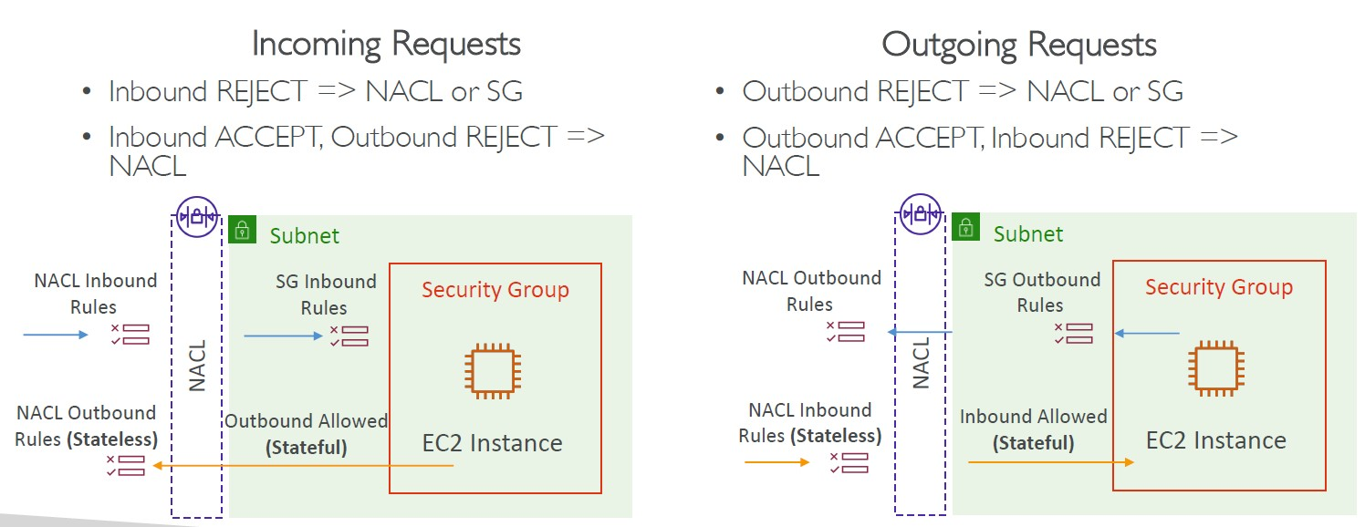

VPC Flow Logs – Architectures

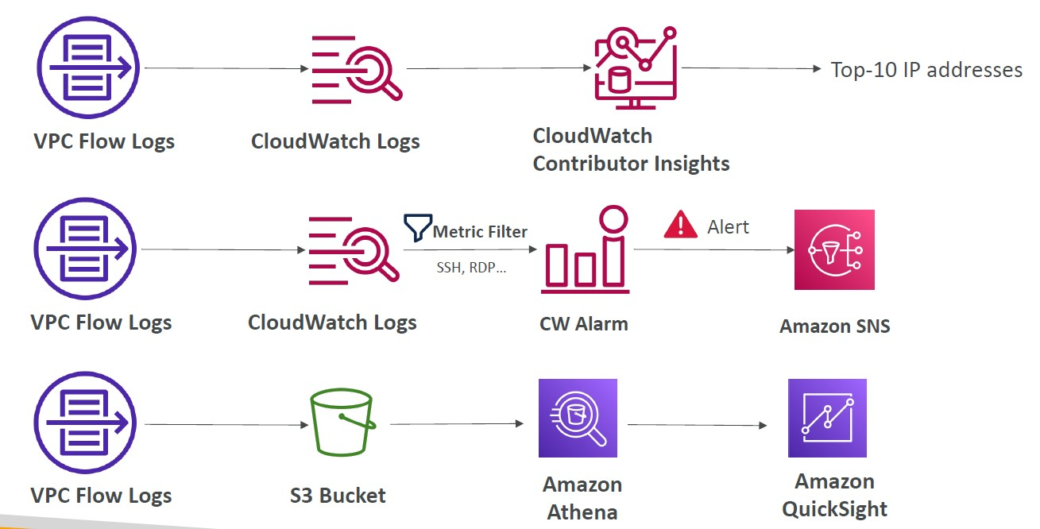

AWS Site-to-Site VPN

- Virtual Private Gateway (VGW)

• VPN concentrator on the AWS side of the VPN connection

• VGW is created and attached to the VPC from which you want to create the Site-to-Site VPN connection

• Possibility to customize the ASN (Autonomous System Number)

- Customer Gateway (CGW)

• Software application or physical device on customer side of the VPN connection

• <https://docs.aws.amazon.com/vpn/latest/s2svpn/your-cgw.html#DevicesTested>

Site-to-Site VPN Connections

• Customer Gateway Device (On-premises)

• What IP address to use?

• Public Internet-routable IP address for your Customer Gateway device

• If it’s behind a NAT device that’s enabled for NAT traversal (NAT-T), use the public IP address of the NAT device

• Important step: enable Route Propagation for the Virtual Private Gateway in the route table that is associated with your subnets

*Route propagation allows a virtual private gateway to automatically propagate routes to the route tables so that you don't need to manually enter VPN routes to your route tables

• If you need to ping your EC2 instances from on-premises, make sure you add the ICMP protocol on the inbound of your security groups

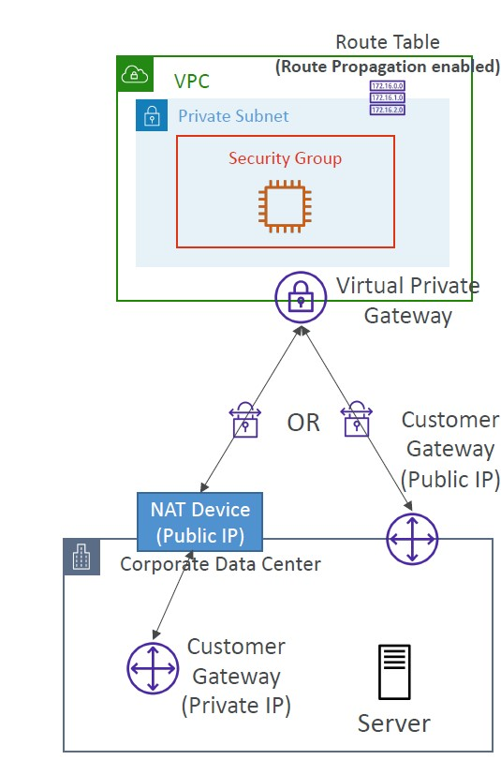

AWS VPN CloudHub

• Provide secure communication between multiple sites, if you have multiple VPN connections

• Low-cost hub-and-spoke model for primary or secondary network connectivity between different locations (VPN only)

• It’s a VPN connection so it goes over thepublic Internet

• To set it up, connect multiple VPN connections on the same VGW, setup dynamic routing and configure route tables

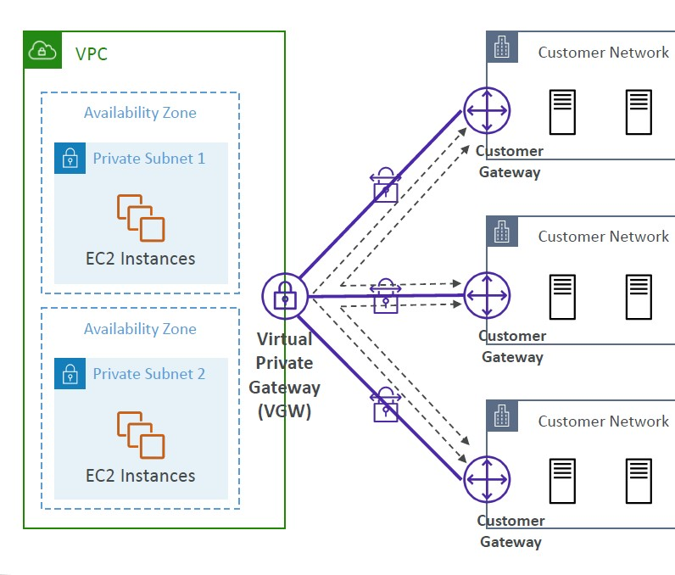

Direct Connect (DX)

• Provides a dedicated private connection from a remote network to your VPC

• Dedicated connection must be setup between your DC and AWS Direct Connect locations

• You need to setup a Virtual Private Gateway on your VPC

• Access public resources (S3) and private (EC2) on same connection

• Use Cases:

• Increase bandwidth throughput - working with large data sets – lower cost

• More consistent network experience - applications using real-time data feeds

• Hybrid Environments (on prem + cloud)

• Supports both IPv4 and IPv6

Direct Connect Diagram

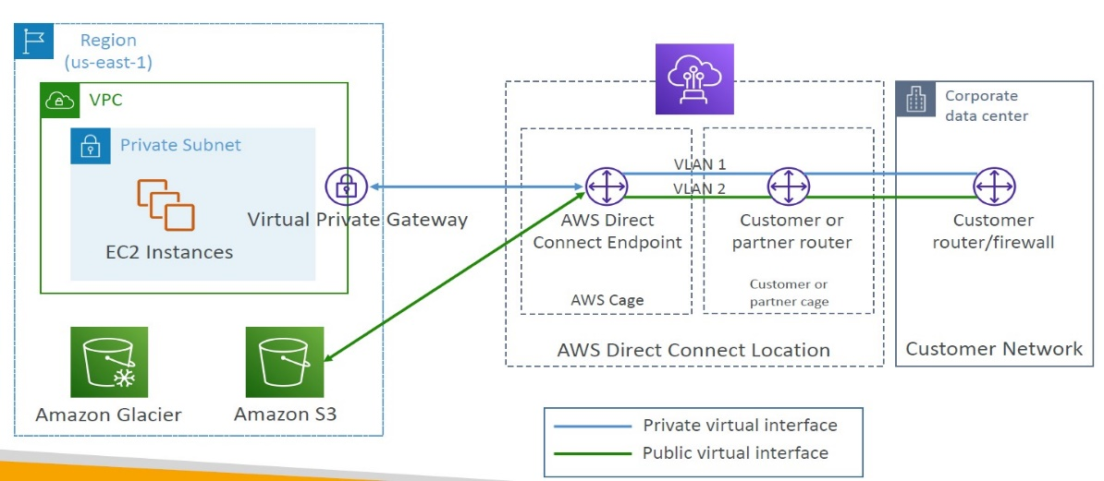

Direct Connect Gateway

• If you want to setup a Direct Connect to one or more VPC in many different regions (same account), you must use a Direct Connect Gateway

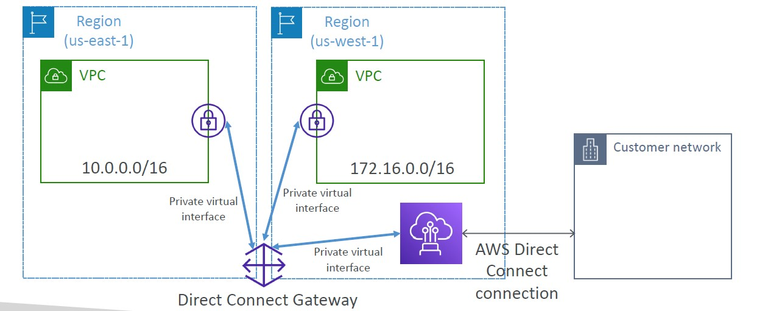

Direct Connect – Connection Types

- Dedicated Connections: 1Gbps,10 Gbps and 100 Gbps capacity

• Physical ethernet port dedicated to a customer

• Request made to AWS first, then completed by AWS Direct Connect Partners

- Hosted Connections: 50Mbps, 500 Mbps, to 10 Gbps

• Connection requests are made via AWS Direct Connect Partners

• Capacity can be added or removed on demand

• 1, 2, 5, 10 Gbps available at select AWS Direct Connect Partners

- Lead times are often longer than 1 month to establish a new connection

Direct Connect – Encryption

• Data in transit is not encrypted but is private

• AWS Direct Connect + VPN provides an IPsec-encrypted private connection

• Good for an extra level of security, but slightly more complex to put in place

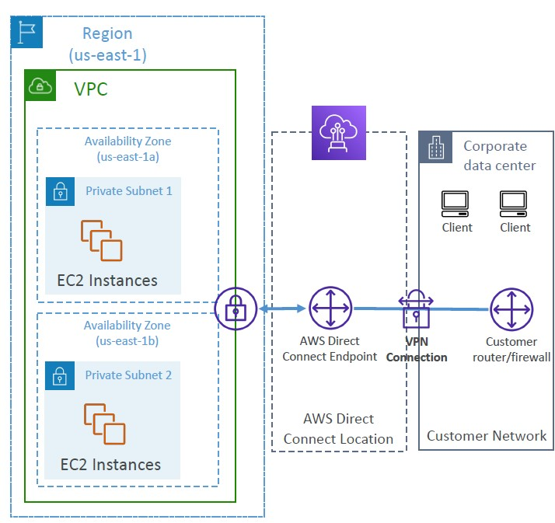

Direct Connect – Resiliency

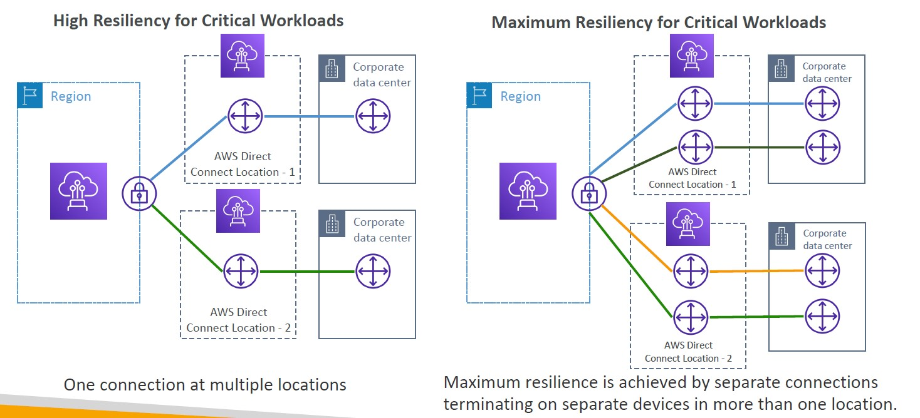

Site-to-Site VPN connection as a backup

• In case Direct Connect fails, you can set up a backup Direct Connect connection (expensive), or a Site-to-Site VPN connection

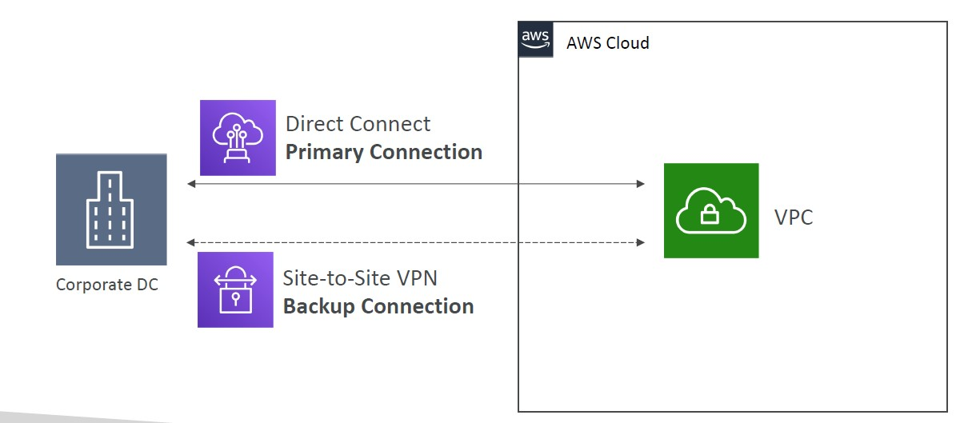

Transit Gateway

• For having transitive peering between thousands of VPC and on-premises, hub-and-spoke (star) connection

• Regional resource, can work cross-region

• Share cross-account using Resource Access Manager (RAM)

• You can peer Transit Gateways across regions

• Route Tables: limit which VPC can talk with other VPC

• Works with Direct Connect Gateway, VPN connections

• Supports IP Multicast (not supported by any other AWS service)

Transit Gateway: Site-to-Site VPN ECMP

• ECMP = Equal-cost multi-path routing

• Routing strategy to allow to forward a packet over multiple best path

• Use case: create multiple Site to Site VPN connections to increase the bandwidth of your connection to AWS

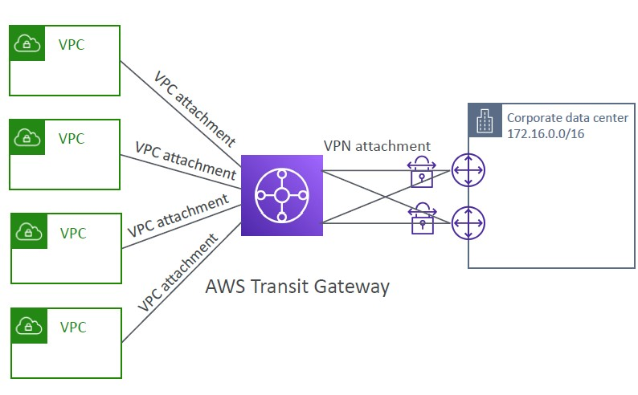

Transit Gateway: throughput with ECMP

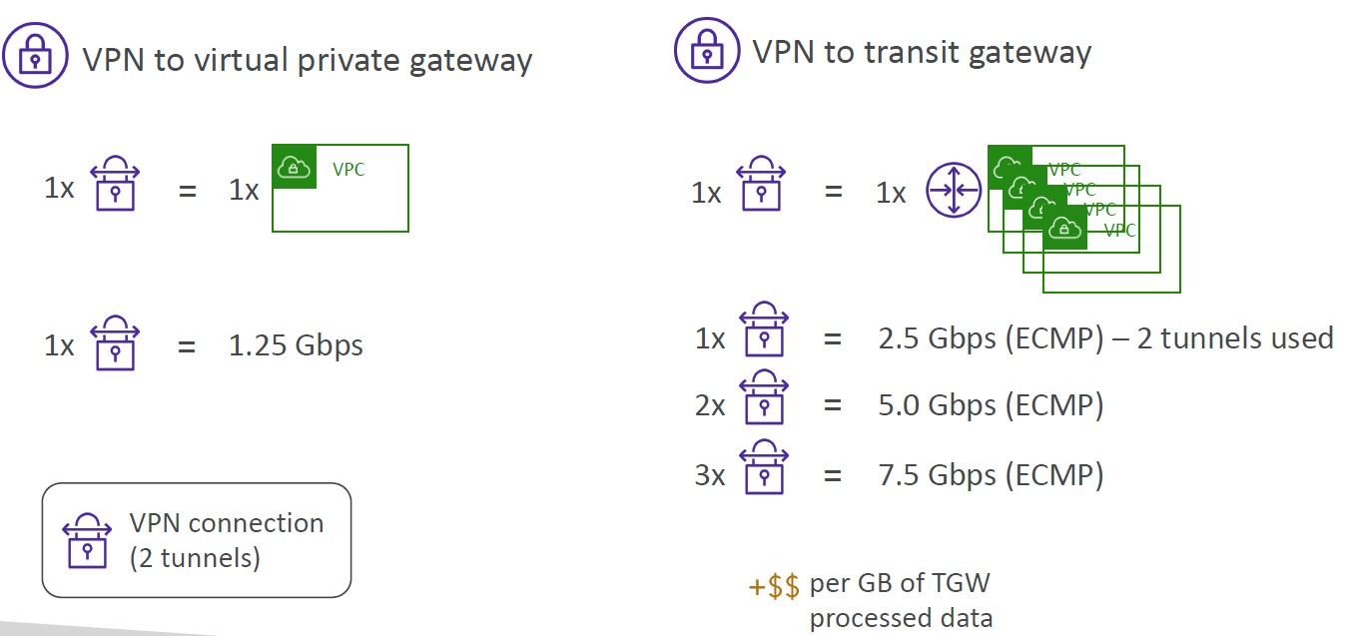

Transit Gateway – Share Direct Connect between multiple accounts

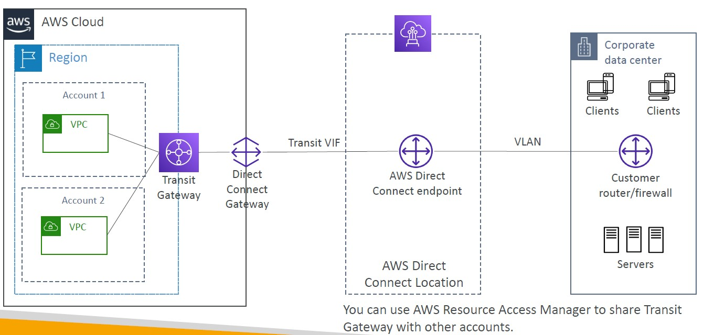

VPC – Traffic Mirroring

• Allows you to capture and inspect network traffic in your VPC

• Route the traffic to security appliances that you manage

• Capture the traffic

• From (Source) – ENIs

• To (Targets) – an ENI or a Network Load Balancer

• Capture all packets or capture the packets of your interest (optionally, truncate packets)

• Source and Target can be in the same VPC or different VPCs (VPC Peering)

• Use cases: content inspection, threat monitoring, troubleshooting, …

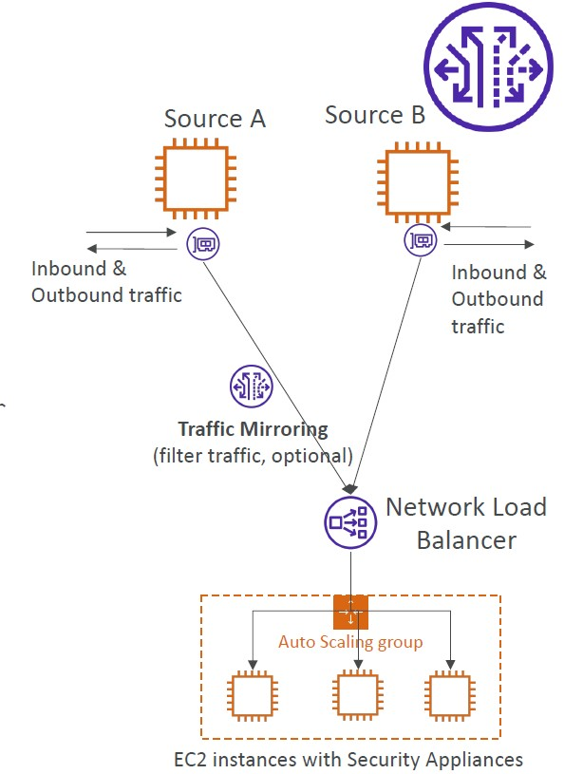

IPv6 in VPC

• IPv4 cannot be disabled for your VPC and subnets

• You can enable IPv6 (they’re public IP addresses) to operate in dual-stack mode

• Your EC2 instances will get at least a private internal IPv4 and a public IPv6

• They can communicate using either IPv4 or IPv6 to the internet through an Internet Gateway

IPv6 Troubleshooting

• IPv4 cannot be disabled for your VPC and subnets

• So, if you cannot launch an EC2 instance in your subnet

• It’s not because it cannot acquire an IPv6 (the space is very large)

• It’s because there are no available IPv4 in your subnet

• Solution: create a new IPv4 CIDR in your subnet

Egress-only Internet Gateway

• Used for IPv6 only

• (similar to a NAT Gateway but for IPv6)

• Allows instances in your VPC outbound connections over IPv6 while preventing the internet to initiate an IPv6 connection

to your instances

• You must update the Route Tables

IPv6 Routing

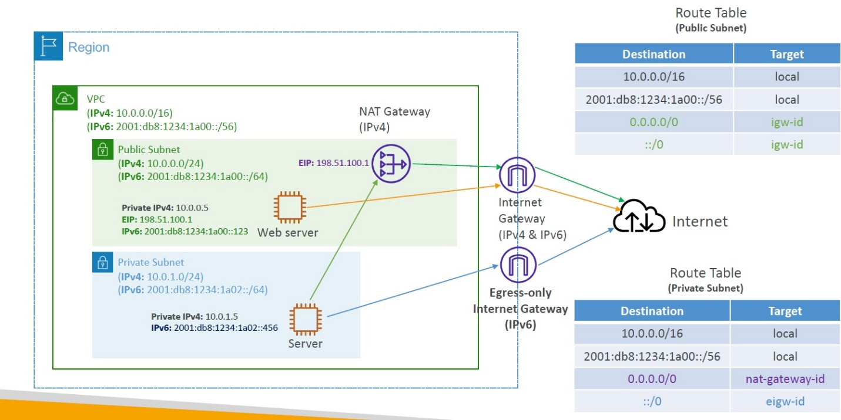

VPC Section Summary

• CIDR – IP Range

• VPC – Virtual Private Cloud => we define a list of IPv4 & IPv6 CIDR

• Subnets – tied to an AZ, we define a CIDR

• Internet Gateway – at the VPC level, provide IPv4 & IPv6 Internet Access

• Route Tables – must be edited to add routes from subnets to the IGW, VPC Peering Connections, VPC Endpoints, …

• Bastion Host – public EC2 instance to SSH into, that has SSH connectivity to EC2 instances in private subnets

• NAT Instances – gives Internet access to EC2 instances in private subnets. Old, must be setup in a public subnet, disable Source / Destination check flag

• NAT Gateway – managed by AWS, provides scalable Internet access to private EC2 instances, IPv4 only

• Private DNS + Route 53 – enable DNS Resolution + DNS Hostnames (VPC)

• NACL – stateless, subnet rules for inbound and outbound, don’t forget Ephemeral Ports

• Security Groups – stateful, operate at the EC2 instance level

• Reachability Analyzer – perform network connectivity testing between AWS resources

• VPC Peering – connect two VPCs with non overlapping CIDR, non-transitive

• VPC Endpoints – provide private access to AWS Services (S3, DynamoDB, CloudFormation, SSM) within a VPC

• VPC Flow Logs – can be setup at the VPC / Subnet / ENI Level, for ACCEPT and REJECT traffic, helps identifying attacks, analyze using Athena or CloudWatch Logs Insights

• Site-to-Site VPN – setup a Customer Gateway on DC, a Virtual Private Gateway on VPC, and site-to-site VPN over public Internet

• AWS VPN CloudHub – hub-and-spoke VPN model to connect your sites

• Direct Connect – setup a Virtual Private Gateway on VPC, and establish a direct private connection to an AWS Direct Connect Location

• Direct Connect Gateway – setup a Direct Connect to many VPCs in different AWS regions

• AWS PrivateLink / VPC Endpoint Services:

• Connect services privately from your service VPC to customers VPC

• Doesn’t need VPC Peering, public Internet, NAT Gateway, Route Tables

• Must be used with Network Load Balancer & ENI

• ClassicLink – connect EC2-Classic EC2 instances privately to your VPC

• Transit Gateway – transitive peering connections for VPC, VPN & DX

• Traffic Mirroring – copy network traffic from ENIs for further analysis

• Egress-only Internet Gateway – like a NAT Gateway, but for IPv6

Networking Costs in AWS per GB – Simplified

• Use Private IP instead of Public IP for good savings and better network performance

• Use same AZ for maximum savings (at the cost of high availability)

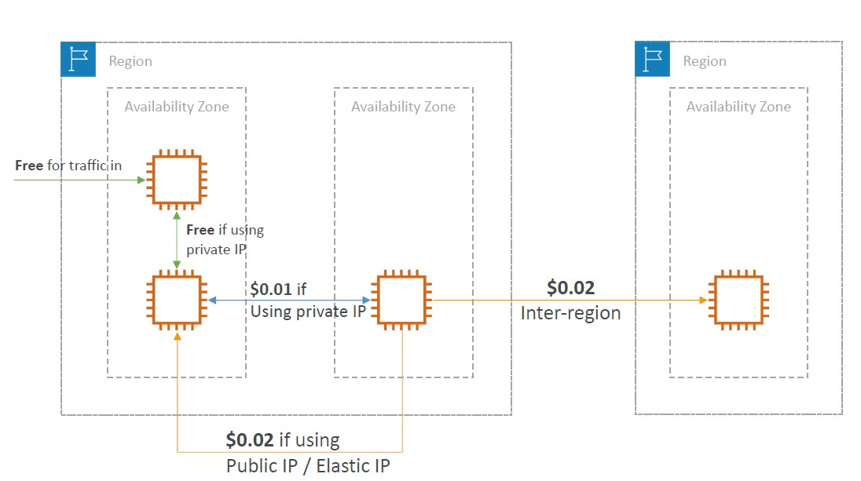

Minimizing egress traffic network cost

• Egress traffic: outbound traffic (from AWS to outside)

• Ingress traffic: inbound traffic - from outside to AWS (typically free)

• Try to keep as much internet traffic within AWS to minimize costs

• Direct Connect location that are co-located in the same AWS Region result in lower cost for egress network

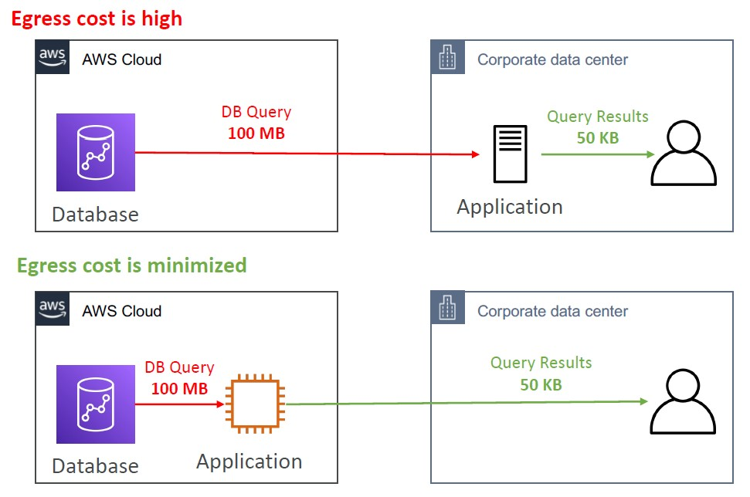

S3 Data Transfer Pricing – Analysis for USA

• S3 ingress: free

• S3 to Internet: $0.09 per GB

• S3 Transfer Acceleration:

• Faster transfer times (50 to 500% better)

• Additional cost on top of Data Transfer Pricing: +$0.04 to $0.08 per GB

• S3 to CloudFront: $0.00 per GB

• CloudFront to Internet: $0.085 per GB (slightly cheaper than S3)

• Caching capability (lower latency)

• Reduce costs associated with S3 Requests Pricing (7x cheaper with CloudFront)

• S3 Cross Region Replication: $0.02 per GB

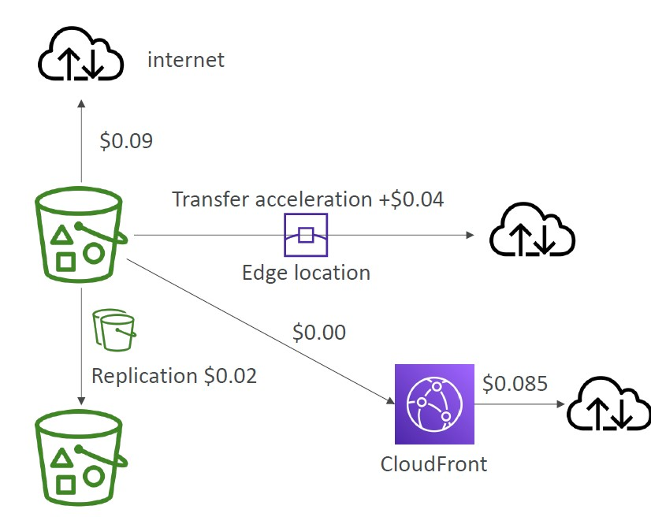

NAT Gateway vs Gateway VPC Endpoint- Pricing

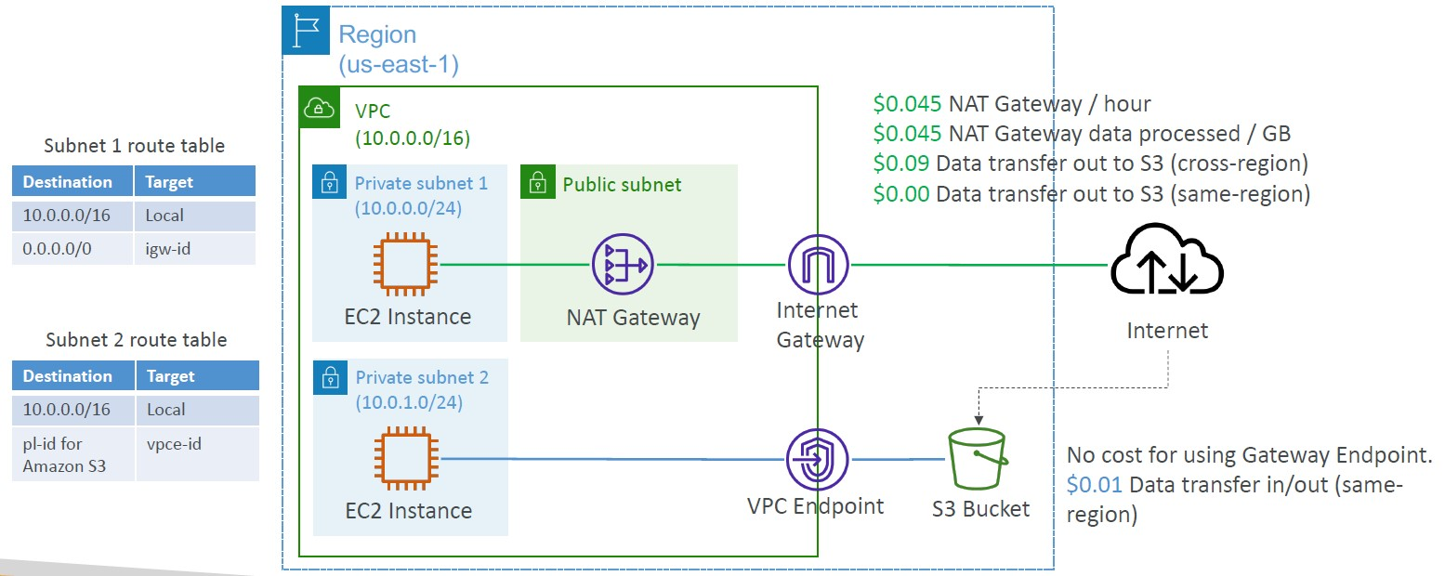

Network Protection on AWS

• Network Access Control Lists (NACLs)

• Amazon VPC security groups

• AWS WAF (protect against malicious requests)

• AWS Shield & AWS Shield Advanced

• AWS Firewall Manager (to manage them across accounts)

AWS Network Firewall

• Protect your entire Amazon VPC

• From Layer 3 to Layer 7 protection

• Any direction, you can inspect

• VPC to VPC traffic

• Outbound to internet

• Inbound from internet

• To / from Direct Connect & Site-to-Site VPN

• Internally, the AWS Network Firewall uses the AWS Gateway Load Balancer

• Rules can be centrally managed cross account by AWS Firewall Manager to apply to many VPCs

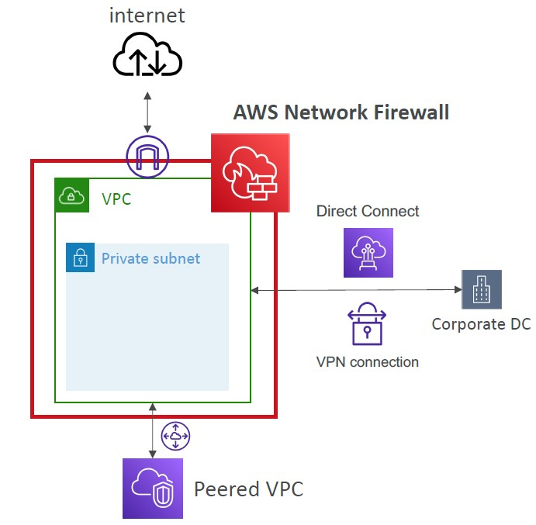

Network Firewall – Fine Grained Controls

• Supports 1000s of rules

• IP & port - example: 10,000s of IPs filtering

• Protocol – example: block the SMB protocol for outbound communications

• Stateful domain list rule groups: only allow outbound traffic to *.mycorp.com or third-party software repo

• General pattern matching using regex

• Traffic filtering: Allow, drop, or alert for the traffic that matches the rules

• Active flow inspection to protect against network threats with intrusion-prevention capabilities (like Gateway Load Balancer, but all managed by AWS)

• Send logs of rule matches to Amazon S3, CloudWatch Logs, Kinesis Data Firehose

Disaster Recovery RPO and RTO

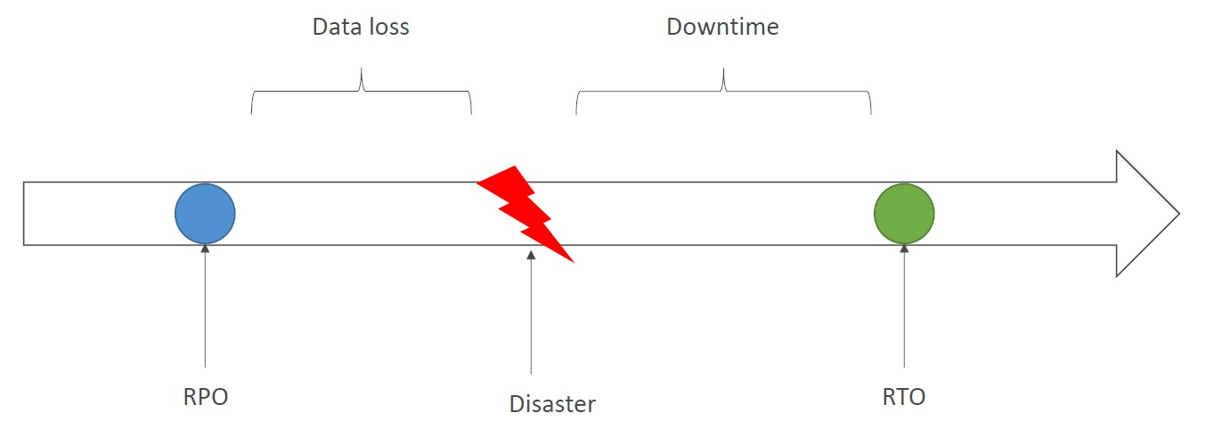

Disaster Recovery Strategies

Backup and Restore (High RPO)

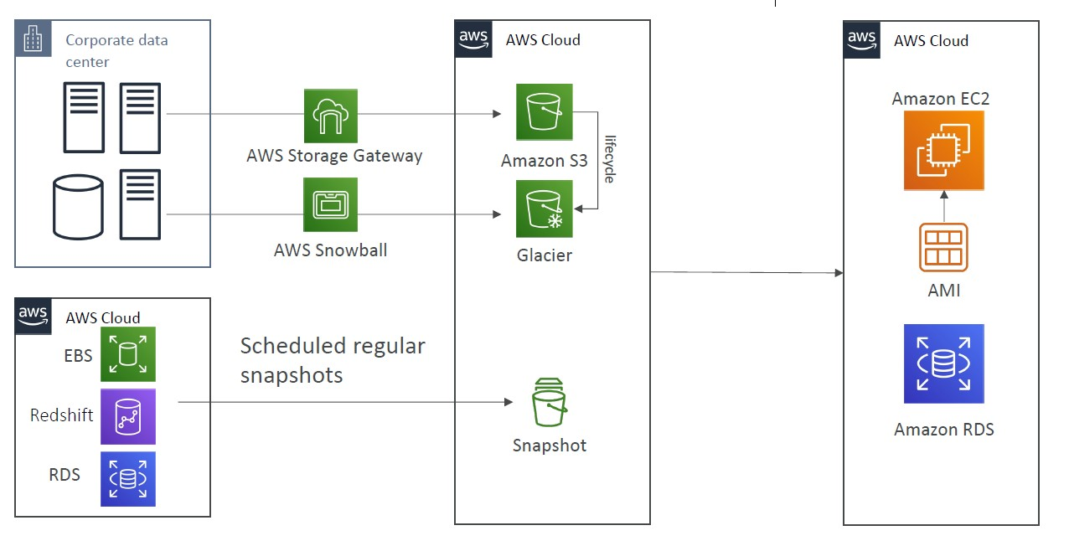

Pilot Light

• A small version of the app is always running in the cloud

• Useful for the critical core (pilot light)

• Very similar to Backup and Restore

• Faster than Backup and Restore as critical systems are already up

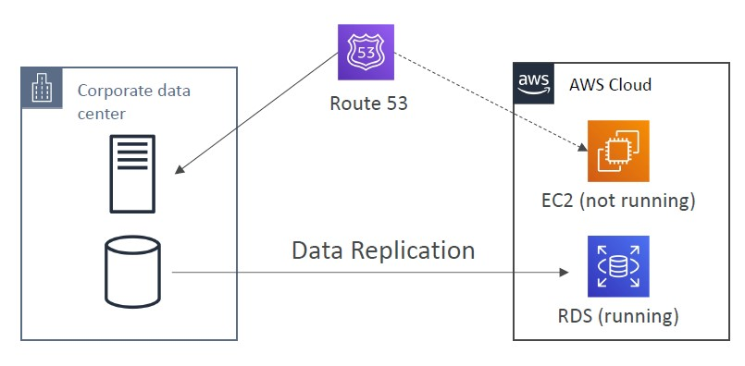

Warm Standby

• Full system is up and running, but at minimum size

• Upon disaster, we can scale to production load

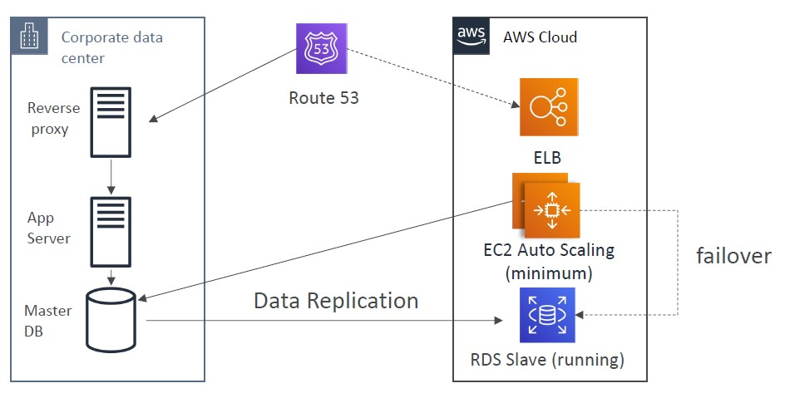

Multi Site / Hot Site Approach

• Very low RTO (minutes or seconds) – very expensive

• Full Production Scale is running AWS and On Premise

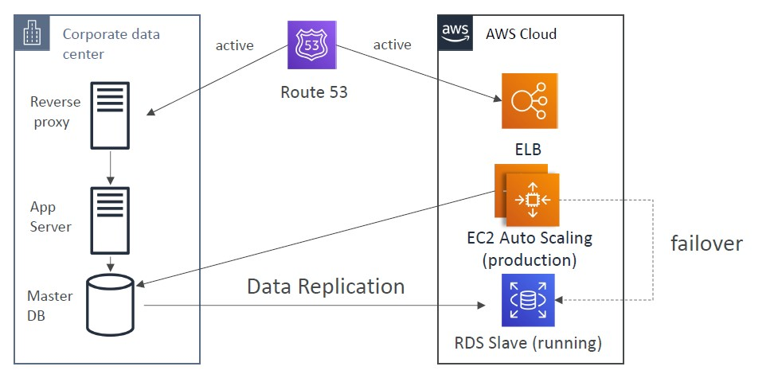

All AWS Multi Region

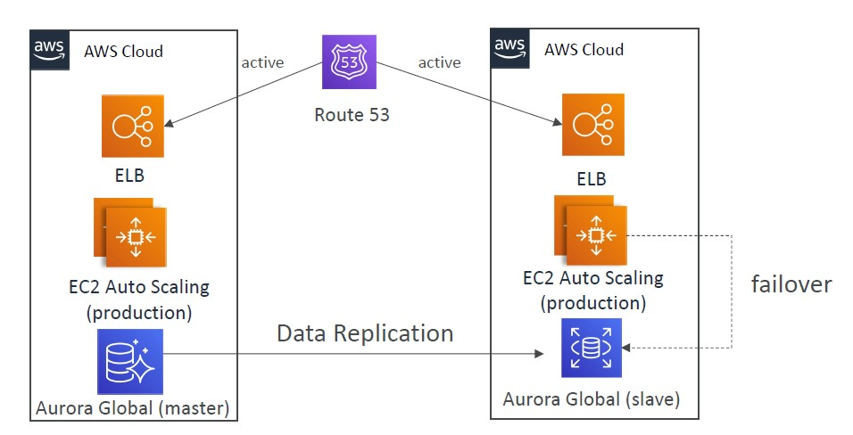

Disaster Recovery Tips

- Backup

• EBS Snapshots, RDS automated backups / Snapshots, etc…

• Regular pushes to S3 / S3 IA / Glacier, Lifecycle Policy, Cross Region Replication

• From On-Premise: Snowball or Storage Gateway

- High Availability

• Use Route53 to migrate DNS over from Region to Region

• RDS Multi-AZ, ElastiCache Multi-AZ, EFS, S3

• Site to Site VPN as a recovery from Direct Connect

- Replication

• RDS Replication (Cross Region), AWS Aurora + Global Databases

• Database replication from on-premises to RDS

• Storage Gateway

- Automation

• CloudFormation / Elastic Beanstalk to re-create a whole new environment

• Recover / Reboot EC2 instances with CloudWatch if alarms fail

• AWS Lambda functions for customized automations

- Chaos

• Netflix has a “simian-army” randomly terminating EC2

DMS – Database Migration Service

• Quickly and securely migrate databases to AWS, resilient, self healing

• The source database remains available during the migration

- Supports:

• Homogeneous migrations: ex Oracle to Oracle

• Heterogeneous migrations: ex Microsoft SQL Server to Aurora

- Continuous Data Replication using CDC

-You must create an EC2 instance to perform the replication tasks

DMS Sources and Targets

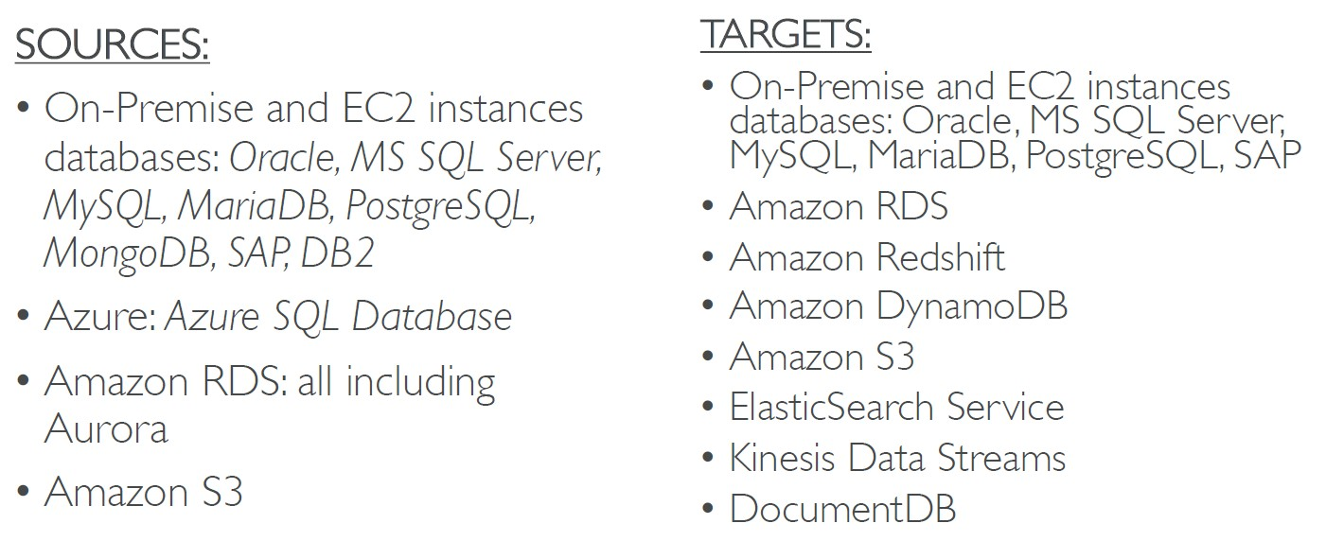

AWS Schema Conversion Tool (SCT)

• Convert your Database’s Schema from one engine to another

• Example OLTP: (SQL Server or Oracle) to MySQL, PostgreSQL, Aurora

• Example OLAP: (Teradata or Oracle) to Amazon Redshift

• Prefer compute-intensive instances to optimize data conversions

• You do not need to use SCT if you are migrating the same DB engine

- Ex: On-Premise PostgreSQL => RDS PostgreSQL

• The DB engine is still PostgreSQL (RDS is the platform)

DMS - Continuous Replication

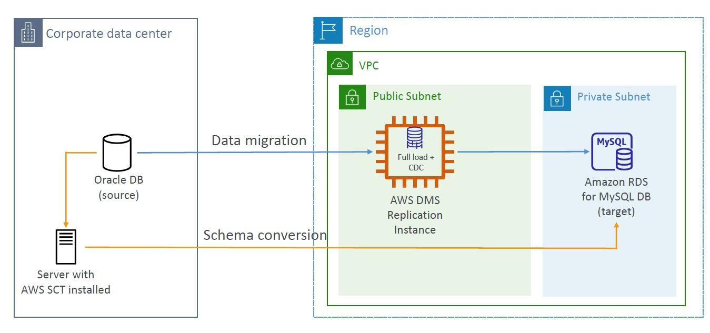

RDS & Aurora MySQL Migrations

- RDS MySQL to Aurora MySQL

- Option 1: DB Snapshots from RDS MySQL restored as

MySQL Aurora DB

- Option 2: Create an Aurora Read Replica from your RDS MySQL, and when the replication lag is 0, promote it as its own DB cluster (can take time and cost $)

- External MySQL to Aurora MySQL

• Option 1:

• Use Percona XtraBackup to create a file backup in Amazon S3

• Create an Aurora MySQL DB from Amazon S3

- Option 2:

• Create an Aurora MySQL DB

• Use the mysqldump utility to migrate MySQL into Aurora (slower than S3 method)

- Use DMS if both databases are up and running

RDS & Aurora PostgreSQL Migrations

- RDS PostgreSQL to Aurora PostgreSQL

- Option 1: DB Snapshots from RDS PostgreSQL restored as PostgreSQL Aurora DB

- Option 2: Create an Aurora Read Replica from your RDS PostgreSQL, and when the replication lag is 0, promote it as its own DB cluster (can take time and cost $)

- External PostgreSQL to Aurora PostgreSQL

• Create a backup and put it in Amazon S3

• Import it using the aws_s3 Aurora extension

- Use DMS if both databases are up and running

On-Premise strategy with AWS

• Ability to download Amazon Linux 2 AMI as a VM (.iso format)

• VMWare, KVM, VirtualBox (Oracle VM), Microsoft Hyper-V

• VM Import / Export

• Migrate existing applications into EC2

• Create a DR repository strategy for your on-premises VMs

• Can export back the VMs from EC2 to on-premises

• AWS Application Discovery Service

• Gather information about your on-premises servers to plan a migration

• Server utilization and dependency mappings

• Track with AWS Migration Hub

• AWS Database Migration Service (DMS)

• replicate On-premise => AWS , AWS => AWS, AWS => On-premise

• Works with various database technologies (Oracle, MySQL, DynamoDB, etc..)

• AWS Server Migration Service (SMS)

• Incremental replication of on-premises live servers to AWS

AWS Backup

• Fully managed service

• Centrally manage and automate backups across AWS services

• No need to create custom scripts and manual processes

• Supported services:

• Amazon EC2 / Amazon EBS

• Amazon S3

• Amazon RDS (all DBs engines) / Amazon Aurora / Amazon DynamoDB

• Amazon DocumentDB / Amazon Neptune

• Amazon EFS / Amazon FSx (Lustre & Windows File Server)

• AWS Storage Gateway (Volume Gateway)

• Supports cross-region backups

• Supports cross-account backups

• Supports PITR for supported services

• On-Demand and Scheduled backups

• Tag-based backup policies

- You create backup policies known as Backup Plans

• Backup frequency (every 12 hours, daily, weekly, monthly, cron expression)

- Backup window

• Transition to Cold Storage (Never, Days, Weeks, Months, Years)

• Retention Period (Always, Days, Weeks, Months, Years)

AWS Backup Vault Lock

• Enforce a WORM (Write Once Read Many) state for all the backups that you store in your AWS Backup Vault

• Additional layer of defense to protect your backups against:

• Inadvertent or malicious delete operations

• Updates that shorten or alter retention periods

• Even the root user cannot delete backups when enabled

AWS Application Discovery Service

• Plan migration projects by gathering information about on-premises data centers

• Server utilization data and dependency mapping are important for migrations

• Agentless Discovery (AWS Agentless Discovery Connector)

• VM inventory, configuration, and performance history such as CPU, memory, and disk usage

• Agent-based Discovery (AWS Application Discovery Agent)

• System configuration, system performance, running processes, and details of the network connections between systems

• Resulting data can be viewed within AWS Migration Hub

AWS Application Migration Service (MGN)

• The “AWS evolution” of CloudEndure Migration, replacing AWS Server Migration Service (SMS)

• Lift-and-shift (rehost) solution which simplify migrating applications to AWS

• Converts your physical, virtual, and cloud-based servers to run natively on AWS

• Supports wide range of platforms, Operating Systems, and databases

• Minimal downtime, reduced costs

VMware Cloud on AWS

• Some customers use VMware Cloud to manage their on-premises Data Center

• They want to extend the Data Center capacity to AWS, but keep using the VMware Cloud software

- Use cases

• Migrate your VMware vSphere-based workloads to AWS

• Run your production workloads across VMware vSphere-based private, public, and hybrid cloud environments

• Have a disaster recover strategy

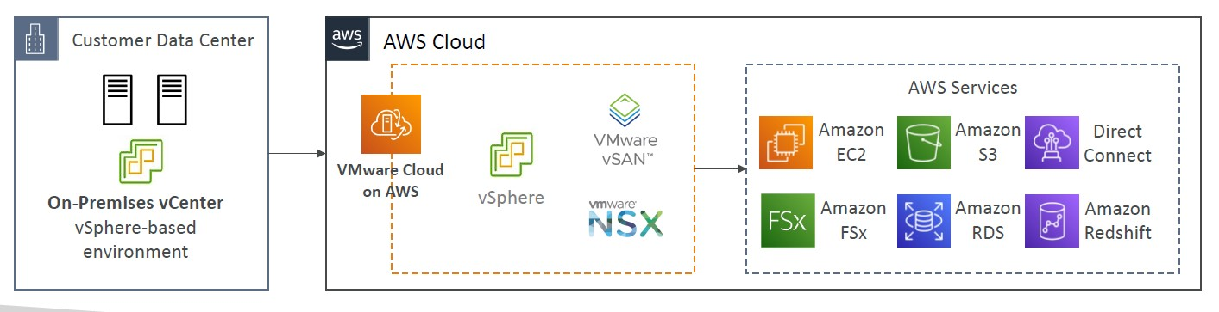

Transferring large amount of data into AWS

• Example: transfer 200 TB of data in the cloud. We have a 100 Mbps internet connection.

- Over the internet / Site-to-Site VPN:

• Immediate to setup

• Will take 200(TB)*1000(GB)*1000(MB)*8(Mb)/100 Mbps = 16,000,000s = 185d

- Over direct connect 1Gbps:

• Long for the one-time setup (over a month)

• Will take 200(TB)*1000(GB)*8(Gb)/1 Gbps = 1,600,000s = 18.5d

- Over Snowball:

• Will take 2 to 3 snowballs in parallel

• Takes about 1 week for the end-to-end transfer

• Can be combined with DMS

- For on-going replication / transfers: Site-to-Site VPN or DX with DMS or DataSync

Automation and Orchestration

• AWS Batch

• AWS Batch supports multi-node parallel jobs, which enables you to run single jobs that span multiple EC2 instances.

• Easily schedule jobs and launch EC2 instances accordingly

• AWS ParallelCluster

• Open-source cluster management tool to deploy HPC on AWS

• Configure with text files

• Automate creation of VPC, Subnet, cluster type and instance types

• Ability to enable EFA on the cluster (improves network performance)

What is CloudFormation

• CloudFormation is a declarative way of outlining your AWS Infrastructure, for any resources (most of them are supported).

- For example, within a CloudFormation template, you say:

• I want a security group

• I want two EC2 instances using this security group

• I want an S3 bucket

• I want a load balancer (ELB) in front of these machines

- Then CloudFormation creates those for you, in the right order, with the exact configuration that you specify

- Infrastructure as code

• No resources are manually created, which is excellent for control

• Changes to the infrastructure are reviewed through code

- Cost

• Each resources within the stack is tagged with an identifier so you can easily see how much a stack costs you

• You can estimate the costs of your resources using the CloudFormation template

• Savings strategy: In Dev, you could automation deletion of templates at 5 PM and recreated at 8 AM, safely

- Productivity

• Ability to destroy and re-create an infrastructure on the cloud on the fly

• Automated generation of Diagram for your templates!

• Declarative programming (no need to figure out ordering and orchestration)

- Don’t re-invent the wheel

• Leverage existing templates on the web

• Leverage the documentation

- Support:

• You can use “custom resources” for resources that are not supported

CloudFormation Stack Designer

• Example: WordPress CloudFormation Stack

• We can see all the resources

• We can see the relations between the components

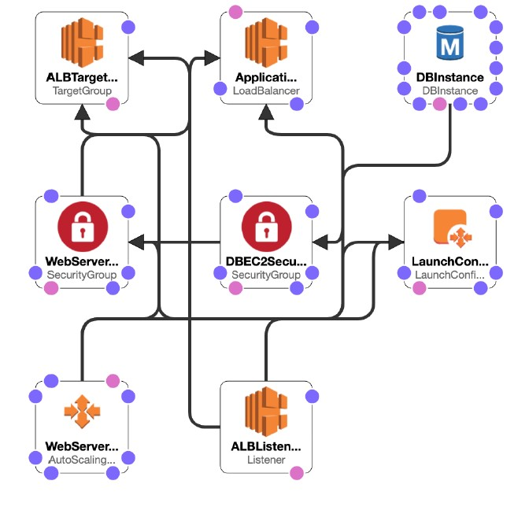

Amazon Simple Email Service (Amazon SES)

• Fully managed service to send emails securely, globally and at scale

• Allows inbound/outbound emails

• Reputation dashboard, performance insights, anti-spam feedback

• Provides statistics such as email deliveries, bounces, feedback loop results, email open

• Supports DomainKeys Identified Mail (DKIM) and Sender Policy Framework (SPF)

• Flexible IP deployment: shared, dedicated, and customer-owned IPs

• Send emails using your application using AWS Console, APIs, or SMTP

• Use cases: transactional, marketing and bulk email communications

Amazon Pinpoint

• Scalable 2-way (outbound/inbound) marketing communications service

• Supports email, SMS, push, voice, and in-app messaging

• Ability to segment and personalize messages with the right content to customers

• Possibility to receive replies

• Scales to billions of messages per day

• Use cases: run campaigns by sending marketing, bulk, transactional SMS messages

- Versus Amazon SNS or Amazon SES

• In SNS & SES you managed each message's audience, content, and delivery schedule

• In Amazon Pinpoint, you create message templates, delivery schedules, highly-targeted segments, and full campaigns

Systems Manager – SSM Session Manager

• Allows you to start a secure shell on your EC2 and on-premises servers

• No SSH access, bastion hosts, or SSH keys needed

• No port 22 needed (better security)

• Supports Linux, macOS, and Windows

• Send session log data to S3 or CloudWatch Logs

Systems Manager – Run Command

• Execute a document (= script) or just run a command

• Run command across multiple instances (using resource groups)

• No need for SSH

• Command Output can be shown in the AWS Console, sent to S3 bucket or CloudWatch Logs

• Send notifications to SNS about command status (In progress, Success, Failed, …)

• Integrated with IAM & CloudTrail

• Can be invoked using EventBridge

Systems Manager – Patch Manager

• Automates the process of patching managed instances

• OS updates, applications updates, security updates

• Supports EC2 instances and on-premises servers

• Supports Linux, macOS, and Windows

• Patch on-demand or on a schedule using Maintenance Windows

• Scan instances and generate patch compliance report (missing patches)

Systems Manager – Maintenance Windows

• Defines a schedule for when to perform actions on your instances

• Example: OS patching, updating drivers, installing software, …

- Maintenance Window contains

• Schedule

• Duration

• Set of registered instances

• Set of registered tasks

Systems Manager - Automation

• Simplifies common maintenance and deployment tasks of EC2 instances and other AWS resources

• Examples: restart instances, create an AMI, EBS snapshot

• Automation Runbook – SSM Documents to define actions preformed on your EC2 instances or AWS resources (pre-defined or custom)

• Can be triggered using:

• Manually using AWS Console, AWS CLI or SDK

• Amazon EventBridge

• On a schedule using Maintenance Windows

• By AWS Config for rules remediations

Cost Explorer

• Visualize, understand, and manage your AWS costs and usage over time

• Create custom reports that analyze cost and usage data.

• Analyze your data at a high level: total costs and usage across all accounts

• Or Monthly, hourly, resource level granularity

• Choose an optimal Savings Plan (to lower prices on your bill)

• Forecast usage up to 12 months based on previous usage

Amazon Elastic Transcoder

• Elastic Transcoder is used to convert media files stored in S3 into media files in the formats required by consumer playback devices (phones etc..)

- Benefits:

• Easy to use

• Highly scalable – can handle large volumes of media files and large file sizes

• Cost effective – duration-based pricing model

• Fully managed & secure, pay for what you use

AWS Batch

• Fully managed batch processing at any scale

• Efficiently run 100,000s of computing batch jobs on AWS

• A “batch” job is a job with a start and an end (opposed to continuous)

• Batch will dynamically launch EC2 instances or Spot Instances

• AWS Batch provisions the right amount of compute / memory

• You submit or schedule batch jobs and AWS Batch does the rest

• Batch jobs are defined as Docker images and run on ECS

• Helpful for cost optimizations and focusing less on the infrastructure

Batch vs Lambda

- Lambda:

• Time limit

• Limited runtimes

• Limited temporary disk space

• Serverless

- Batch:

• No time limit

• Any runtime as long as it’s packaged as a Docker image

• Rely on EBS / instance store for disk space

• Relies on EC2 (can be managed by AWS)

Amazon AppFlow

• Fully managed integration service that enables you to securely transfer data between Software-as-a-Service (SaaS) applications and AWS

• Sources: Salesforce, SAP, Zendesk, Slack, and ServiceNow

• Destinations: AWS services like Amazon S3, Amazon Redshift or non- AWS such as SnowFlake and Salesforce

• Frequency: on a schedule, in response to events, or on demand

• Data transformation capabilities like filtering and validation

• Encrypted over the public internet or privately over AWS PrivateLink

• Don’t spend time writing the integrations and leverage APIs immediately

Well Architected Framework

6 Pillars

• 1) Operational Excellence

• 2) Security

• 3) Reliability

• 4) Performance Efficiency

• 5) Cost Optimization

• 6) Sustainability

AWS Well-Architected Tool

• Free tool to review your architectures against the 6 pillars Well-Architected Framework and adopt architectural best practices

• How does it work?

• Select your workload and answer questions

• Review your answers against the 6 pillars

• Obtain advice: get videos and documentations, generate a report, see the results in a dashboard

Trusted Advisor

• No need to install anything – high level AWS account assessment

• Analyze your AWS accounts and provides recommendation:

Cost optimization, Performance, Security, Fault tolerance, Service quotas

• Core Checks and recommendations – all customers

• Can enable weekly email notification from the console

- Full Trusted Advisor – Available for Business & Enterprise support plans

• Ability to set CloudWatch alarms when reaching limits

• Programmatic Access using AWS Support API

- Cost Optimization:

• low utilization EC2 instances, idle load balancers, under-utilized EBS volumes…

• Reserved instances & savings plans optimizations,

- Performance:

• High utilization EC2 instances, CloudFront CDN optimizations

• EC2 to EBS throughput optimizations, Alias records recommendations

- Security:

• MFA enabled on Root Account, IAM key rotation, exposed Access Keys

• S3 Bucket Permissions for public access, security groups with unrestricted ports

- Fault Tolerance:

• EBS snapshots age, Availability Zone Balance

• ASG Multi-AZ, RDS Multi-AZ, ELB configuration…